SQL Functions Learnt

SELECT, use to select attributes you want from a df

SELECT x AS y, use to rename fields in query result

FROM, use to select the dataframe you want to select attributes from

SELECT DISTINCT x, use to select only unique values from selection

COUNT(), use to count number of rows of selected (value)

WHERE, use to specify conditions on a selection

AND, use to add conditions

OR, use to add an alternate condition

x BETWEEN, numerical selection conditon based on two values in attribute

WHERE IN, use to streamline selections to anything in an array

IS NULL, to query for missing data

NOT, to query the opposite of a statement

LIKE 'X%', used in a WHERE clause to search for a pattern

'X%' % wildcard will match zero, one, or many characters in text

'X_' _ wildcard will match a single character

e.g. LIKE '_r%' will give rows where the second letter ='r'

'%r_' will give records where the second to last letter = r

Variable Types, (can be viewed in database 'schemas'):

VARCHAR - variable character (common for strings)

INT - intergers

NUMERIC, DATE etc...

CREATE VIEW x AS, assigns subsequent query to 'x' so that the

selection can be made in shorthand in the future

Aggregate Functions

AVG(), SUM(), MIN(), MAX(), COUNT()

ROUND(x, decimalplaces) , round to specified decimal (leave blank for no dec)

GROUP BY

ORDER BY ... ASC/DESC

HAVING, use to filter grouped records

Order of execution:

FROM, WHERE, GROUP BY, HAVING, SELECT, ORDER BY, LIMIT

INNER JOIN

ON xxx.yyy = xxx.yyy, or USING(yyy), (for when key field is named the same)

e.g.

-- Select fields with aliases

SELECT c.code AS country_code, name, year, inflation_rate

FROM countries AS c

-- Join to economies (alias e)

INNER JOIN economies AS e

-- Match on code field using table aliases

ON c.code = e.code

LEFT JOIN x, joins table x as the right to FROM y

RIGHT

FULL JOIN

CROSS JOIN (do not need ON or USING), use to create output of every possible combination of values

<>, operator means 'does not equal'

self joins, used to compare parts of the same table

eg.

FROM x AS x1

INNER JOIN x AS x2

ON x1.key = x2.key

AND x1.key <> x2.key; <-- This removes matching rows with themselves

-- Set Theory --

UNION, set operator that merges two tables excluding duplicates

UNION ALL, merges two tables including duplicates

e.g.

SELECT *

FROM left_table

UNION

SELECT *

FROM right_table

eg2.

SELECT p.country_code, p.year

FROM populations AS p

UNION

SELECT e.code, e.year

FROM economies AS e

ORDER BY country_code , year;

INTERSECT, set operator that only returns values present in both tables

eg.1

-- Return all cities with the same name as a country

SELECT name

FROM cities

INTERSECT

SELECT name

FROM countries;

EXCEPT, set operator that returns unique values from the left table

e.g.

-- Return all cities that do not have the same name as a country

SELECT name

FROM cities

EXCEPT

SELECT name

FROM countries

ORDER BY name;

SUBQUERIES: can occur in WHERE, SELECT and FROM clauses

e.g.

-- Select relevant fields from cities table

SELECT name, country_code, urbanarea_pop

FROM cities

-- Filter using a subquery on the countries table

WHERE name IN

(SELECT capital

FROM countries)

ORDER BY urbanarea_pop DESC;

LEFT JOIN & SUBQUERY FOR SAME TASK:

-- Find top nine countries with the most cities

SELECT countries.name AS country, COUNT(*) AS cities_num

FROM countries

LEFT JOIN cities

ON countries.code = cities.country_code

GROUP BY country

-- Order by count of cities as cities_num

ORDER BY cities_num DESC, country

LIMIT 9;

SELECT countries.name AS country,

-- Subquery that provides the count of cities

(SELECT COUNT(country_code)

FROM cities

WHERE country_code=code) AS cities_num

FROM countries

ORDER BY cities_num DESC, country

LIMIT 9;

SUBQUERY INSIDE FROM

SELECT DISTINCT monarchs.continent, sub.most_recent

FROM monarchs,

(SELECT

continent,

MAX(indep_year) AS most_recent

FROM states

GROUP BY continent) AS sub

WHERE monarchs.continent = sub.continent

ORDER BY continent;

(Count of languages relating to country (key field = code)):

-- Select code, and language count as lang_num

SELECT code, (SELECT COUNT(*) FROM languages AS l WHERE l.code = c.code) AS lang_num

FROM countries AS c

MULTIPLE TABLE IN FROM CLAUSE

e.g. or to prevent table dups:

SELECT left_table.id, left_val SELECT DISTINCT left_table.id, left_val

FROM left_table, right_table FROM left_table, right_table

WHERE left_table.id = right_table.id WHERE left_table.id = right_table.id

INCLUDE SUBQUERY AS A TEMPOARY TABLE IN FROM CLAUSE AND SELECT FROM IT:

eg2. -- Query to return continents with monarchs and the year the most recent country

gained independence:

SELECT DISTINCT monarchs.continent, sub.most_recent

FROM monarchs,

(SELECT

continent,

MAX(indep_year) AS most_recent

FROM states

GROUP BY continent) AS sub

WHERE monarchs.continent = sub.continent

ORDER BY continent;

SUBQUERY INSIDE FROM EXERCISE:

1.

-- Select code, and language count as lang_num

SELECT code, COUNT(code) AS lang_num

FROM languages

GROUP BY code; --< Need the GROUP BY clause here to prevent an error

2. Put above query as a subquery and fill in blanks

-- Select local_name and lang_num from appropriate tables

SELECT countries.local_name, sub.lang_num

FROM countries,

(SELECT code, COUNT(*) AS lang_num

FROM languages

GROUP BY code) AS sub

WHERE countries.code = sub.code

ORDER BY lang_num DESC;

SUBQUERY EXERCISE

1. using where subquery to exclude monarchy or republican countries

SELECT code, inflation_rate, unemployment_rate

FROM economies

WHERE year = 2015

AND code NOT IN

-- Subquery returning country codes filtered on gov_form

(SELECT code

FROM countries

WHERE gov_form = 'Republic' OR gov_form = 'Monarchy')

ORDER BY inflation_rate;

can also use 'LIKE':

(SELECT code

FROM countries

WHERE gov_form LIKE '%Republic%' OR gov_form LIKE '%Monarchy%')

Final Exercise for subquery module:

Determine the top 10 capital cities in europe and the Americas by city_perc,

a metric you'll calculate. city_perc is a percentage that calculates the "proper" population

in a city as a percentage of the total population in the wider metro area, as follows:

city_proper_pop / metroarea_pop * 100

-- Select fields from cities

SELECT name, country_code, city_proper_pop,

metroarea_pop,

city_proper_pop / metroarea_pop * 100 AS city_perc

FROM cities

-- Use subquery to filter city name

WHERE country_code in

(SELECT code

FROM countries

WHERE capital = cities.name ---- (This line was actually not needed)

AND continent LIKE '%America'

OR continent LIKE 'Europe')

-- Add filter condition such that metroarea_pop does not have null values

AND metroarea_pop IS NOT NULL

-- Sort and limit the result

ORDER BY city_perc DESC

LIMIT 10;

In this module, I learned of many types of joins:

INNER JOIN (just JOIN)

Outer joins: LEFT, RIGHT and FULL

CROSS JOIN

Semi joins / anti join

Self join

I learned about set operations:

UNION / UNION ALL

INTERSECT

EXCEPT

I also learnt basic subqueries:

Inside, SELECT, FROM and WHERE clauses

CASE statements, contain WHEN, THEN, ELSE and END

(used as SQLs 'if' statements)

e.g

CASE WHEN x=1 THEN 'a'

WHEN x=2 THEN 'b'

ELSE 'c' END AS new_column

e.g.2

-- Identify the home team as Bayern Munich, Schalke 04, or neither

SELECT

CASE WHEN hometeam_id = 10189 THEN 'FC Schalke 04' <-IMPORTANT CASE is a statement

WHEN hometeam_id = 9823 THEN 'FC Bayern Munich' within the SELECT clause

ELSE 'Other' END AS home_team,

COUNT(id) AS total_matches

FROM matches_germany

-- Group by the CASE statement alias

GROUP BY home_team;

eg3. Gives the date, opponent (away team) and outcome of every match

SELECT

m.date,

--Select the team long name column and call it 'opponent'

t.team_long_name AS opponent,

-- Complete the CASE statement with an alias

CASE WHEN m.home_goal > m.away_goal THEN 'Home win!'

WHEN m.home_goal < m.away_goal THEN 'Home loss :('

ELSE 'Tie' END AS outcome

FROM matches_spain AS m

-- Left join teams_spain onto matches_spain

LEFT JOIN teams_spain AS t

ON m.awayteam_id = t.team_api_id;

ext. Filter for just barcelona

SELECT

m.date,

t.team_long_name AS opponent,

-- Complete the CASE statement with an alias

CASE WHEN m.home_goal > m.away_goal THEN 'Barcelona win!'

WHEN m.home_goal < m.away_goal THEN 'Barcelona loss :('

ELSE 'Tie' END AS outcome

FROM matches_spain AS m

LEFT JOIN teams_spain AS t

ON m.awayteam_id = t.team_api_id

-- Filter for Barcelona as the home team

WHERE m.hometeam_id = 8634;

***

AND statements can also be used in CASE statements

Removing the ELSE statement will work, however all other conditions will be returned as NULL

***

By repeating your CASE statement in a WHERE clause will filter your results, removing NULL values

eg.

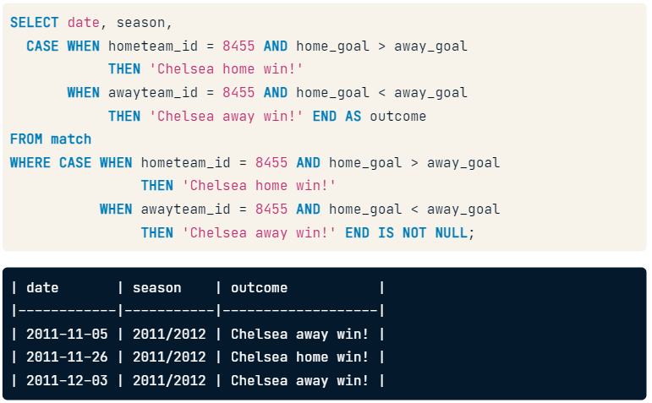

SELECT

        date,

        CASE WHEN hometeam_id = 8634 THEN 'FC Barcelona'

         ELSE 'Real Madrid CF' END as home,

        CASE WHEN awayteam_id = 8634 THEN 'FC Barcelona'

         ELSE 'Real Madrid CF' END as away,

        -- Identify all possible match outcomes

        CASE WHEN home_goal > away_goal AND hometeam_id = 8634 THEN 'Barcelona win!'

        WHEN home_goal < away_goal AND hometeam_id = 8633 THEN 'Real Madrid win!'

        WHEN home_goal > away_goal AND awayteam_id = 8634 THEN 'Barcelona win!'

        WHEN home_goal < away_goal AND awayteam_id = 8633 THEN 'Real Madrid win!'

        ELSE 'Tie!' END AS outcome

FROM matches_spain

WHERE (awayteam_id = 8634 OR hometeam_id = 8634)

      AND (awayteam_id = 8633 OR hometeam_id = 8633);

^^^ Shows code example using CASE to label team names and all combination of match outcomes, filtering for just those two teams.

-- Select the season and date columns

SELECT

    season,

    date,

    -- Identify when Bologna won a match

    CASE WHEN hometeam_id = 9857 AND home_goal > away_goal

        THEN 'Bologna Win'

        WHEN awayteam_id = 9857 AND away_goal > home_goal

        THEN 'Bologna Win'

        END AS outcome

FROM matches_italy; 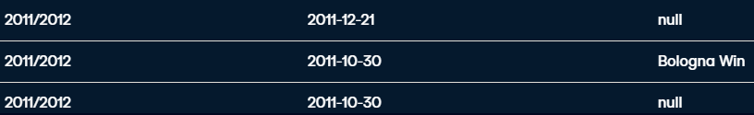

^^ Labels wins but doesn’t remove nulls

-- Select the season, date, home_goal, and away_goal columns

SELECT

    season,

    date,

    home_goal,

    away_goal

FROM matches_italy

WHERE

-- Exclude games not won by Bologna

    CASE WHEN hometeam_id = 9857 AND home_goal > away_goal THEN 'Bologna Win'

        WHEN awayteam_id = 9857 AND away_goal > home_goal THEN 'Bologna Win'

        END IS NOT NULL;

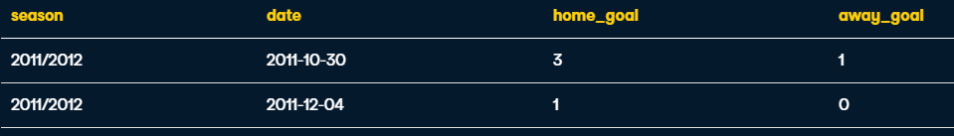

^ Filters results to show only wins of Bologna

It has been shown how CASE statements can be used to categorise/select data and now filter data.

CASE statements can also be used in Aggregating data:

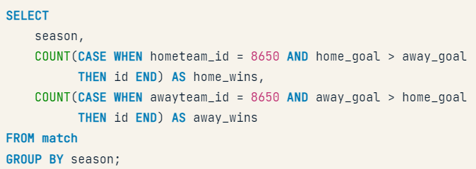

^ CASE statement within Aggregate COUNT function, also works with SUM & AVG

Creating an average goal count\/

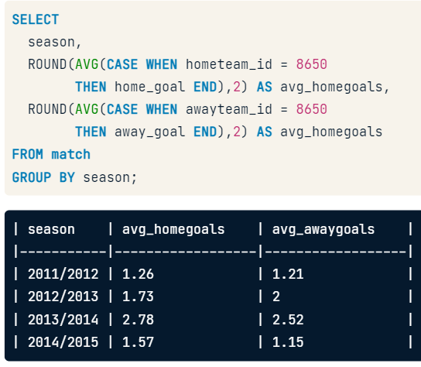

Creating a percentage win rate:

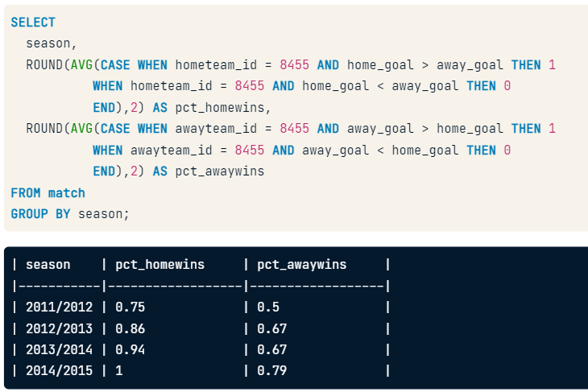

-- \/\/\/\/ Creating

SELECT

    c.name AS country,

    -- Count matches in each of the 3 seasons

    COUNT(CASE WHEN m.season = '2012/2013' THEN m.id END) AS matches_2012_2013,

    COUNT(CASE WHEN m.season = '2013/2014' THEN m.id END) AS matches_2013_2014,

    COUNT(CASE WHEN m.season = '2014/2015' THEN m.id END) AS matches_2014_2015

FROM country AS c

LEFT JOIN match AS m

ON c.id = m.country_id

-- Group by country name alias

GROUP BY country;

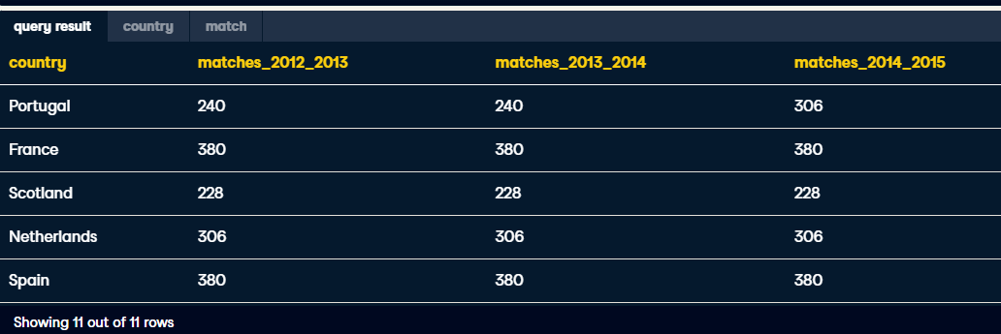

SELECT

        c.name AS country,

    -- Sum the total records in each season where the home team won

        SUM(CASE WHEN m.season = '2012/2013' AND m.home_goal > m.away_goal

        THEN 1 ELSE 0 END) AS matches_2012_2013,

        SUM(CASE WHEN m.season = '2013/2014' AND m.home_goal > m.away_goal

        THEN 1 ELSE 0 END) AS matches_2013_2014,

        SUM(CASE WHEN m.season = '2014/2015' AND m.home_goal > m.away_goal

        THEN 1 ELSE 0 END) AS matches_2014_2015

FROM country AS c

LEFT JOIN match AS m

ON c.id = m.country_id

-- Group by country name alias

GROUP BY country;

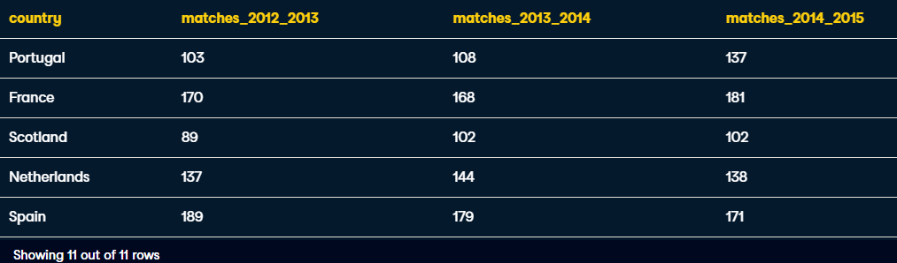

SELECT

    -- Select the stage and average goals for each stage

    m.stage,

    ROUND(AVG(m.home_goal + m.away_goal),2) AS avg_goals,

    -- Select the average overall goals for the 2012/2013 season

    ROUND((SELECT AVG(home_goal + away_goal)

           FROM match

           WHERE season = '2012/2013'),2) AS overall

FROM match AS m

-- Filter for the 2012/2013 season

WHERE season = '2012/2013'

-- Group by stage

GROUP BY m.stage;

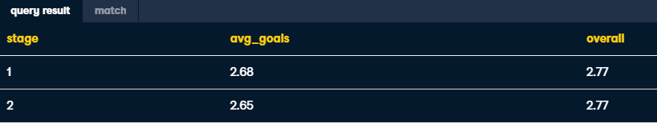

Now this query will be used as a subquery within a FROM clause to find all stages where their average goals scored were above the total average goals:

SELECT

    -- Select the stage and average goals from the subquery

    s.stage,

    ROUND(s.avg_goals,2) AS avg_goals

FROM

    -- Select the stage and average goals in 2012/2013

    (SELECT

         stage,

         AVG(home_goal  + away_goal) AS avg_goals

     FROM match

     WHERE season = '2012/2013'

     GROUP BY stage) AS s

WHERE

    -- Filter the main query using the subquery

    s.avg_goals >= (SELECT AVG(home_goal + away_goal)

                    FROM match WHERE season = '2012/2013');

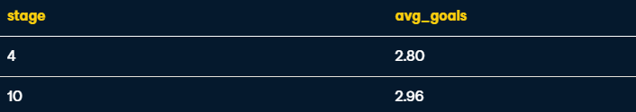

**Building in another subquery in the SELECT clause:**

subquery in FROM that calculates the average goals scored in each stage during the 2012/2013 season

subquery in SELECT that yields the average goals scored in the 2012/2013 season

Filter the main query for stages where the average goals exceeds the overall average in 2012/2013:

SELECT

    -- Select the stage and average goals from s

    s.stage,

    ROUND(s.avg_goals,2) AS avg_goal,

    -- Select the overall average for 2012/2013

    (SELECT AVG(home_goal + away_goal) FROM match WHERE season = '2012/2013') AS overall_avg

FROM

    -- Select the stage and average goals in 2012/2013 from match

    (SELECT

         stage,

         AVG(home_goal + away_goal) AS avg_goals

     FROM match

     WHERE season = '2012/2013'

     GROUP BY stage) AS s

WHERE

    -- Filter the main query using the subquery

    s.avg_goals >= (SELECT AVG(home_goal + away_goal)

                    FROM match WHERE season = '2012/2013');

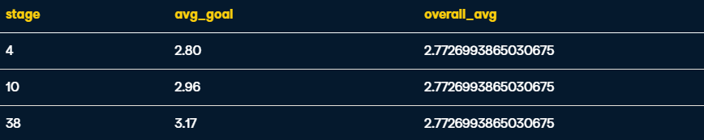

**Correlated subqueries:**

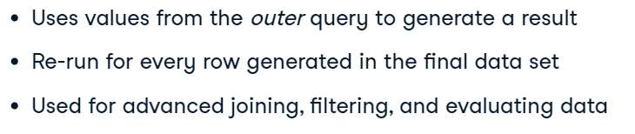

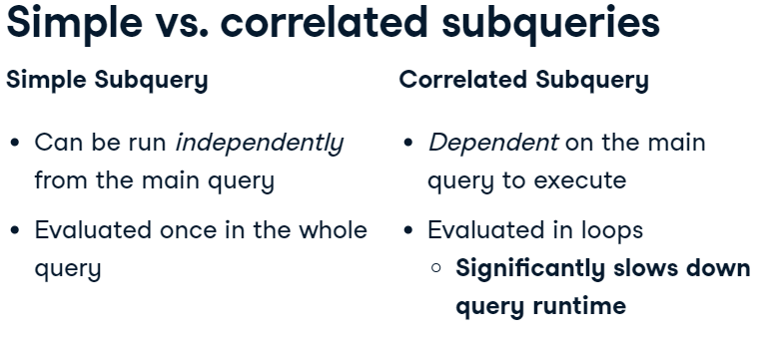

**Simple:**

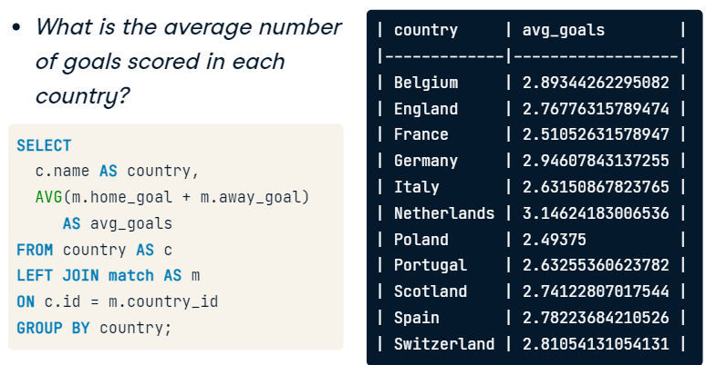

**Correlated:**

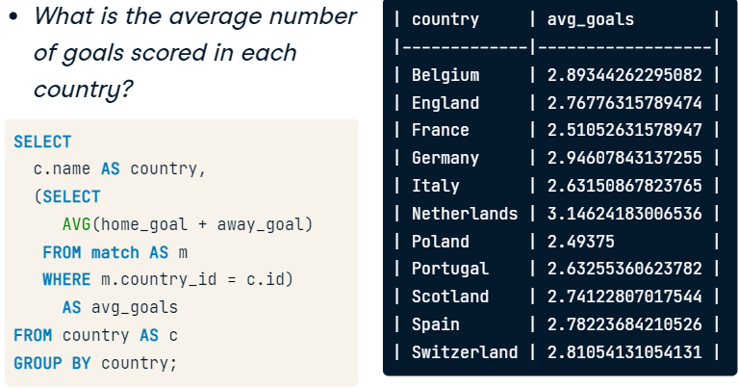

SELECT

    -- Select country ID, date, home, and away goals from match

    main.country_id,

    main.date,

    main.home_goal,

    main.away_goal

FROM match AS main

WHERE

    -- Filter the main query by the subquery

    (home_goal + away_goal) >

        (SELECT AVG((sub.home_goal + sub.away_goal) * 3)

         FROM match AS sub

         -- Join the main query to the subquery in WHERE

         WHERE main.country_id = sub.country_id);

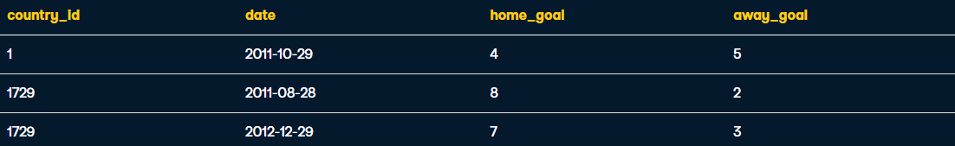

add an additional column for matching to answer the question -- what was the highest scoring match for each country, in each season:

SELECT

    -- Select country ID, date, home, and away goals from match

    main.country_id,

    main.date,

    main.home_goal,

    main.away_goal

FROM match AS main

WHERE

    -- Filter for matches with the highest number of goals scored

    (home_goal + away_goal) =

        (SELECT MAX(sub.home_goal + sub.away_goal)

         FROM match AS sub

         WHERE main.country_id = sub.country_id

               AND main.season = sub.season);

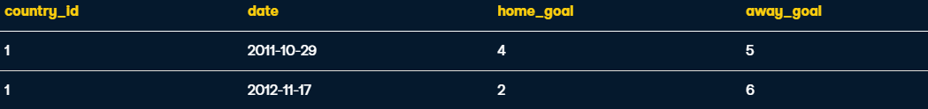

**Nested Subqueries**

**Subqueries inside another subquery – For performing layers of transformation**

**e.g.**

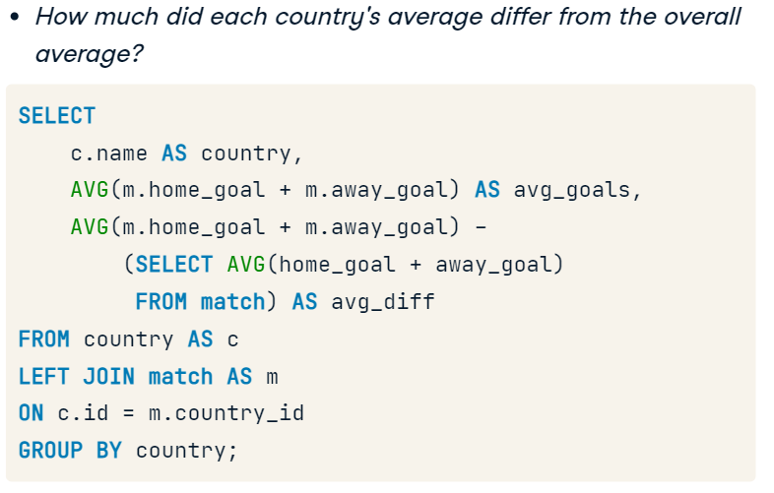 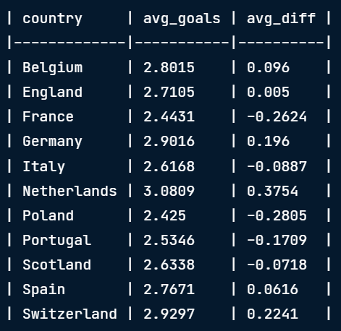

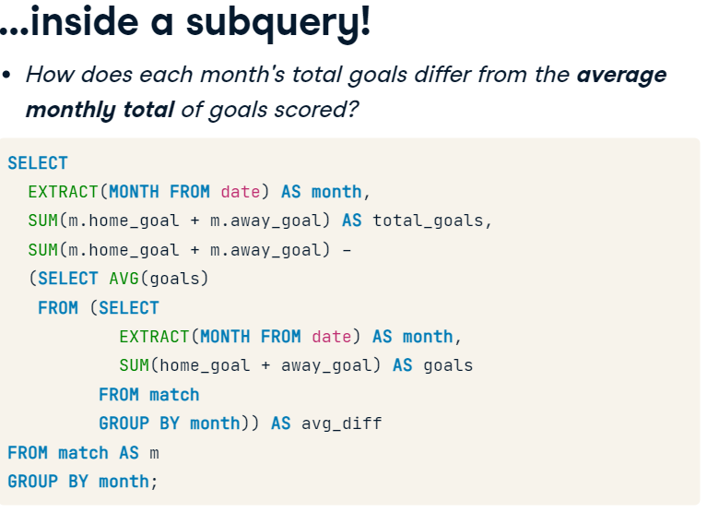

2. Gets average of inner query

1. Select the sum of goals from each month

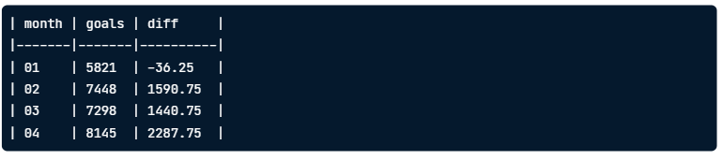EXTRACT, - takes pre-formatted data out of a field eg. Month out of a date

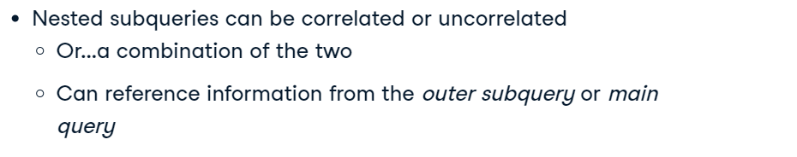

**Nested Subquery where outer query is correlated :**

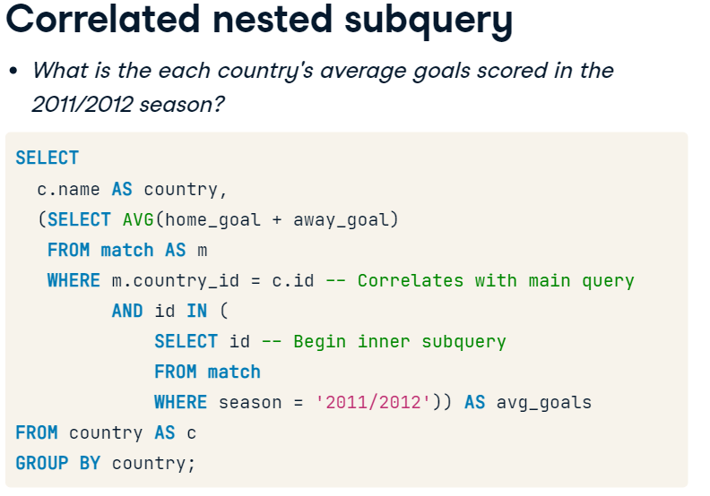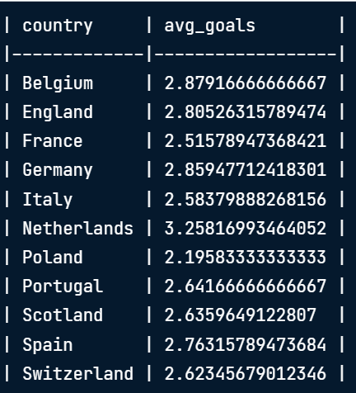

examine the highest total number of goals in each season, overall, and during July across all seasons:

SELECT

    -- Select the season and max goals scored in a match

    season,

    MAX(home_goal + away_goal) AS max_goals,

    -- Select the overall max goals scored in a match

   (SELECT MAX(home_goal + away_goal) FROM match) AS overall_max_goals,

   -- Select the max number of goals scored in any match in July

   (SELECT MAX(home_goal + away_goal)

    FROM match

    WHERE id IN (

          SELECT id FROM match WHERE EXTRACT(MONTH FROM date) = 07)) AS july_max_goals

FROM match

GROUP BY season;

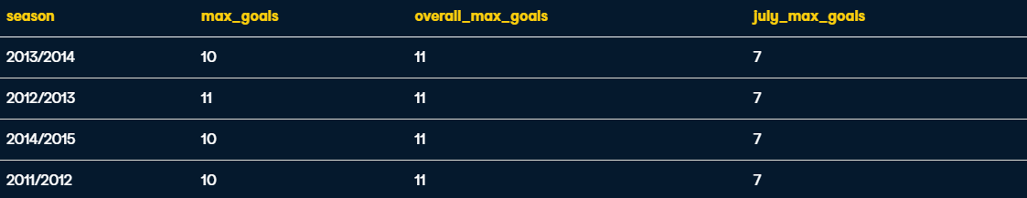

Average number of matches per season where a team scored >=5 goals:

1. Subquery for FROM:

-- Select matches where a team scored 5+ goals

SELECT

    country_id,

    season,

    id

FROM match

WHERE home_goal >= 5 OR away_goal >= 5;

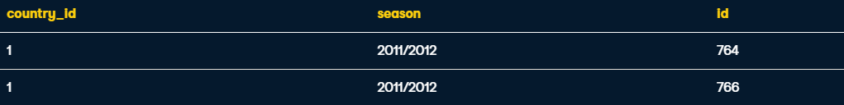

2. Putting Subquery into FROM:

-- Count match ids

SELECT

    country_id,

    season,

    COUNT(id) AS matches

-- Set up and alias the subquery

FROM (

    SELECT

        country_id,

        season,

        id

    FROM match

    WHERE home_goal >= 5 OR away_goal >= 5)

    AS subquery

-- Group by country_id and season

GROUP BY country_id, season;

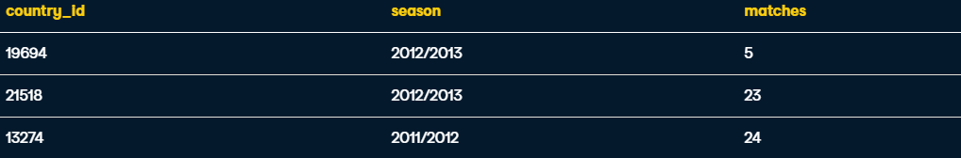

3. Nest that query as a query within FROM

SELECT

  c.name AS country,

    -- Calculate the average matches per season

  AVG(outer_s.matches) AS avg_seasonal_high_scores

FROM country AS c

-- Left join outer_s to country

LEFT JOIN (

  SELECT country_id, season,

         COUNT(id) AS matches

  FROM (

    SELECT country_id, season, id

  FROM match

  WHERE home_goal >= 5 OR away_goal >= 5) AS inner_s

  -- Close parentheses and alias the subquery

  GROUP BY country_id, season) AS outer_s

ON c.id = outer_s.country_id

GROUP BY country;

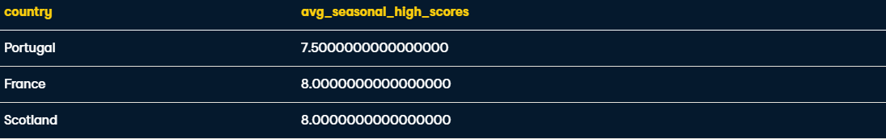

**Common Table Expressions**

A Table declared before the main query for improving readability

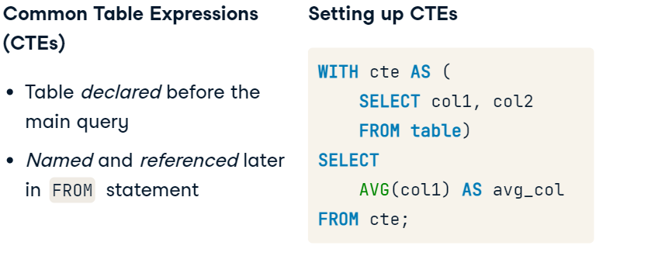

e.g. Rewriting a subquery in FROM

Results of countries with a count of very few high scoring matches

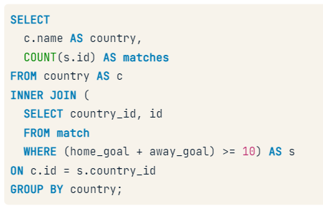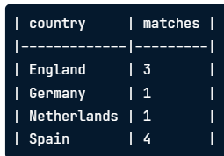

This subquery can be created and treated like an existing table by taking it out of the main query and referencing it like a table:

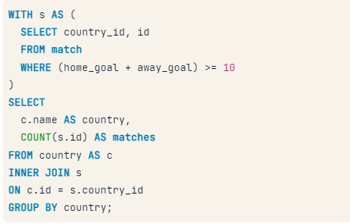

We use these instead of subqueries due to:

Performance, as it’s only run once

Organisation

Each CTE can reference the CTEs that came before it

They can also SELF JOIN (recursive CTEs)

-- Set up your CTE

WITH match_list AS (

    SELECT

        country_id,

        id

    FROM match

    WHERE (home_goal + away_goal) >= 10)

-- Select league and count of matches from the CTE

SELECT

    l.name AS league,

    COUNT(match_list.id) AS matches

FROM league AS l

-- Join the CTE to the league table

LEFT JOIN match_list ON l.id = match_list.country_id

GROUP BY l.name;



**Join inside a CTE**

-- Set up your CTE

WITH match_list AS (

  -- Select the league, date, home, and away goals

    SELECT

      l.name AS league,

      m.date,

      m.home_goal,

      m.away_goal,

       (m.home_goal + m.away_goal) AS total_goals

    FROM match AS m

    LEFT JOIN league as l ON m.country_id = l.id)

-- Select the league, date, home, and away goals from the CTE

SELECT league, date, home_goal, away_goal

FROM match_list

-- Filter by total goals

WHERE total_goals >= 10;

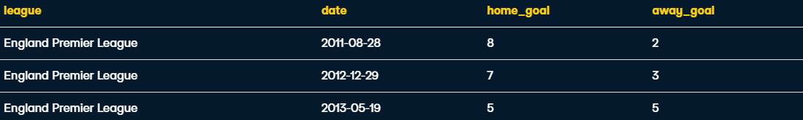

**Nested Subquery within a CTE**

-- Set up your CTE

WITH match_list AS (

    SELECT

      country_id,

       (home_goal + away_goal) AS goals

    FROM match

    -- Create a list of match IDs to filter data in the CTE

    WHERE id IN (

       SELECT id

       FROM match

       WHERE season = '2013/2014' AND EXTRACT(MONTH FROM date) = 08))

-- Select the league name and average of goals in the CTE

SELECT

  l.name,

    AVG(match_list.goals)

FROM league AS l

-- Join the CTE onto the league table

LEFT JOIN match_list ON l.id = match_list.country_id

GROUP BY l.name;

**Differentiating Techniques**

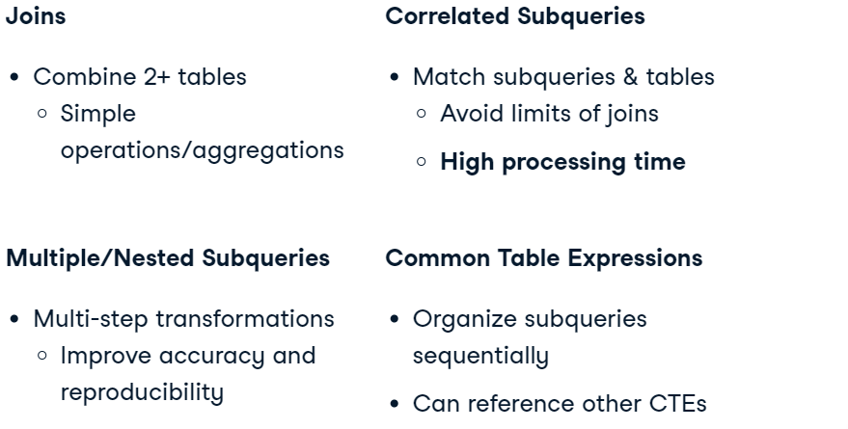

# Get team names with a subquery

Let's solve a problem we've encountered a few times in this course so far -- How do you get both the home and away team names into one final query result?

Out of the 4 techniques we just discussed, this can be performed using subqueries, correlated subqueries, and CTEs. Let's practice creating similar result sets using each of these 3 methods over the next 3 exercises, starting with subqueries in FROM.

**2 subqueries:**

SELECT

  m.date,

    -- Get the home and away team names

    hometeam,

    awayteam,

    m.home_goal,

    m.away_goal

FROM match AS m

-- Join the home subquery to the match table

LEFT JOIN (

  SELECT match.id, team.team_long_name AS hometeam

  FROM match

  LEFT JOIN team

  ON match.hometeam_id = team.team_api_id) AS home

ON home.id = m.id

-- Join the away subquery to the match table

LEFT JOIN (

  SELECT match.id, team.team_long_name AS awayteam

  FROM match

  LEFT JOIN team

  -- Get the away team ID in the subquery

  ON match.awayteam_id = team.team_api_id) AS away

ON away.id = m.id;

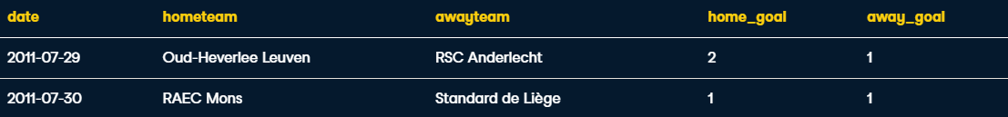

**Correlated Subquery:**

SELECT

    m.date,

    (SELECT team_long_name

     FROM team AS t

     WHERE t.team_api_id = m.hometeam_id) AS hometeam,

    -- Connect the team to the match table

    (SELECT team_long_name

     FROM team AS t

     WHERE t.team_api_id = m.awayteam_id) AS awayteam,

    -- Select home and away goals

     m.home_goal,

     m.away_goal

FROM match AS m;

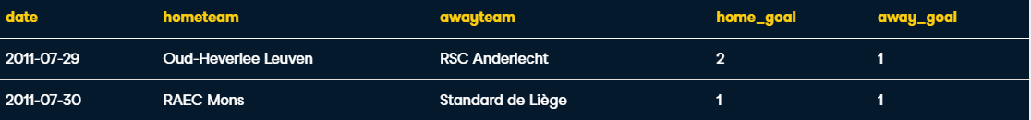

**Common Table Expressions: (*Note that you only need to write* WITH *once)***

WITH home AS (

  SELECT m.id, m.date,

       t.team_long_name AS hometeam, m.home_goal

  FROM match AS m

  LEFT JOIN team AS t

  ON m.hometeam_id = t.team_api_id),

-- Declare and set up the away CTE

away AS (

  SELECT m.id, m.date,

       t.team_long_name AS awayteam, m.away_goal

  FROM match AS m

  LEFT JOIN team AS t

  ON m.awayteam_id = t.team_api_id)

-- Select date, home_goal, and away_goal

SELECT

  home.date,

    home.hometeam,

    away.awayteam,

    home.home_goal,

    away.away_goal

-- Join away and home on the id column

FROM home

INNER JOIN away

ON home.id = away.id;

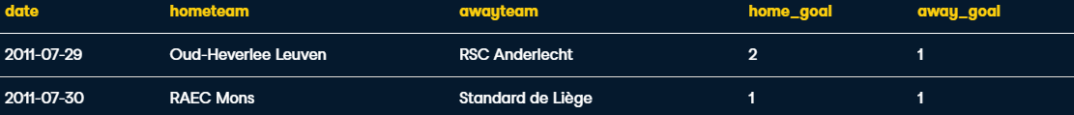

**Window Functions:**

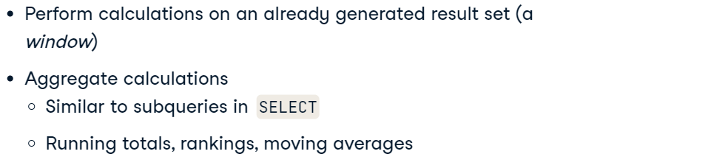

**OVER(), clause to initiate window function**

**Eg. Subquery in Select (complex version)**

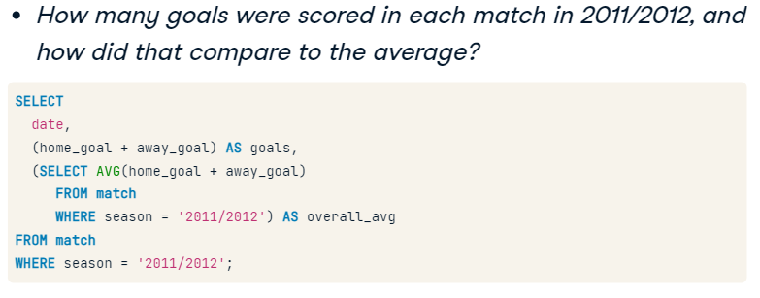**\/**

**Window Function (more concise)**

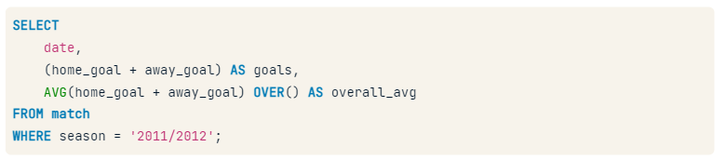 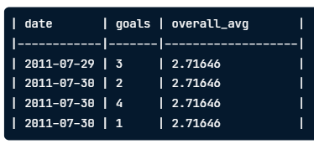

**RANK window function example:** 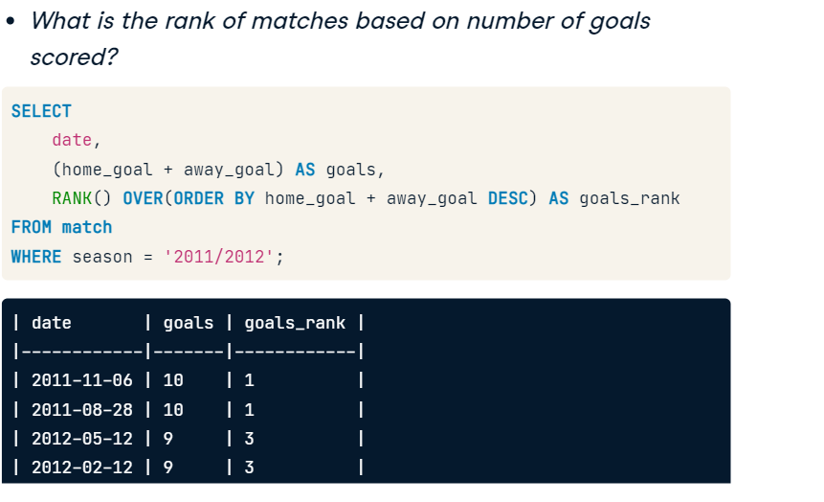



SELECT

    -- Select the id, country name, season, home, and away goals

    m.id,

    c.name AS country,

    m.season,

    m.home_goal,

    m.away_goal,

    -- Use a window to include the aggregate average in each row

    AVG(m.home_goal + m.away_goal) OVER() AS overall_avg

FROM match AS m

LEFT JOIN country AS c ON m.country_id = c.id;

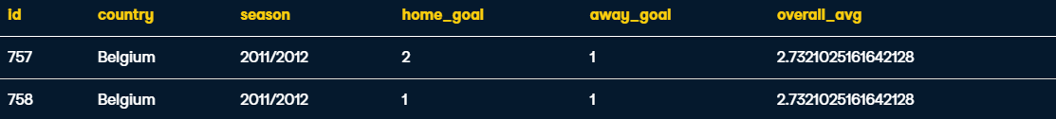

SELECT

    -- Select the league name and average goals scored

    l.name AS league,

    AVG(m.home_goal + m.away_goal) AS avg_goals,

    -- Rank each league according to the average goals

    RANK() OVER(ORDER BY AVG(m.home_goal + m.away_goal)) AS league_rank

FROM league AS l

LEFT JOIN match AS m

ON l.id = m.country_id

WHERE m.season = '2011/2012'

GROUP BY l.name

-- Order the query by the rank you created

ORDER BY league_rank;



**Add DESC to order the RANK**



**Window Partitions**

**OVER** and **PARTITION BY**:

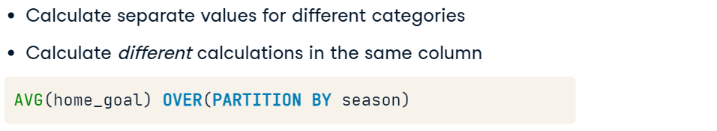

**e.g.**

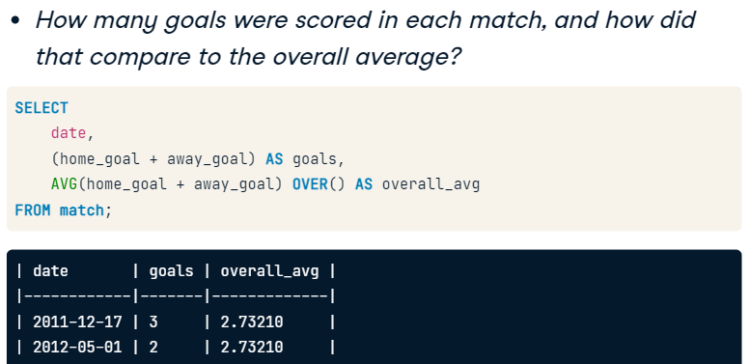

**e.g.2**

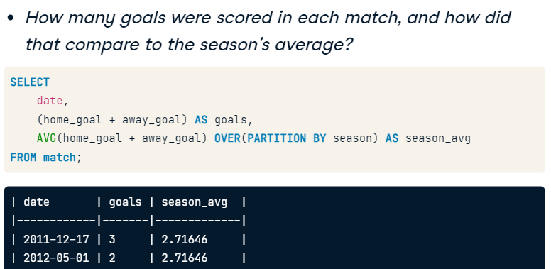

**PARTITION BY** multiple columns:

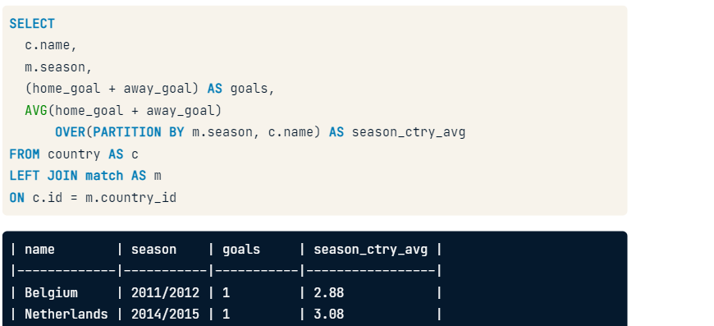

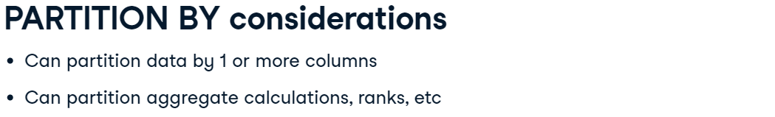

Ex1.

SELECT

    date,

    season,

    home_goal,

    away_goal,

    CASE WHEN hometeam_id = 8673 THEN 'home'

         ELSE 'away' END AS warsaw_location,

    -- Calculate the average goals scored partitioned by season

    AVG(home_goal) OVER(PARTITION BY season) AS season_homeavg,

    AVG(away_goal) OVER(PARTITION BY season) AS season_awayavg

FROM match

-- Filter the data set for Legia Warszawa matches only

WHERE

    hometeam_id = 8673

    OR awayteam_id = 8673

ORDER BY (home_goal + away_goal) DESC;

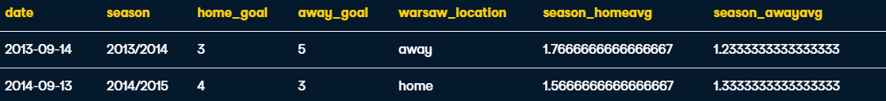

Ex2. (Partition by 2 columns_)

SELECT

    date,

    season,

    home_goal,

    away_goal,

    CASE WHEN hometeam_id = 8673 THEN 'home'

         ELSE 'away' END AS warsaw_location,

    -- Calculate average goals partitioned by season and month

    AVG(home_goal) OVER(PARTITION BY season,

            EXTRACT(MONTH FROM date)) AS season_mo_home,

    AVG(away_goal) OVER(PARTITION BY season,

            EXTRACT(MONTH FROM date)) AS season_mo_away

FROM match

WHERE

    hometeam_id = 8673

    OR awayteam_id = 8673

ORDER BY (home_goal + away_goal) DESC;

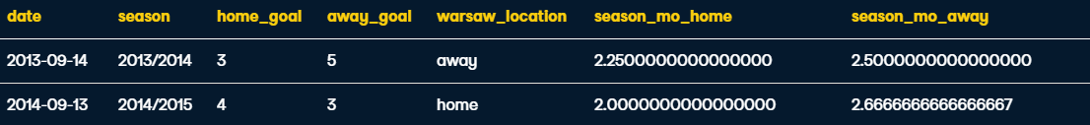

**Sliding Windows**



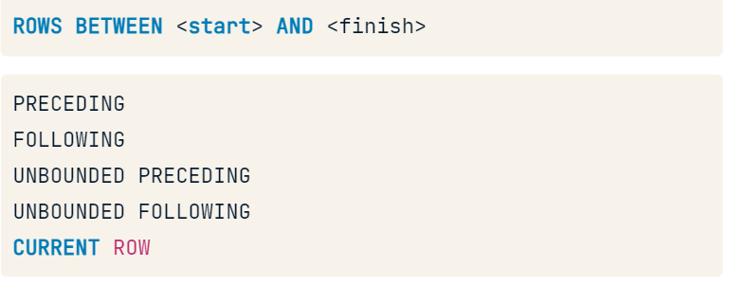

e.g.

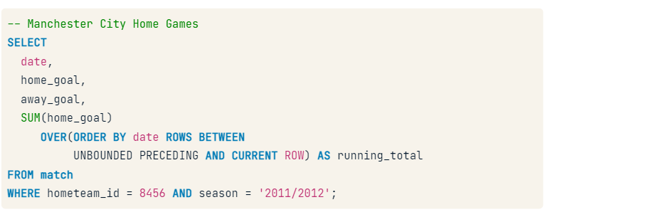

^ Here the query first calculates the sum of goals when Manchester city played as the home team during the 2011/2012 season. Then states you want the calculation into a running total ordered by date of match, oldest -> most recent and calculated from the beginning of the dataset to the current row.

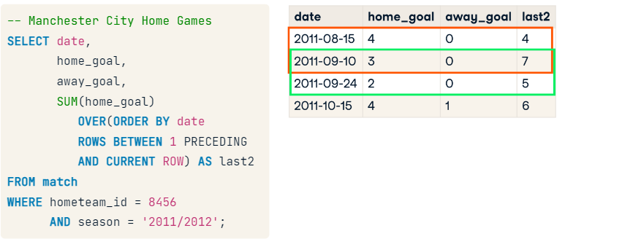

^ Creates a running total of every two

Ex1. UNBOUNDED PRECEDING AND CURRENT ROW

SELECT

     date,

     home_goal,

     away_goal,

    -- Create a running total and running average of home goals

    SUM(home_goal) OVER(ORDER BY date

         ROWS BETWEEN UNBOUNDED PRECEDING AND CURRENT ROW) AS running_total,

    AVG(home_goal) OVER(ORDER BY date

         ROWS BETWEEN UNBOUNDED PRECEDING AND CURRENT ROW) AS running_avg

FROM match

WHERE

     hometeam_id = 9908

     AND season = '2011/2012';

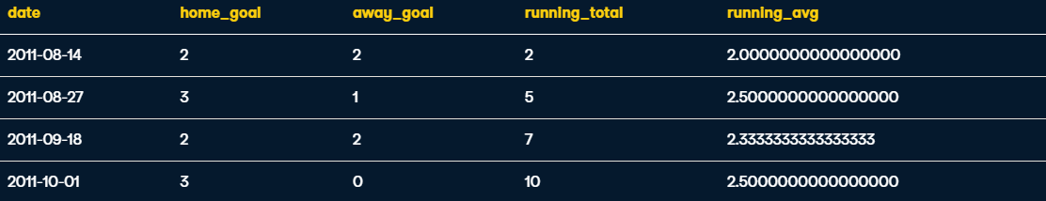

Ex2. Backward running total/avg CURRENT ROW AND UNBOUNDED FOLLOWING

SELECT

     -- Select the date, home goal, and away goals

     date,

    home_goal,

    away_goal,

    -- Create a running total and running average of home goals

    SUM(home_goal) OVER(ORDER BY date DESC

         ROWS BETWEEN CURRENT ROW AND UNBOUNDED FOLLOWING) AS running_total,

    AVG(home_goal) OVER(ORDER BY date DESC

         ROWS BETWEEN CURRENT ROW AND UNBOUNDED FOLLOWING) AS running_avg

FROM match

WHERE

     awayteam_id = 9908

    AND season = '2011/2012';

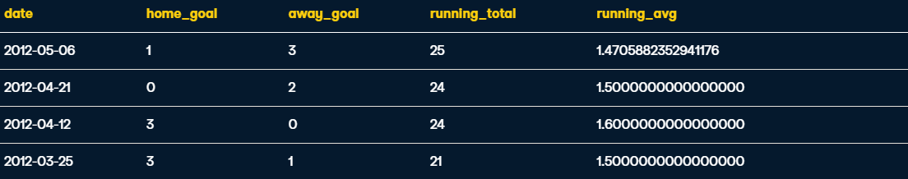

Final Exercise of Module,

Investigating Manchester United

Ex1. CTE for **2014/2015** **Manchester United**, **home** game outcomes

SELECT

    m.id,

    t.team_long_name,

    -- Identify matches as home/away wins or ties

    CASE WHEN m.home_goal > m.away_goal THEN 'MU Win'

        WHEN m.home_goal < m.away_goal THEN 'MU Loss'

        ELSE 'Tie' END AS outcome

FROM match AS m

-- Left join team on the home team ID and team API id

LEFT JOIN team AS t

ON m.hometeam_id = t.team_api_id

WHERE

    -- Filter for 2014/2015 and Manchester United as the home team

    m.season = '2014/2015'

    AND t.team_long_name = 'Manchester United';

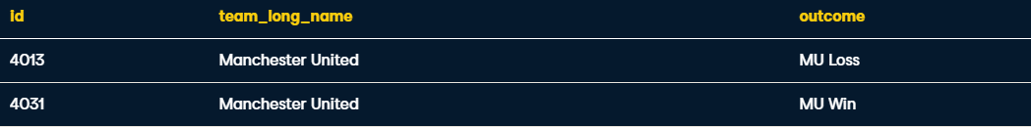

Ex2. CTE for **Manchester United**, **away**, game outcomes (switch variables to awayteam)

SELECT

    m.id,

    t.team_long_name,

    -- Identify matches as home/away wins or ties

    CASE WHEN m.home_goal < m.away_goal THEN 'MU Win'

        WHEN m.home_goal > m.away_goal THEN 'MU Loss'

        ELSE 'Tie' END AS outcome

FROM match AS m

-- Left join team on the home team ID and team API id

LEFT JOIN team AS t

ON m.awayteam_id = t.team_api_id

WHERE

    -- Filter for 2014/2015 and Manchester United as the home team

    m.season = '2014/2015'

    AND t.team_long_name = 'Manchester United';



Ex3. Load both CTEs and JOIN to match table during the 2014/2015 season

-- Set up the home team CTE

WITH home AS (

  SELECT m.id, t.team_long_name,

    CASE WHEN m.home_goal > m.away_goal THEN 'MU Win'

       WHEN m.home_goal < m.away_goal THEN 'MU Loss'

         ELSE 'Tie' END AS outcome

  FROM match AS m

  LEFT JOIN team AS t ON m.hometeam_id = t.team_api_id),

-- Set up the away team CTE

away AS (

  SELECT m.id, t.team_long_name,

    CASE WHEN m.home_goal > m.away_goal THEN 'MU Win'

       WHEN m.home_goal < m.away_goal THEN 'MU Loss'

         ELSE 'Tie' END AS outcome

  FROM match AS m

  LEFT JOIN team AS t ON m.awayteam_id = t.team_api_id)

-- Select team names, the date and goals

SELECT DISTINCT

    date,

    home.team_long_name AS home_team,

    away.team_long_name AS away_team,

    m.home_goal,

    m.away_goal

-- Join the CTEs onto the match table

FROM match AS m

LEFT JOIN home ON m.id = home.id

LEFT JOIN away ON m.id = away.id

WHERE m.season = '2014/2015'

      AND (home.team_long_name = 'Manchester United'

           OR away.team_long_name = 'Manchester United');

Ex4. Adding a rank window function to the query

-- Set up the home team CTE

WITH home AS (

  SELECT m.id, t.team_long_name,

    CASE WHEN m.home_goal > m.away_goal THEN 'MU Win'

       WHEN m.home_goal < m.away_goal THEN 'MU Loss'

         ELSE 'Tie' END AS outcome

  FROM match AS m

  LEFT JOIN team AS t ON m.hometeam_id = t.team_api_id),

-- Set up the away team CTE

away AS (

  SELECT m.id, t.team_long_name,

    CASE WHEN m.home_goal > m.away_goal THEN 'MU Loss'

       WHEN m.home_goal < m.away_goal THEN 'MU Win'

         ELSE 'Tie' END AS outcome

  FROM match AS m

  LEFT JOIN team AS t ON m.awayteam_id = t.team_api_id)

-- Select columns and and rank the matches by goal difference

SELECT DISTINCT

    date,

    home.team_long_name AS home_team,

    away.team_long_name AS away_team,

    m.home_goal, m.away_goal,

    RANK() OVER(ORDER BY ABS(home_goal - away_goal) DESC) AS match_rank

-- Join the CTEs onto the match table

FROM match AS m

LEFT JOIN home ON m.id = home.id

LEFT JOIN away ON m.id = away.id

WHERE m.season = '2014/2015'

      AND ((home.team_long_name = 'Manchester United' AND home.outcome = 'MU Loss')

      OR (away.team_long_name = 'Manchester United' AND away.outcome = 'MU Loss'));

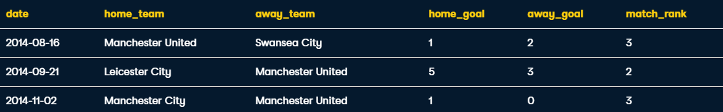

**Complex Window Functions**

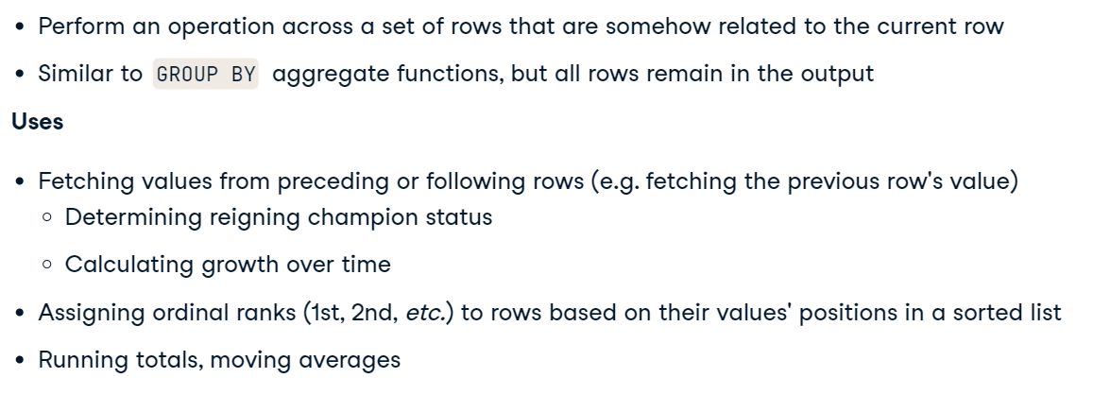

ROW_NUMBER

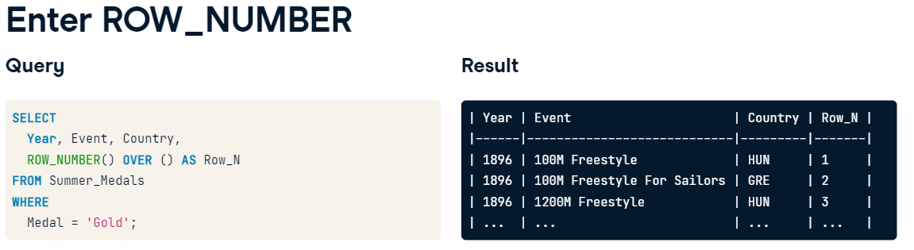

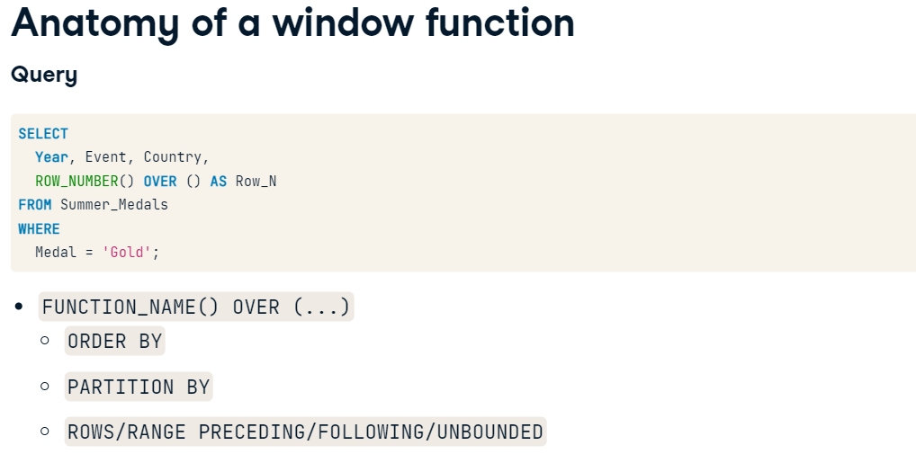

Add row number column:

SELECT

  *,

  -- Assign numbers to each row

  ROW_NUMBER() OVER() AS Row_N

FROM Summer_Medals

ORDER BY Row_N ASC;

Number each year of the Summer Olympics:

SELECT

  Year,

  -- Assign numbers to each year

  ROW_NUMBER() OVER() AS Row_N

FROM (

  SELECT DISTINCT(Year)

  FROM Summer_Medals

  ORDER BY Year ASC

) AS Years

ORDER BY Year ASC;

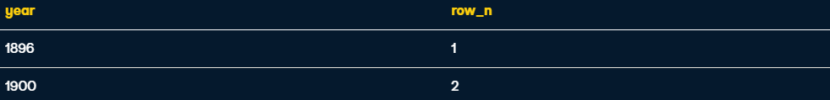

**ORDER BY**

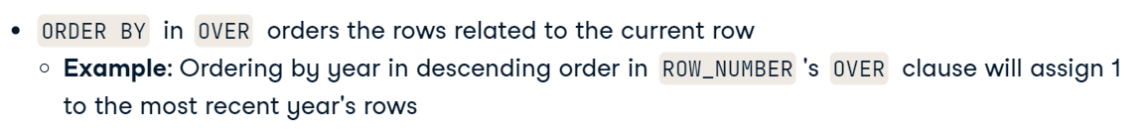

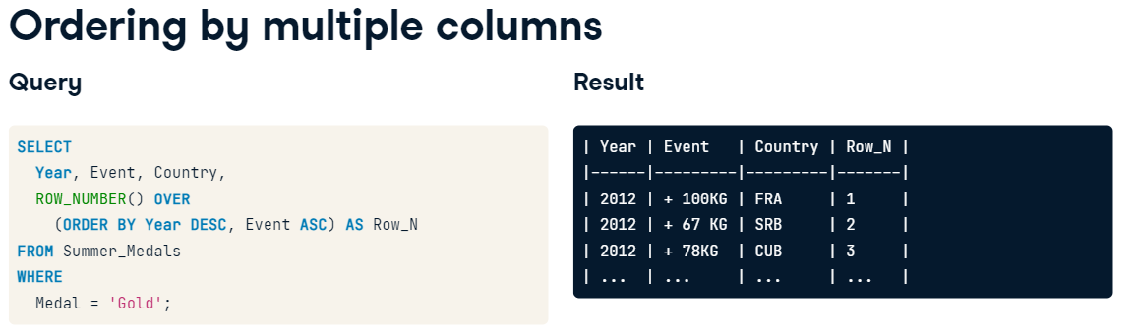

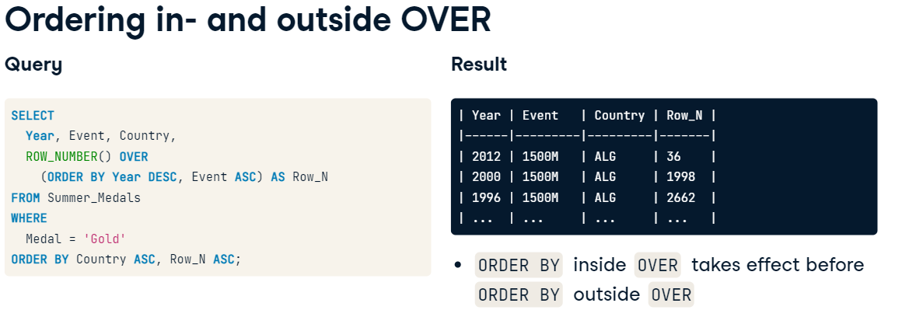

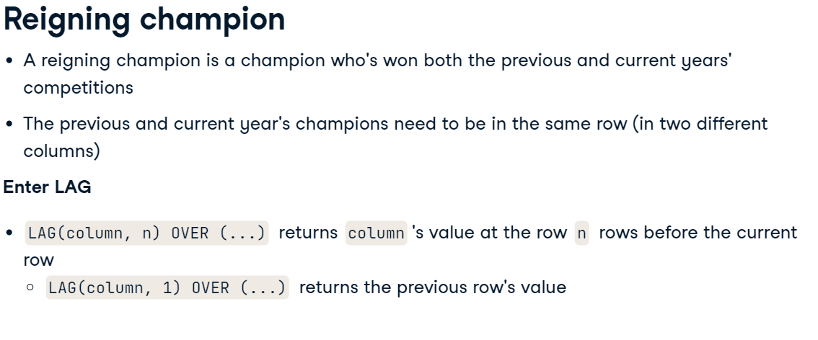

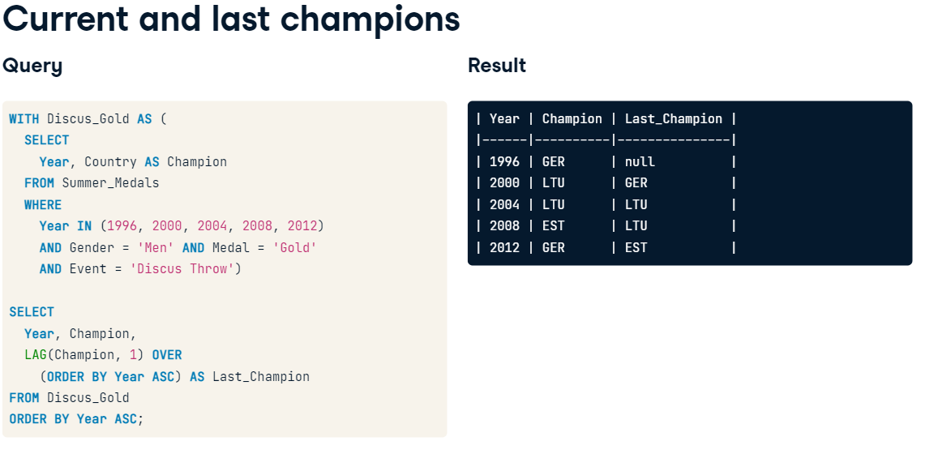

**Ex1** . Number years, with most recent years being the low numbers

SELECT

  Year,

  -- Assign the lowest numbers to the most recent years

  ROW_NUMBER() OVER (ORDER BY Year DESC) AS Row_N

FROM (

  SELECT DISTINCT Year

  FROM Summer_Medals

) AS Years

ORDER BY Year;

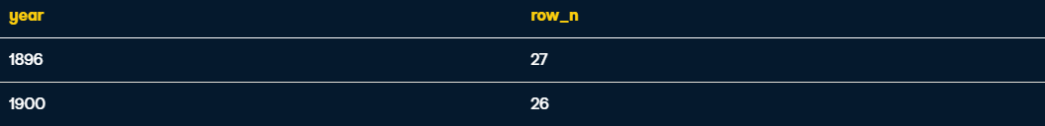

**Ex2.**  Count medals each athlete has and rank them accordingly

WITH Athlete_Medals AS (

  SELECT

    -- Count the number of medals each athlete has earned

    Athlete,

    COUNT(*) AS Medals

  FROM Summer_Medals

  GROUP BY Athlete)

SELECT

  -- Number each athlete by how many medals they've earned

  Athlete,

  ROW_NUMBER() OVER (ORDER BY Medals DESC) AS Row_N

FROM Athlete_Medals

ORDER BY Medals DESC;



**Ex3.** Find the reigning champions from each year's gold medalists in the Men's 69KG weightlifting cte

WITH Weightlifting_Gold AS (

  SELECT

    -- Return each year's champions' countries

    Year,

    Country AS champion

  FROM Summer_Medals

  WHERE

    Discipline = 'Weightlifting' AND

    Event = '69KG' AND

    Gender = 'Men' AND

    Medal = 'Gold')

SELECT

  Year, Champion,

  -- Fetch the previous year's champion

  LAG(Champion) OVER

    (ORDER BY Year ASC) AS Last_Champion

FROM Weightlifting_Gold

ORDER BY Year ASC;

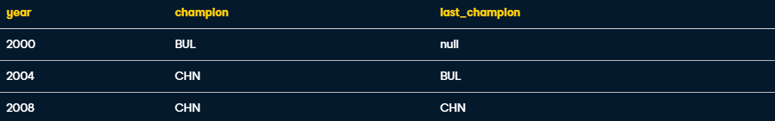

**PARTITION BY**

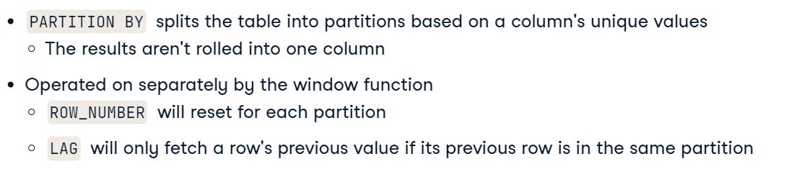 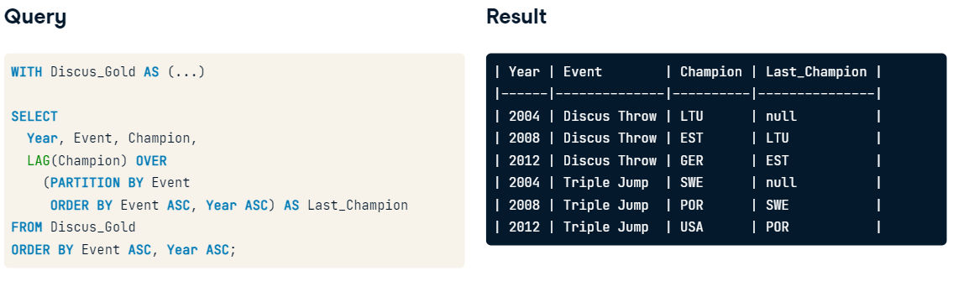

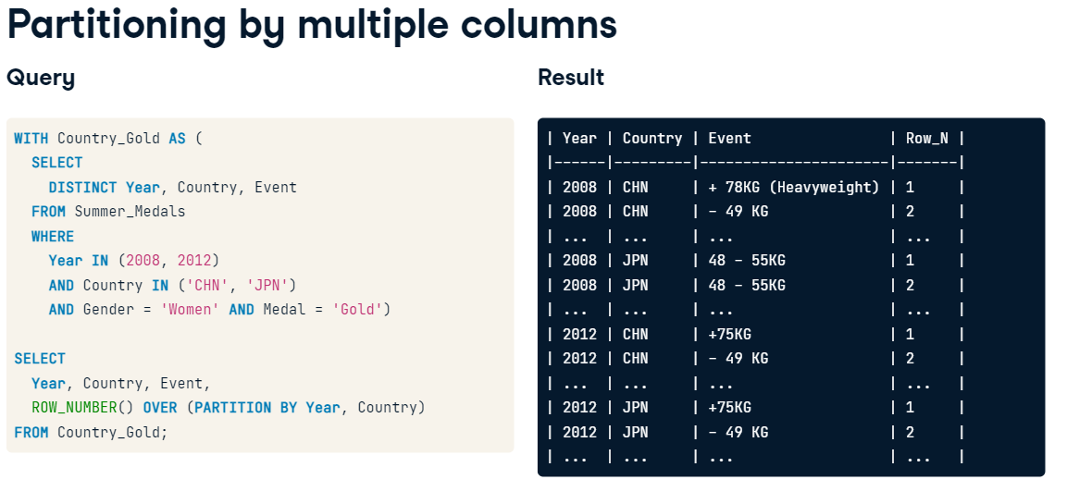

**Ex1. Partition by gender and order by year**

WITH Tennis_Gold AS (

  SELECT DISTINCT

    Gender, Year, Country

  FROM Summer_Medals

  WHERE

    Year >= 2000 AND

    Event = 'Javelin Throw' AND

    Medal = 'Gold')

SELECT

  Gender, Year,

  Country AS Champion,

  -- Fetch the previous year's champion by gender

  LAG(Country) OVER (PARTITION BY Gender

            ORDER BY Gender, Year ASC) AS Last_Champion

FROM Tennis_Gold

ORDER BY Gender ASC, Year ASC;

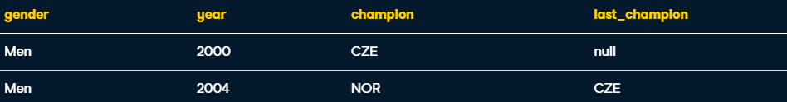

**Ex2. Partition by Gender and Event**

WITH Athletics_Gold AS (

  SELECT DISTINCT

    Gender, Year, Event, Country

  FROM Summer_Medals

  WHERE

    Year >= 2000 AND

    Discipline = 'Athletics' AND

    Event IN ('100M', '10000M') AND

    Medal = 'Gold')

SELECT

  Gender, Year, Event,

  Country AS Champion,

  -- Fetch the previous year's champion by gender and event

  LAG(Country) OVER (PARTITION BY Gender, Event

            ORDER BY Year ASC) AS Last_Champion

FROM Athletics_Gold

ORDER BY Event ASC, Gender ASC, Year ASC;

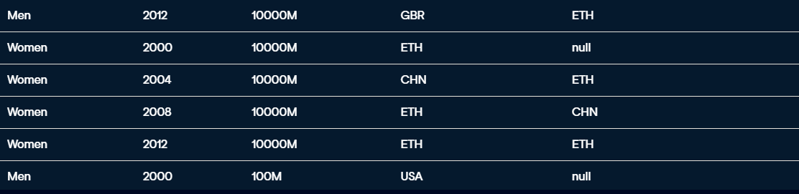

**Fetching**

**LAG/ LEAD/ FIRST_VALUE/ LAST_VALUE**

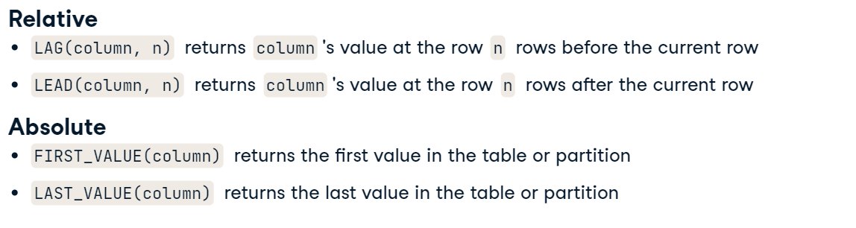

**LEAD**

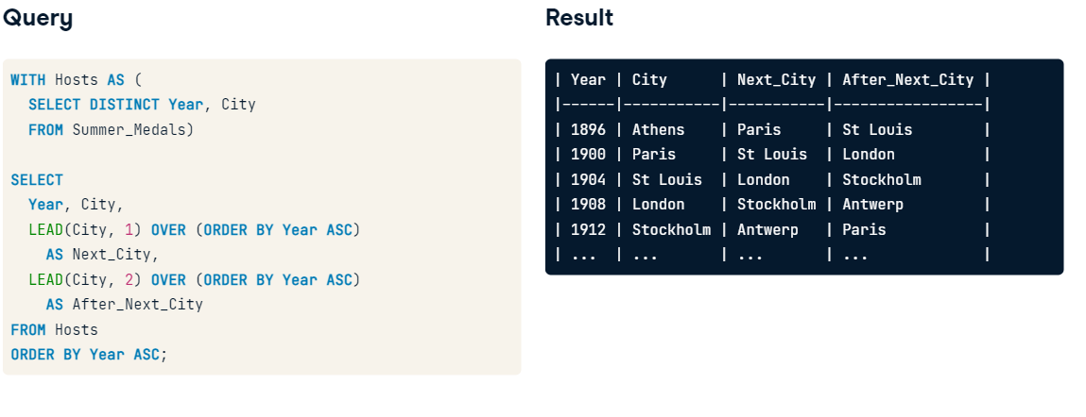

**FIRST_VALUE and LAST_VALUE**

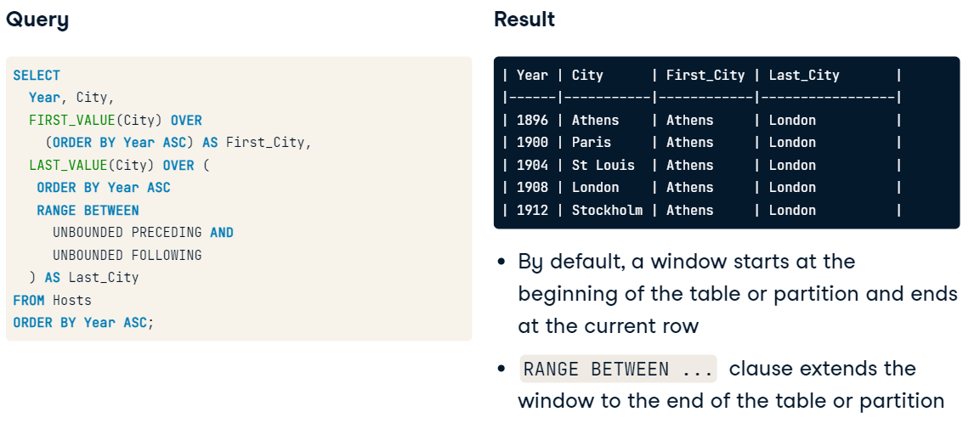

**With partitioning**

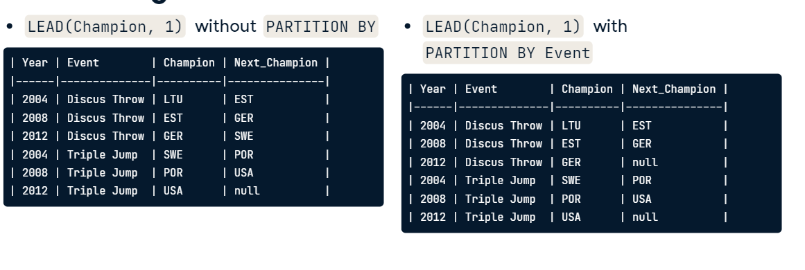

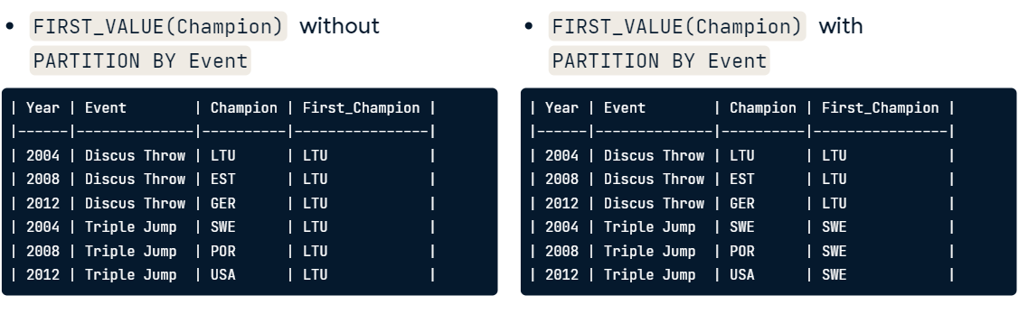

**Ex1. Fetch Olympic champion 3 Olympics ahead**

WITH Discus_Medalists AS (

  SELECT DISTINCT

    Year,

    Athlete

  FROM Summer_Medals

  WHERE Medal = 'Gold'

    AND Event = 'Discus Throw'

    AND Gender = 'Women'

    AND Year >= 2000)

SELECT

  -- For each year, fetch the current and future medalists

  year,

  athlete,

  LEAD(Athlete,3) OVER (ORDER BY Year ASC) AS Future_Champion

FROM Discus_Medalists

ORDER BY Year ASC;

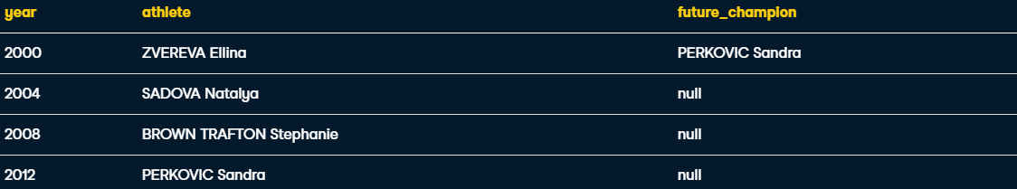

**EX2. Using FIRST_VALUE**

WITH All_Male_Medalists AS (

  SELECT DISTINCT

    Athlete

  FROM Summer_Medals

  WHERE Medal = 'Gold'

    AND Gender = 'Men')

SELECT

  -- Fetch all athletes and the first athlete alphabetically

  athlete,

  FIRST_VALUE(athlete) OVER (

    ORDER BY athlete ASC

  ) AS First_Athlete

FROM All_Male_Medalists;



**Ex3. LAST_VALUE**

WITH Hosts AS (

  SELECT DISTINCT Year, City

    FROM Summer_Medals)

SELECT

  Year,

  City,

  -- Get the last city in which the Olympic games were held

  LAST_VALUE(City) OVER (

   ORDER BY Year ASC

   RANGE BETWEEN

     UNBOUNDED PRECEDING AND

     UNBOUNDED FOLLOWING

  ) AS Last_City

FROM Hosts

ORDER BY Year ASC;

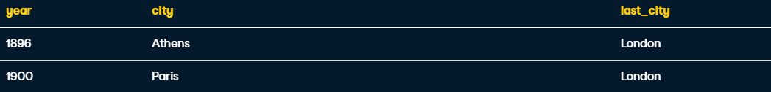

**Ranking**

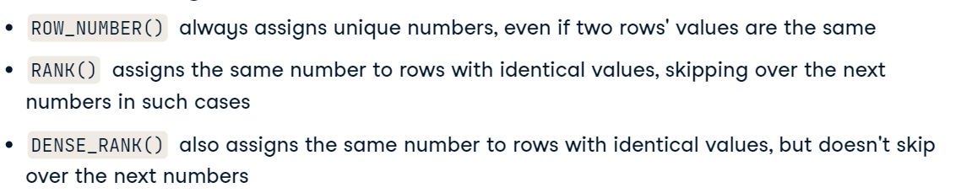

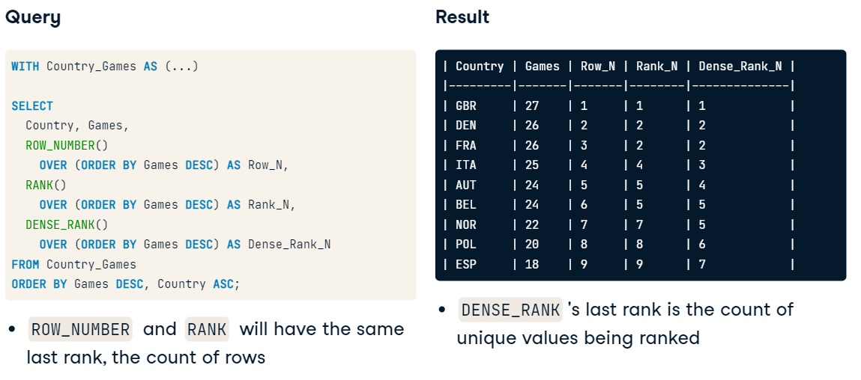

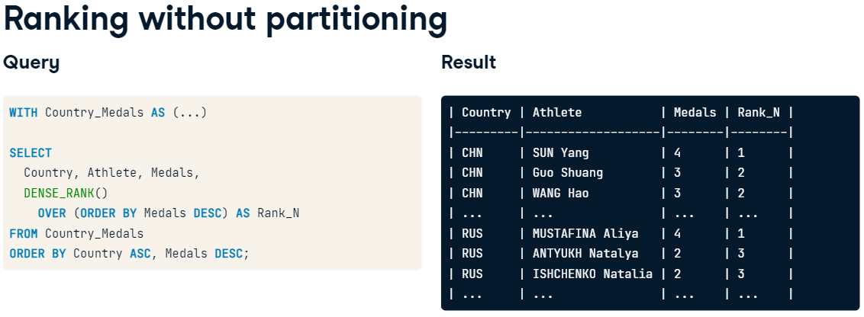

Ranked relative to other partitions **^**

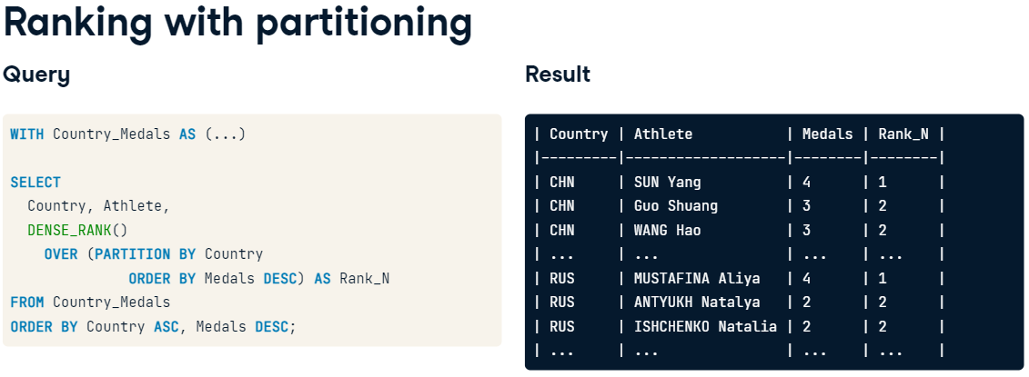

WITH Athlete_Medals AS (

  SELECT

    Athlete,

    COUNT(*) AS Medals

  FROM Summer_Medals

  GROUP BY Athlete)

SELECT

  Athlete,

  Medals,

  -- Rank athletes by the medals they've won

  RANK() OVER (ORDER BY Medals DESC) AS Rank_N

FROM Athlete_Medals

ORDER BY Medals DESC;

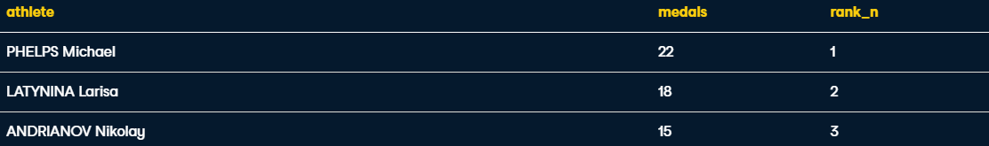

**Ex2. Partition by country**

WITH Athlete_Medals AS (

  SELECT

    Country, Athlete, COUNT(*) AS Medals

  FROM Summer_Medals

  WHERE

    Country IN ('JPN', 'KOR')

    AND Year >= 2000

  GROUP BY Country, Athlete

  HAVING COUNT(*) > 1)

SELECT

  Country,

  -- Rank athletes in each country by the medals they've won

  athlete,

  DENSE_RANK() OVER (PARTITION BY Country

                ORDER BY Medals DESC) AS Rank_N

FROM Athlete_Medals

ORDER BY Country ASC, RANK_N ASC;



**Paging ( NTILE(n) )**

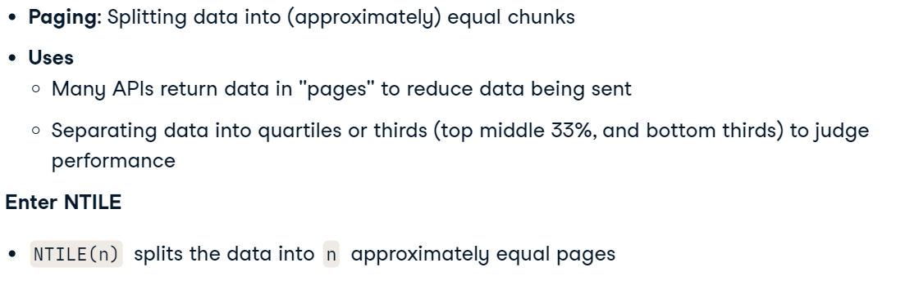

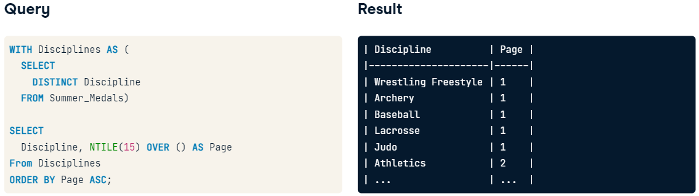**split into 15 pages**

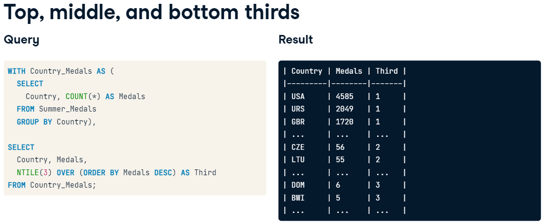

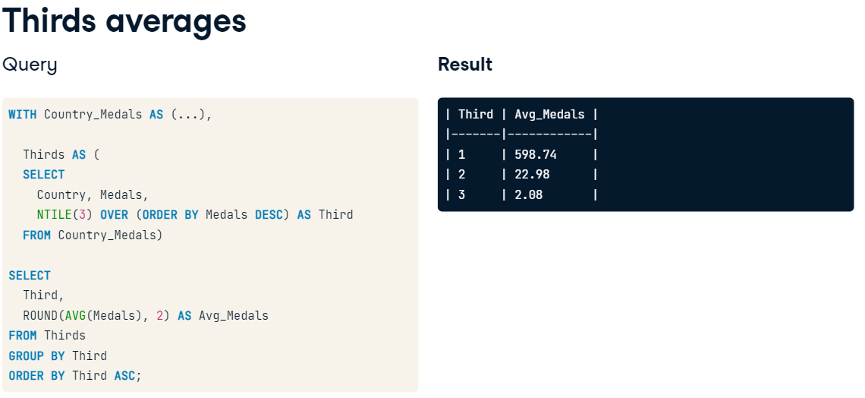

**Ex1. Divide all events into 111 pages**

WITH Events AS (

  SELECT DISTINCT Event

  FROM Summer_Medals)

SELECT

  --- Split up the distinct events into 111 unique groups

  event,

  NTILE(111) OVER (ORDER BY event ASC) AS Page

FROM Events

ORDER BY Event ASC;

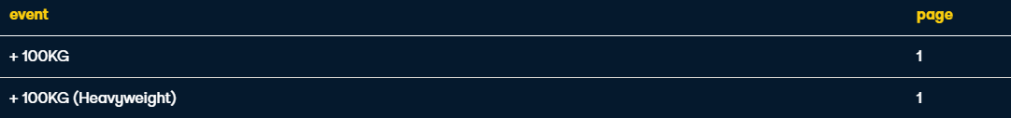

**Ex2. Average thirds**

WITH Athlete_Medals AS (

  SELECT Athlete, COUNT(*) AS Medals

  FROM Summer_Medals

  GROUP BY Athlete

  HAVING COUNT(*) > 1),

  Thirds AS (

  SELECT

    Athlete,

    Medals,

    NTILE(3) OVER (ORDER BY Medals DESC) AS Third

  FROM Athlete_Medals)

SELECT

  -- Get the average medals earned in each third

  Third,

  AVG(Medals) AS Avg_Medals

FROM Thirds

GROUP BY Third

ORDER BY Third ASC;

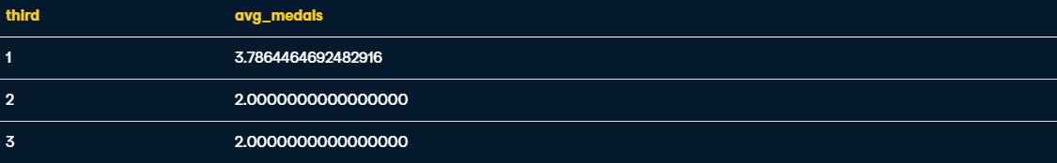

**Aggregate Window Functions**

**MAX()**

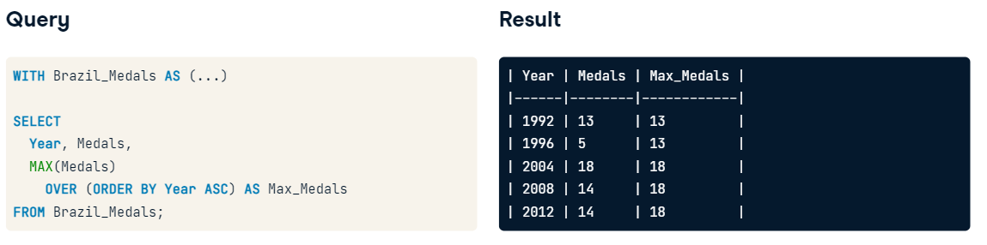

**SUM()**

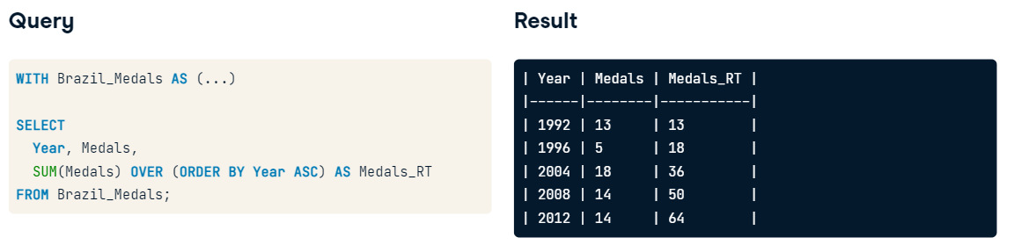

**Partitioning with aggregate functions**

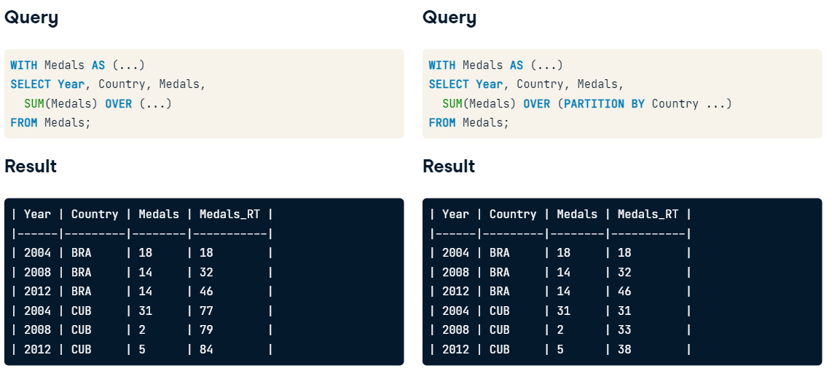

**Ex1. Medals running total**

WITH Athlete_Medals AS (

  SELECT

    Athlete, COUNT(*) AS Medals

  FROM Summer_Medals

  WHERE

    Country = 'USA' AND Medal = 'Gold'

    AND Year >= 2000

  GROUP BY Athlete)

SELECT

  -- Calculate the running total of athlete medals

  athlete,

  medals,

  SUM(Medals) OVER (ORDER BY Athlete ASC) AS Max_Medals

FROM Athlete_Medals

ORDER BY Athlete ASC;

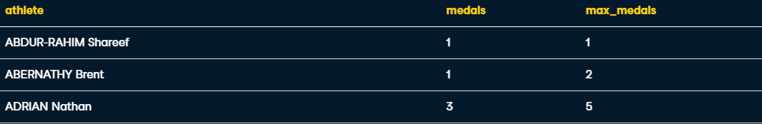

**Ex2.** Return the year, country, medals, and the maximum medals earned so far for each country, ordered by year in ascending order.

WITH Country_Medals AS (

  SELECT

    Year, Country, COUNT(*) AS Medals

  FROM Summer_Medals

  WHERE

    Country IN ('CHN', 'KOR', 'JPN')

    AND Medal = 'Gold' AND Year >= 2000

  GROUP BY Year, Country)

SELECT

  -- Return the max medals earned so far per country

  year,

  country,

  medals,

  MAX(medals) OVER (PARTITION BY country

                ORDER BY year ASC) AS Max_Medals

FROM Country_Medals

ORDER BY Country ASC, Year ASC;



**Ex3. Minimum medals by country**

WITH France_Medals AS (

  SELECT

    Year, COUNT(*) AS Medals

  FROM Summer_Medals

  WHERE

    Country = 'FRA'

    AND Medal = 'Gold' AND Year >= 2000

  GROUP BY Year)

SELECT

  year,

  medals,

  MIN(medals) OVER (ORDER BY year ASC) AS Min_Medals

FROM France_Medals

ORDER BY Year ASC;

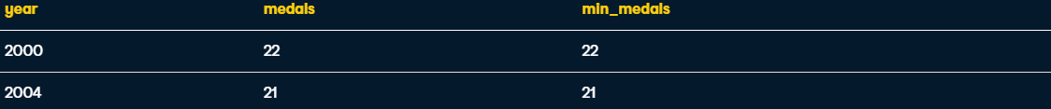

**Frames**

Used to change the way a window function behaves

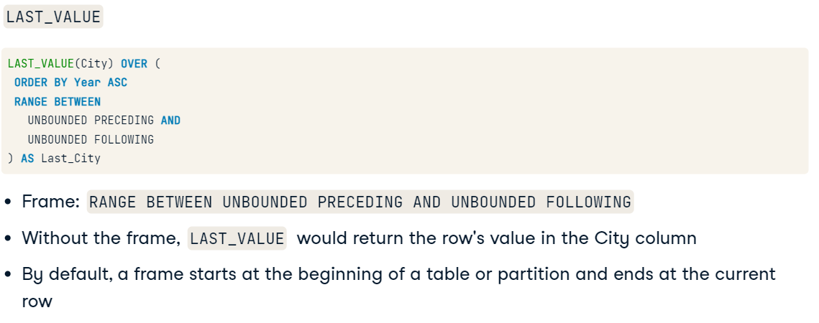

Start a frame with **RANGE BETWEEN** or **ROWS BETWEEN**

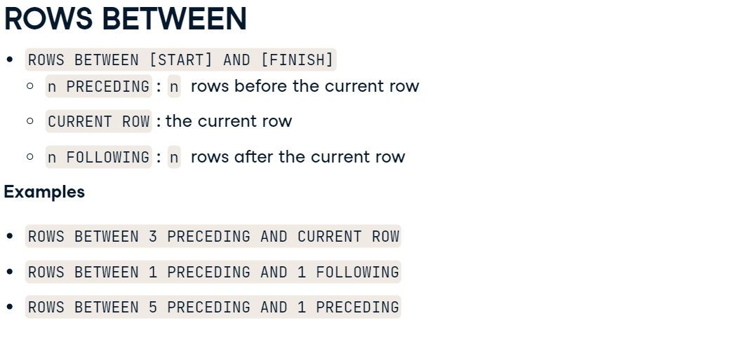

**Frame Examples**

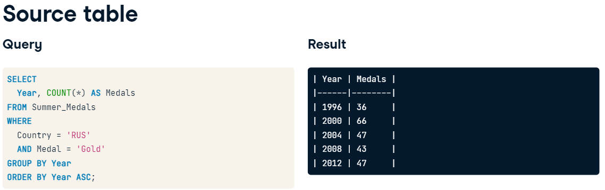

1. **MAX with and without frame**

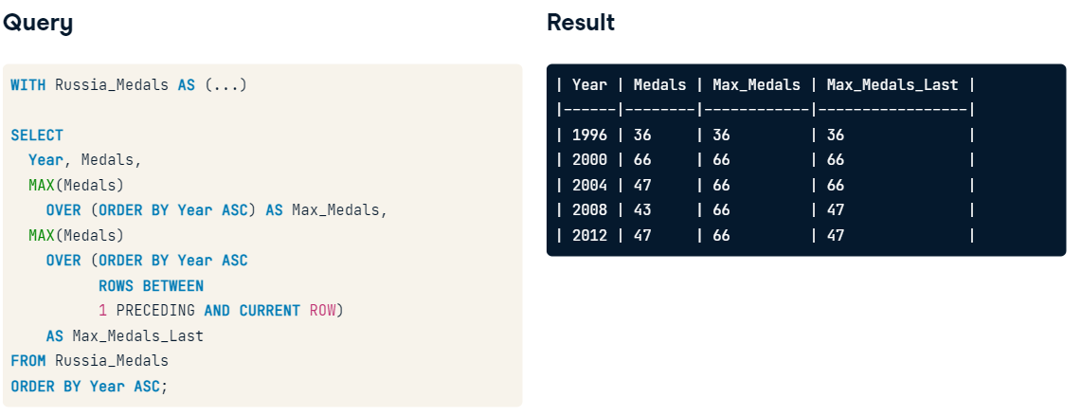

**2.**

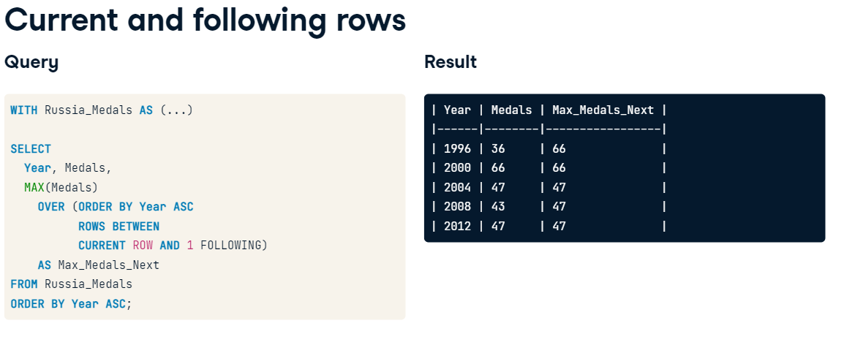

**Ex1.**

WITH Scandinavian_Medals AS (

  SELECT

    Year, COUNT(*) AS Medals

  FROM Summer_Medals

  WHERE

    Country IN ('DEN', 'NOR', 'FIN', 'SWE', 'ISL')

    AND Medal = 'Gold'

  GROUP BY Year)

SELECT

  -- Select each year's medals

  year,

  Medals,

  -- Get the max of the current and next years'  medals

  MAX(Medals) OVER (ORDER BY Year ASC

             ROWS BETWEEN CURRENT ROW

             AND 1 FOLLOWING) AS Max_Medals

FROM Scandinavian_Medals

ORDER BY Year ASC;

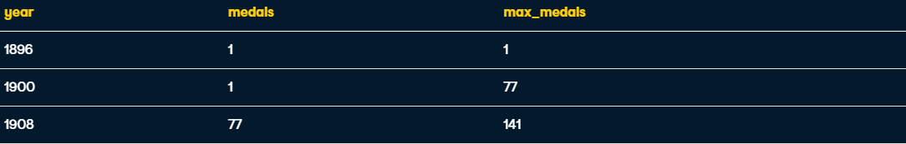

**Ex2. Return the athletes, medals earned, and the maximum medals earned, comparing only the last two and current athletes, ordering by athletes' names in alphabetical order.**

WITH Chinese_Medals AS (

  SELECT

    Athlete, COUNT(*) AS Medals

  FROM Summer_Medals

  WHERE

    Country = 'CHN' AND Medal = 'Gold'

    AND Year >= 2000

  GROUP BY Athlete)

SELECT

  -- Select the athletes and the medals they've earned

  athlete,

  Medals,

  -- Get the max of the last two and current rows' medals

  MAX(Medals) OVER (ORDER BY athlete ASC

            ROWS BETWEEN 2 PRECEDING

            AND CURRENT ROW) AS Max_Medals

FROM Chinese_Medals

ORDER BY Athlete ASC;



**Moving averages and totals**

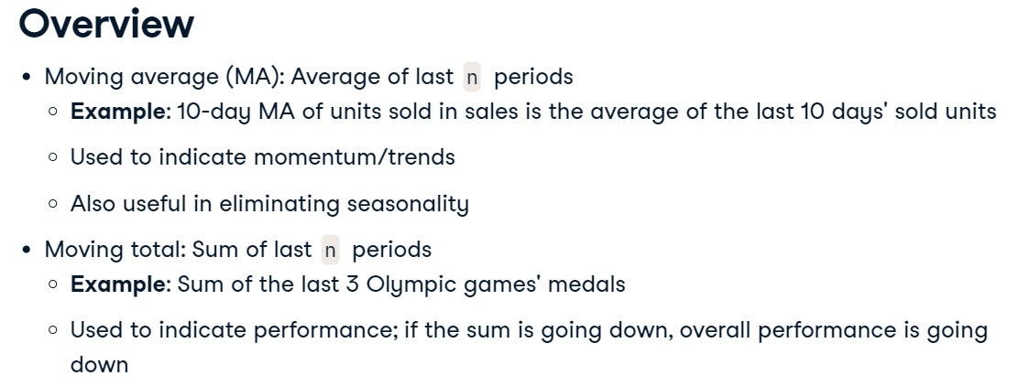

**Examples**

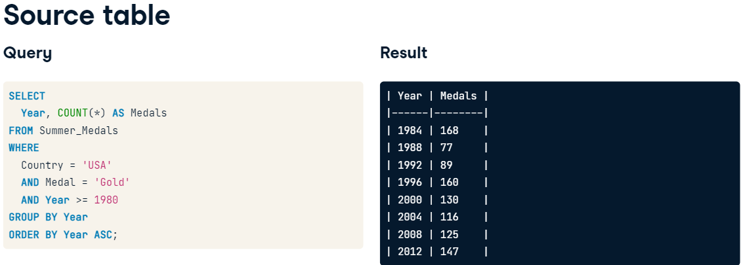

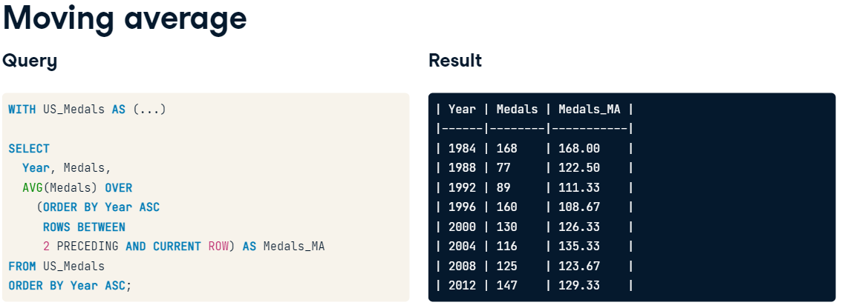

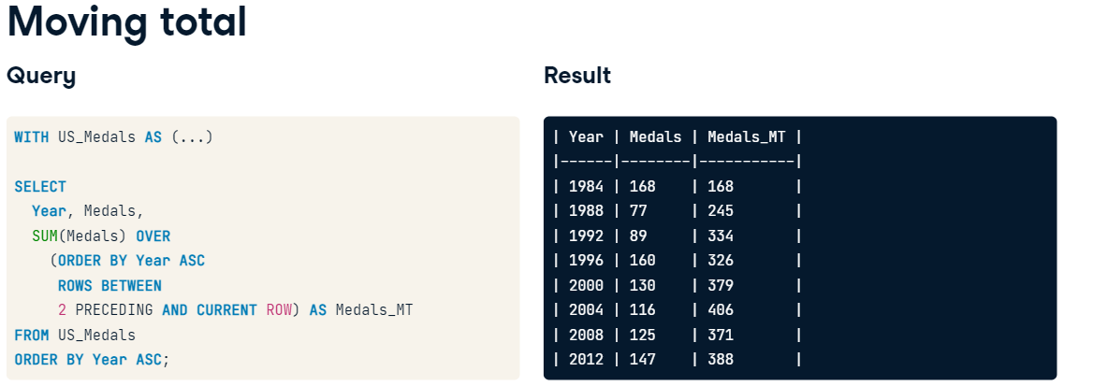

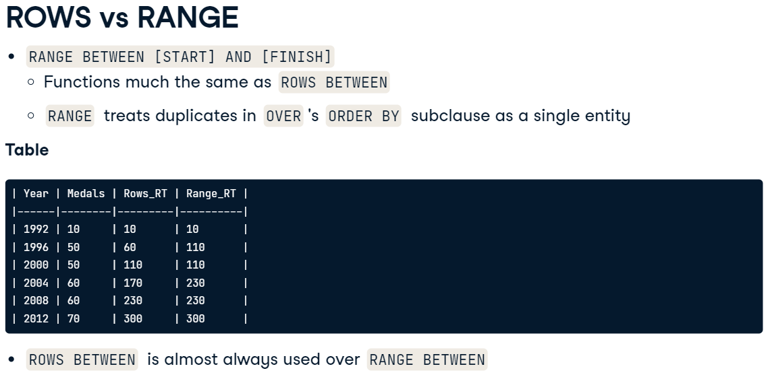

**Ex1. 3 year moving average of medals earned**

WITH Russian_Medals AS (

  SELECT

    Year, COUNT(*) AS Medals

  FROM Summer_Medals

  WHERE

    Country = 'RUS'

    AND Medal = 'Gold'

    AND Year >= 1980

  GROUP BY Year)

SELECT

  Year, Medals,

  --- Calculate the 3-year moving average of medals earned

  AVG(Medals) OVER

    (ORDER BY Year ASC

     ROWS BETWEEN

     2 PRECEDING AND CURRENT ROW) AS Medals_MA

FROM Russian_Medals

ORDER BY Year ASC;

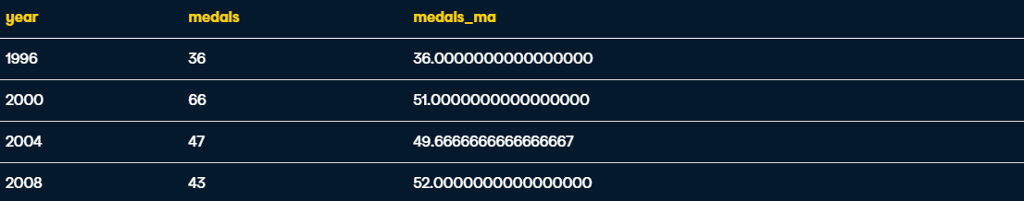

**Ex2. With partitioning**

WITH Country_Medals AS (

  SELECT

    Year, Country, COUNT(*) AS Medals

  FROM Summer_Medals

  GROUP BY Year, Country)

SELECT

  Year, Country, Medals,

  -- Calculate each country's 3-game moving total

  SUM(medals) OVER

    (PARTITION BY country

     ORDER BY Year ASC

     ROWS BETWEEN

     2 PRECEDING AND CURRENT ROW) AS Medals_MA

FROM Country_Medals

ORDER BY Country ASC, Year ASC;

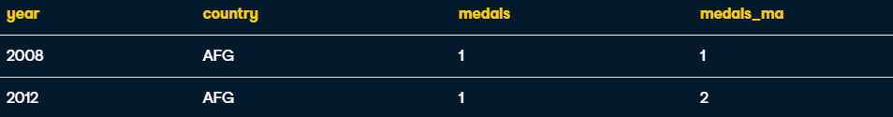

**Pivoting**

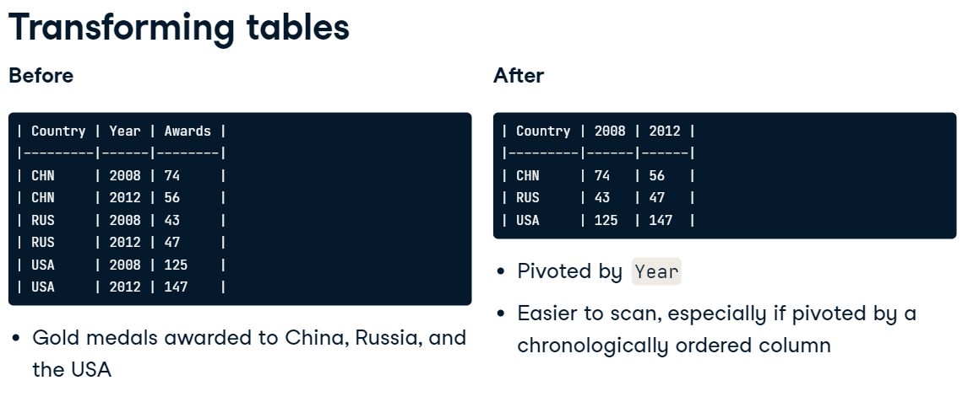

**CROSSTAB**

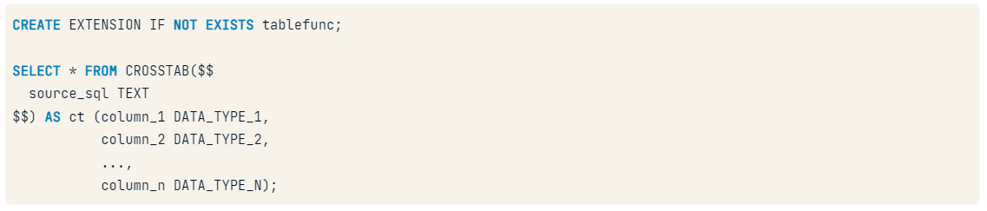

Example 1

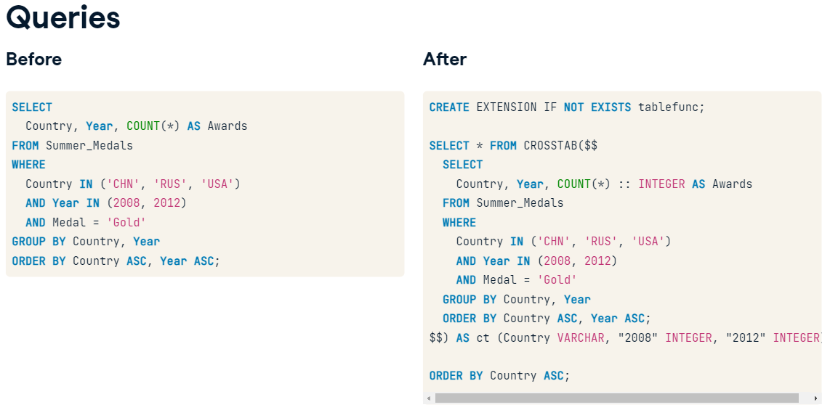

Example 2

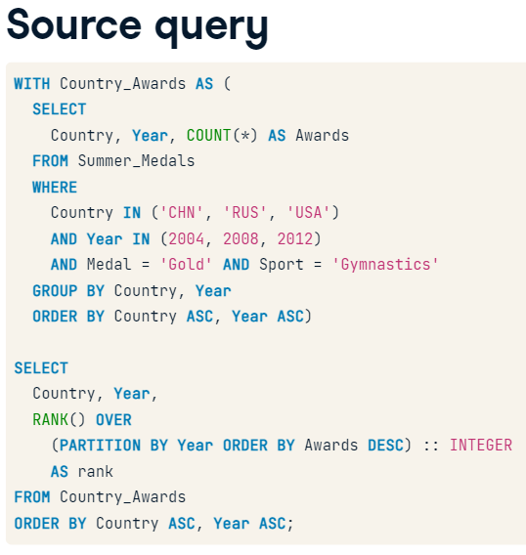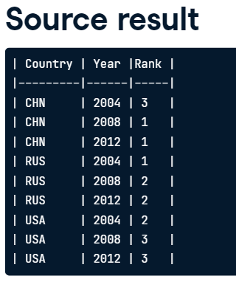

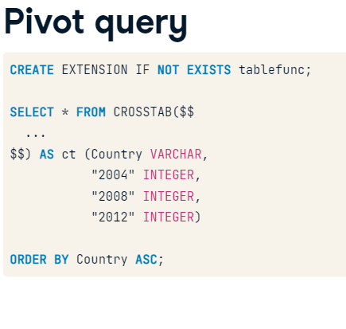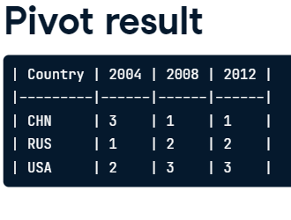

Ex1.

**A basic pivot**

You have the following table of Pole Vault gold medalist countries by gender in 2008 and 2012.

| Gender | Year | Country |

|--------|------|---------|

| Men | 2008 | AUS |

| Men | 2012 | FRA |

| Women | 2008 | RUS |

| Women | 2012 | USA |

Pivot it by Year to get the following reshaped, cleaner table.

| Gender | 2008 | 2012 |

|--------|------|------|

| Men | AUS | FRA |

| Women | RUS | USA |

-- Create the correct extention to enable CROSSTAB

CREATE EXTENSION IF NOT EXISTS tablefunc;

SELECT * FROM CROSSTAB($$

  SELECT

    Gender, Year, Country

  FROM Summer_Medals

  WHERE

    Year IN (2008, 2012)

    AND Medal = 'Gold'

    AND Event = 'Pole Vault'

  ORDER By Gender ASC, Year ASC;

-- Fill in the correct column names for the pivoted table

$$) AS ct (Gender VARCHAR,

           "2008" VARCHAR,

           "2012" VARCHAR)

ORDER BY Gender ASC;

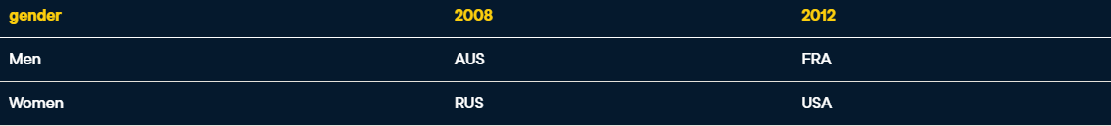

Ex2. Pivoting with ranking

CREATE EXTENSION IF NOT EXISTS tablefunc;

SELECT * FROM CROSSTAB($$

  WITH Country_Awards AS (

    SELECT

      Country,

      Year,

      COUNT(*) AS Awards

    FROM Summer_Medals

    WHERE

      Country IN ('FRA', 'GBR', 'GER')

      AND Year IN (2004, 2008, 2012)

      AND Medal = 'Gold'

    GROUP BY Country, Year)

  SELECT

    Country,

    Year,

    RANK() OVER

      (PARTITION BY Year

       ORDER BY Awards DESC) :: INTEGER AS rank

  FROM Country_Awards

  ORDER BY Country ASC, Year ASC;

-- Fill in the correct column names for the pivoted table

$$) AS ct (Country VARCHAR,

           "2004" INTEGER,

           "2008" INTEGER,

           "2012" INTEGER)

Order by Country ASC;

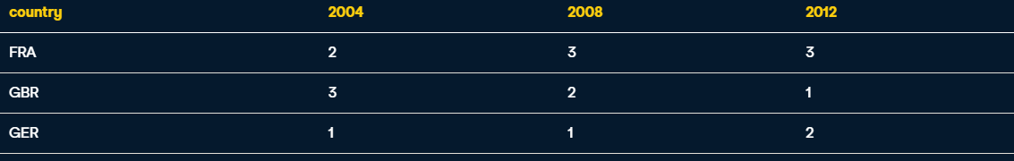

**ROLLUP and CUBE**

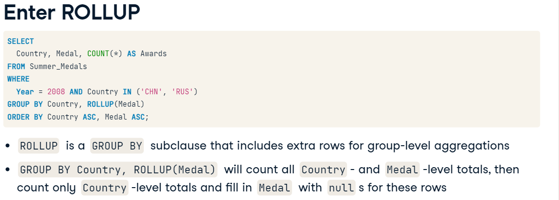

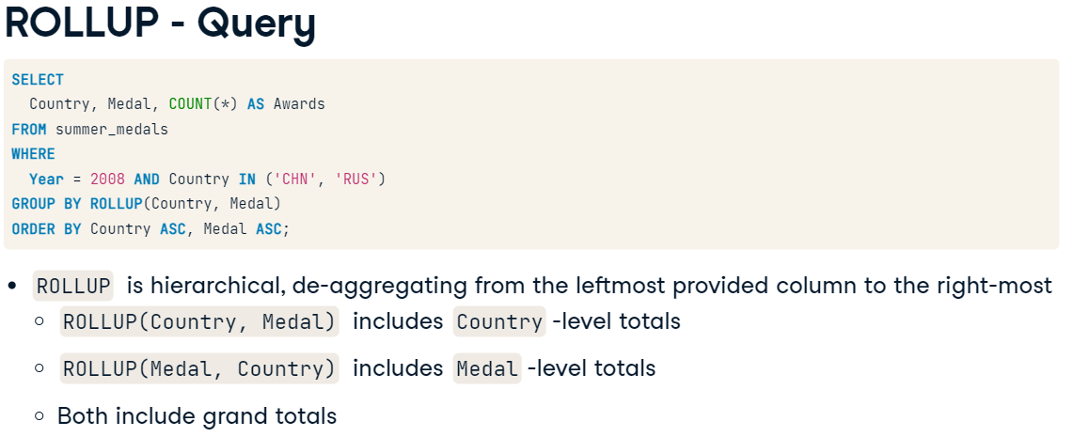

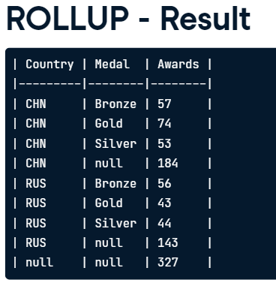

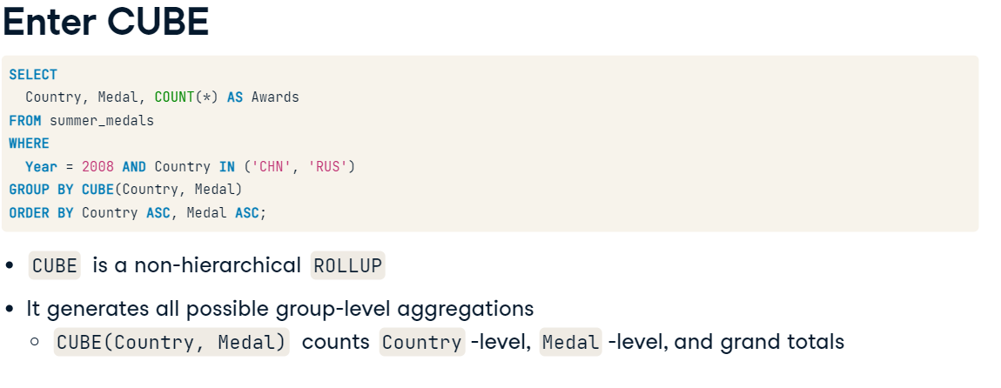

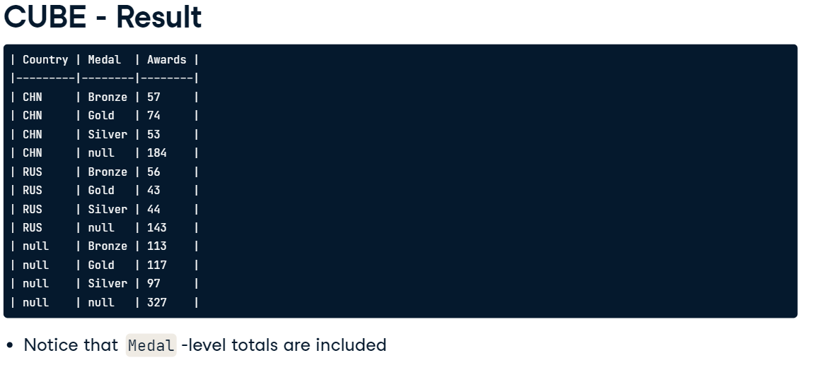

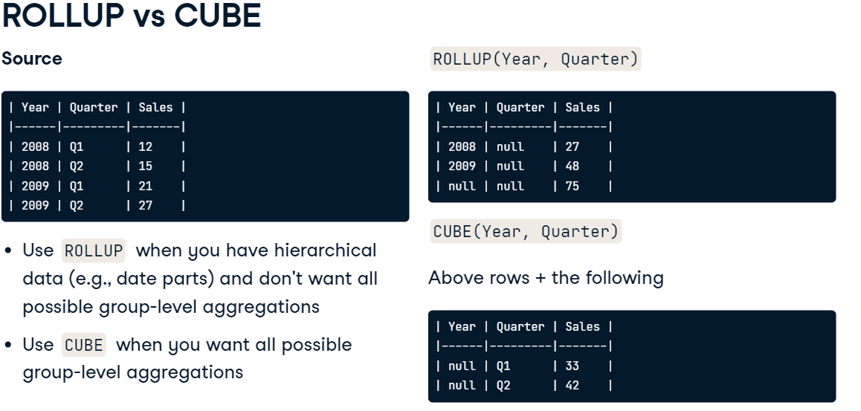

Ex1. You want to look at three Scandinavian countries' earned gold medals per country and gender in the year 2004. You're also interested in Country-level subtotals to get the total medals earned for each country, but Gender-level subtotals don't make much sense in this case, so disregard them.

-- Count the gold medals per country and gender

SELECT

  country,

  gender,

  COUNT(*) AS Gold_Awards

FROM Summer_Medals

WHERE

  Year = 2004

  AND Medal = 'Gold'

  AND Country IN ('DEN', 'NOR', 'SWE')

-- Generate Country-level subtotals

GROUP BY country, ROLLUP(gender)

ORDER BY Country ASC, gender ASC;



Ex2. You want to break down all medals awarded to Russia in the 2012 Olympic games per gender and medal type. Since the medals all belong to one country, Russia, it makes sense to generate all possible subtotals (Gender- and Medal-level subtotals), as well as a grand total.

Generate a breakdown of the medals awarded to Russia per country and medal type, including all group-level subtotals and a grand total.

-- Count the medals per gender and medal type

SELECT

  gender,

  medal,

  count(*) AS Awards

FROM Summer_Medals

WHERE

  Year = 2012

  AND Country = 'RUS'

-- Get all possible group-level subtotals

GROUP BY CUBE(gender, medal)

ORDER BY Gender ASC, Medal ASC;

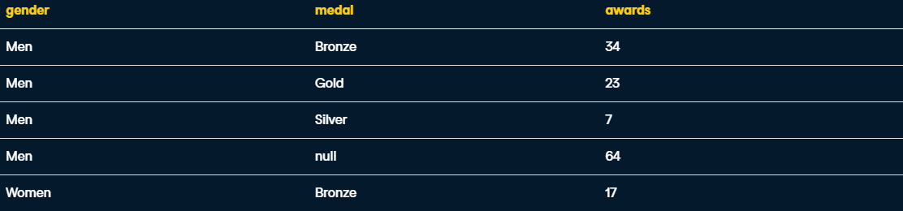

**Coalesce (remove nulls from results)**

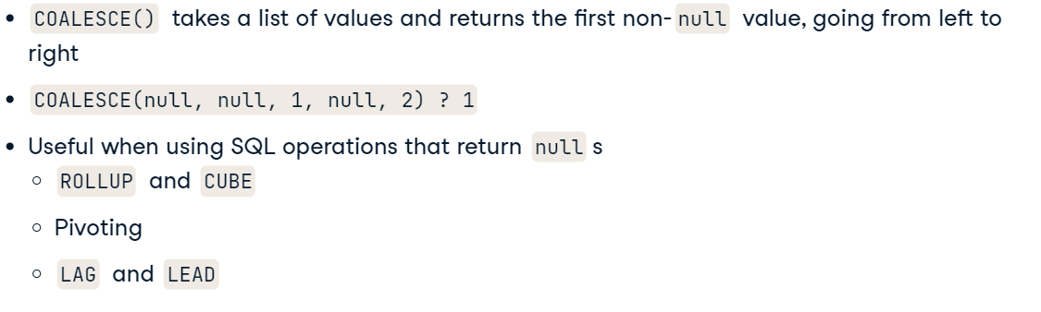

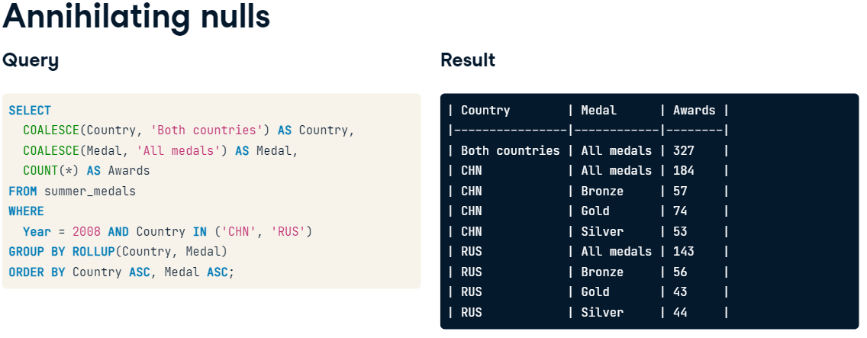

---- STRING_AGG ------------

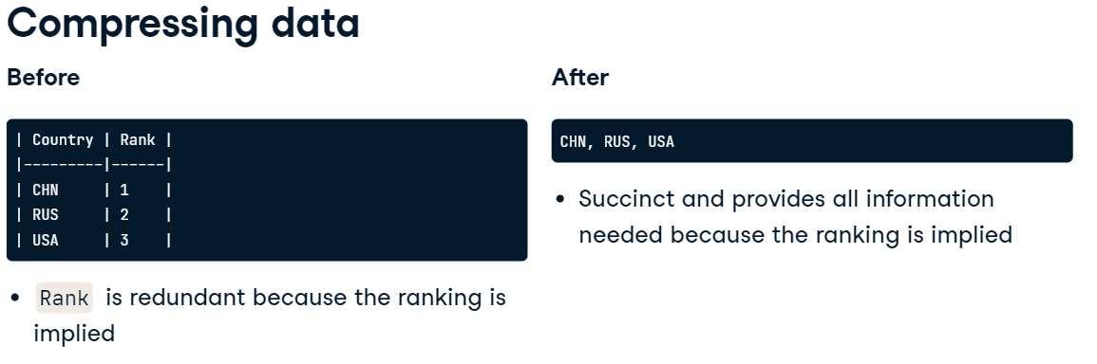

e.g.

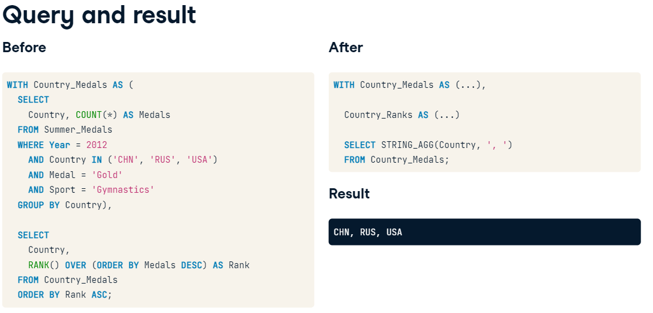

Ex1. Coalesce

SELECT

  -- Replace the nulls in the columns with meaningful text

  COALESCE(Country, 'All countries') AS Country,

  COALESCE(Gender, 'All genders') AS Gender,

  COUNT(*) AS Awards

FROM Summer_Medals

WHERE

  Year = 2004

  AND Medal = 'Gold'

  AND Country IN ('DEN', 'NOR', 'SWE')

GROUP BY ROLLUP(Country, Gender)

ORDER BY Country ASC, Gender ASC;

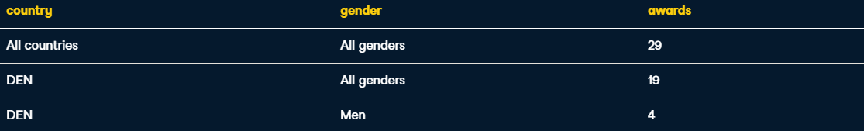

Ex2. Summarise ranking

WITH Country_Medals AS (

  SELECT

    Country,

    COUNT(*) AS Medals

  FROM Summer_Medals

  WHERE Year = 2000

    AND Medal = 'Gold'

  GROUP BY Country),

  Country_Ranks AS (

  SELECT

    Country,

    RANK() OVER (ORDER BY Medals DESC) AS Rank

  FROM Country_Medals

  ORDER BY Rank ASC)

-- Compress the countries column

SELECT STRING_AGG(Country, ', ')

FROM Country_Ranks

-- Select only the top three ranks

WHERE rank <= 3;



Functions for Manipulating Data in SQL module



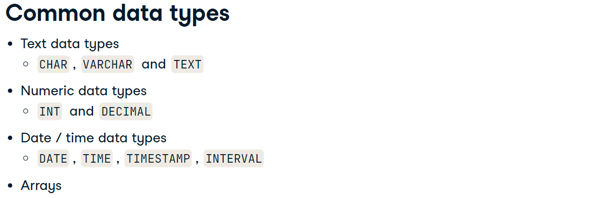

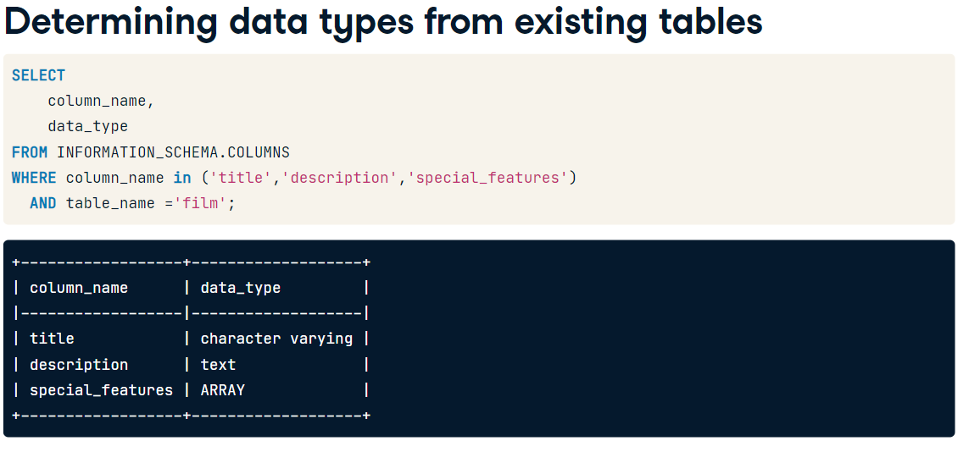

INFORMATION_SCHEMA.tables

INFORMATION_SCHEMA.COLUMNS

 -- Select all columns from the COLUMNS system database

 SELECT *

 FROM INFORMATION_SCHEMA.COLUMNS

 WHERE table_name = 'actor';

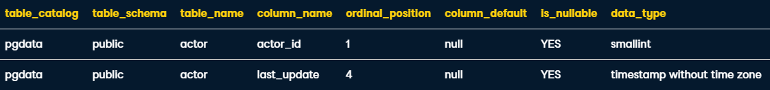

Ex2. Determining Data types

-- Get the column name and data type

SELECT

    column_name,

    data_type

-- From the system database information schema

FROM INFORMATION_SCHEMA.COLUMNS

-- For the customer table

WHERE table_name = 'customer';

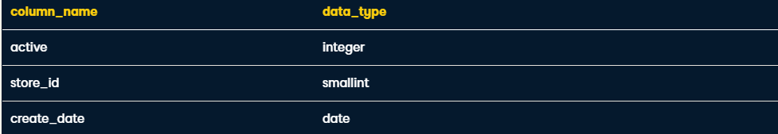

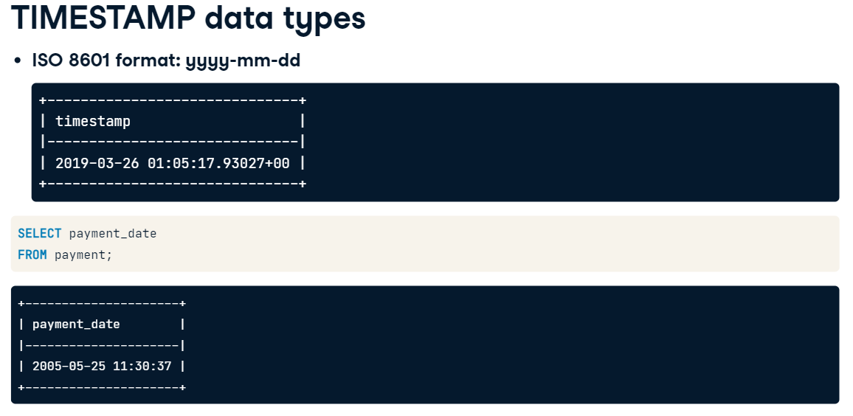

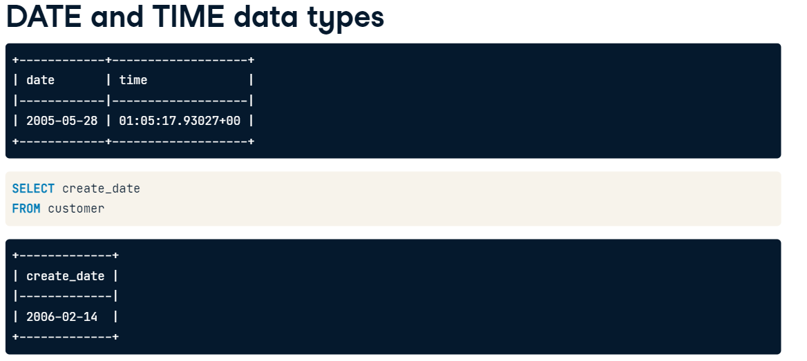

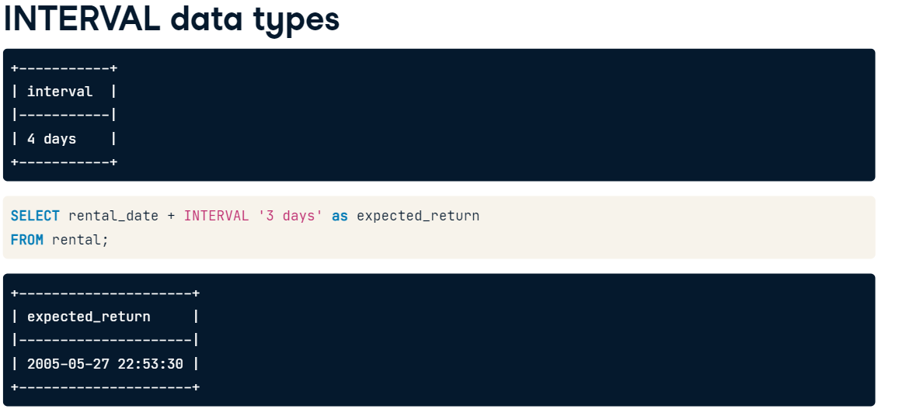

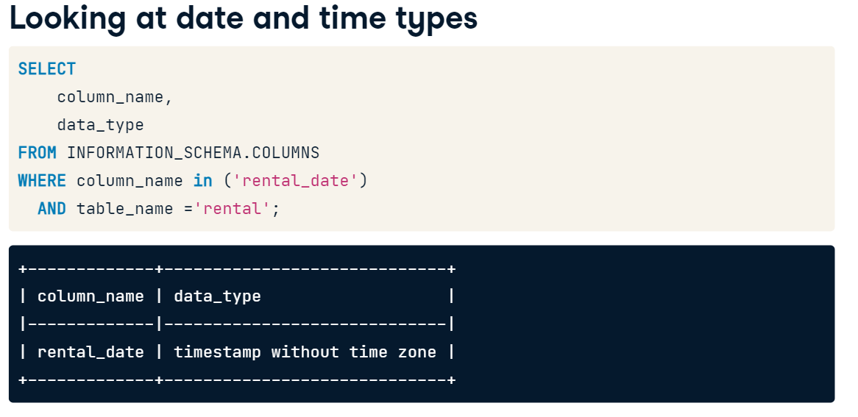

most of the time you'll work with TIMESTAMP values without a timezone which is the default behavior.

Ex1.

SELECT

    -- Select the rental and return dates

    rental_date,

    return_date,

    -- Calculate the expected_return_date

    rental_date + INTERVAL '3 days' AS expected_return_date

FROM rental;

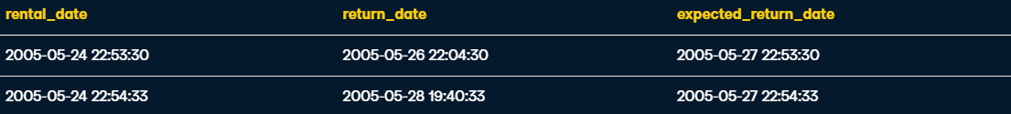

# Working with ARRAYs

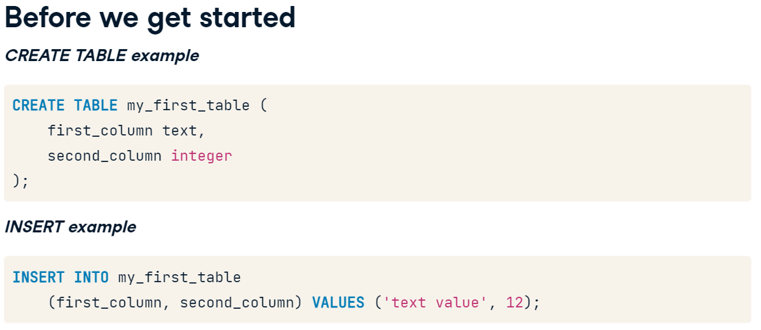

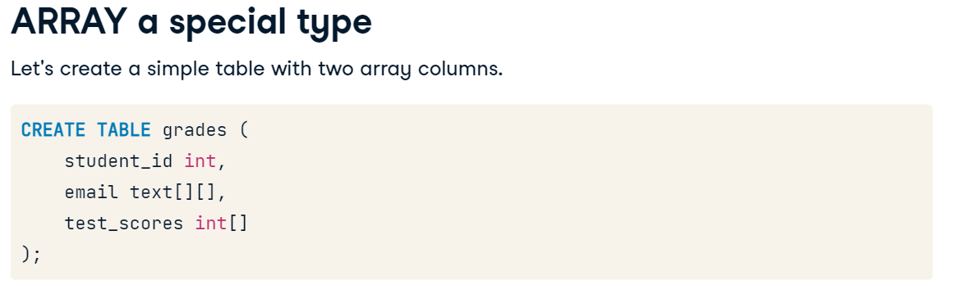 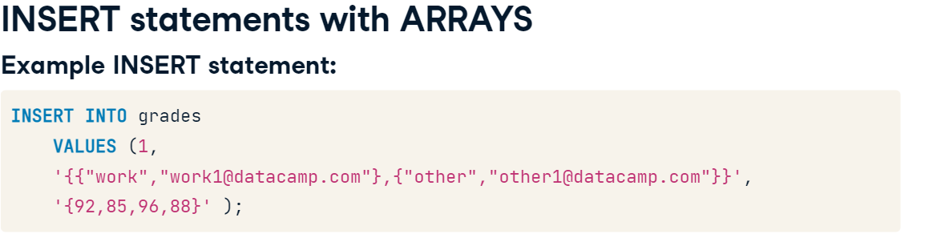

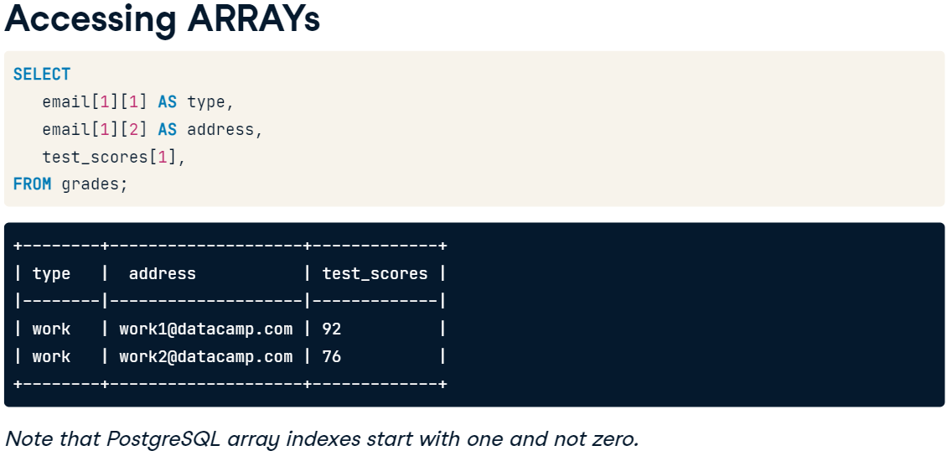

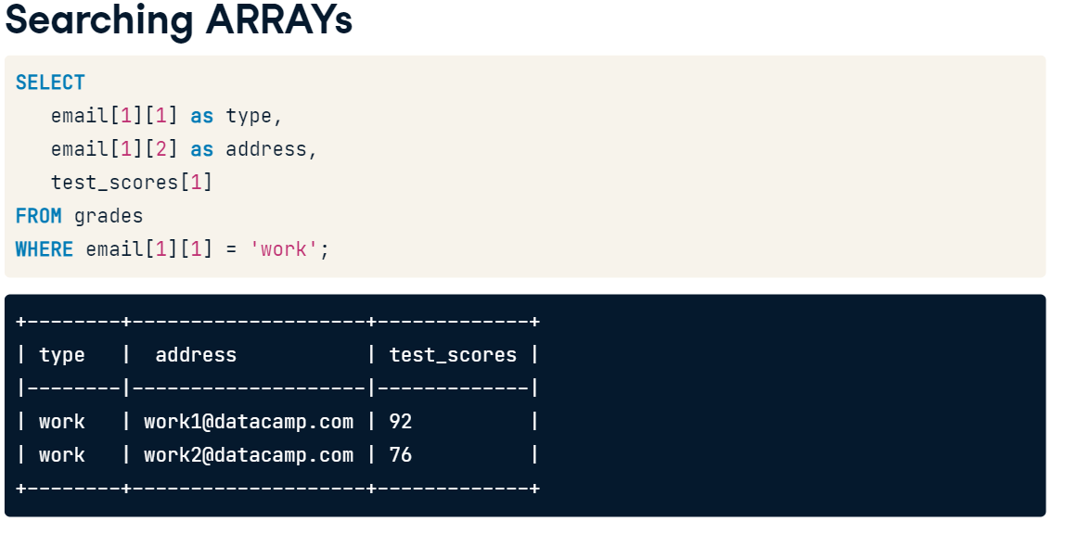

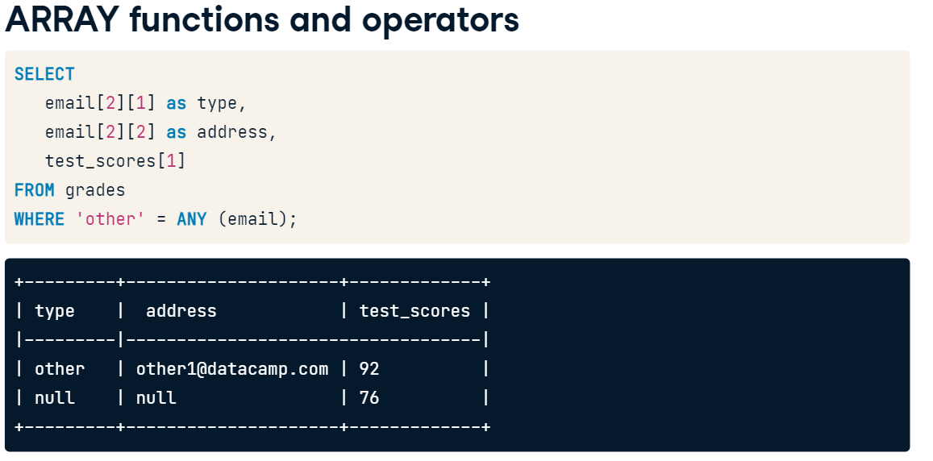

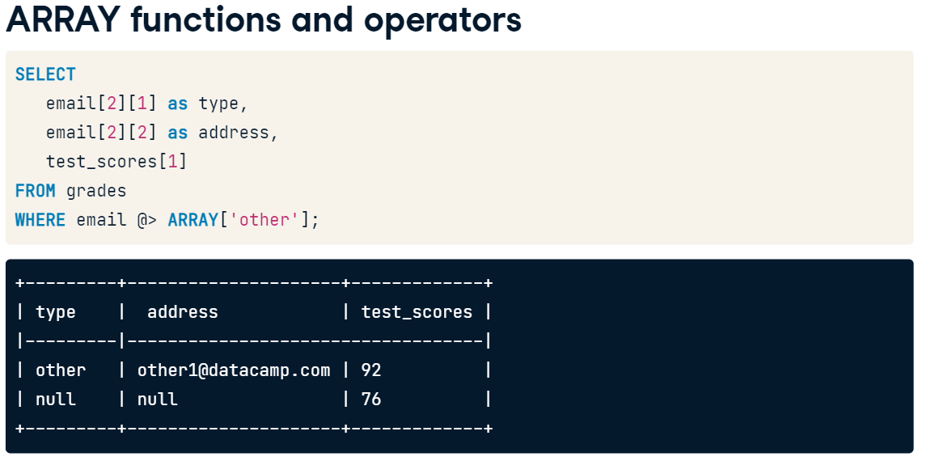

-- Select the title and special features column

SELECT

  title,

  special_features

FROM film

-- Use the array index of the special_features column

WHERE special_features[2] = 'Deleted Scenes';



Ex2. Find trailer special feature at any position of array

SELECT

  title,

  special_features

FROM film

-- Modify the query to use the ANY function

WHERE 'Trailers' = ANY (special_features);



Ex3. Same but using ARRAY function

SELECT

  title,

  special_features

FROM film

-- Filter where special_features contains 'Deleted Scenes'

WHERE special_features @> ARRAY['Deleted Scenes'];



# Overview of basic arithmetic operators

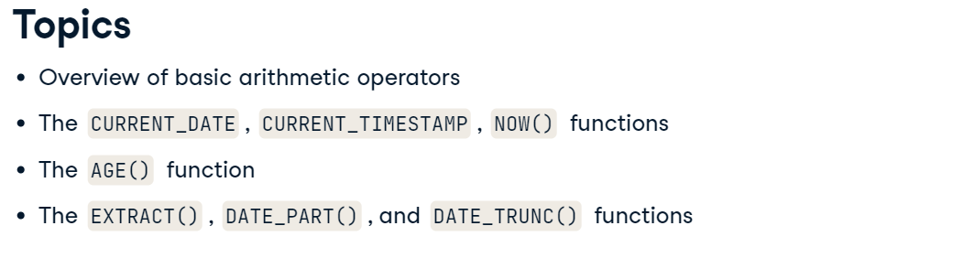

Date – date = integer

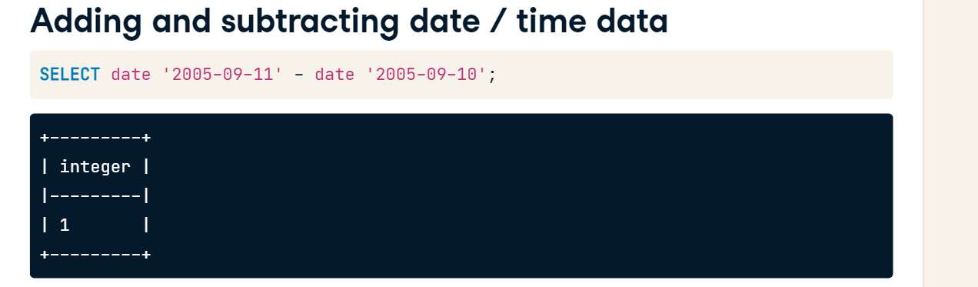

Date + interger = date

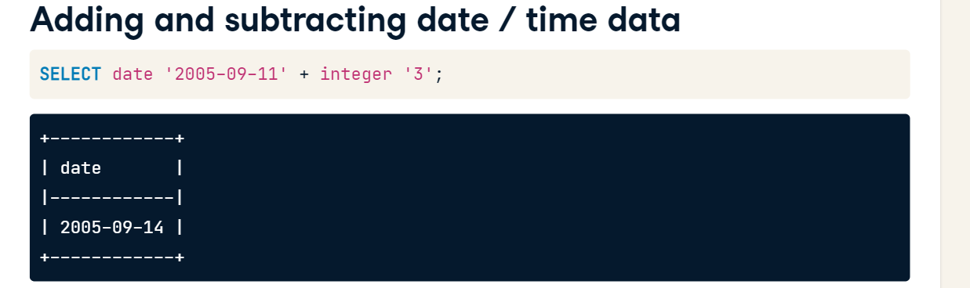

Timestamp – Timestamp = interval

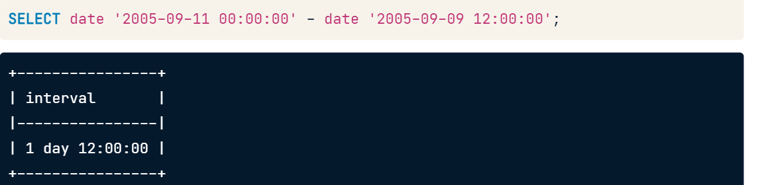

Using AGE() to calculate time periods

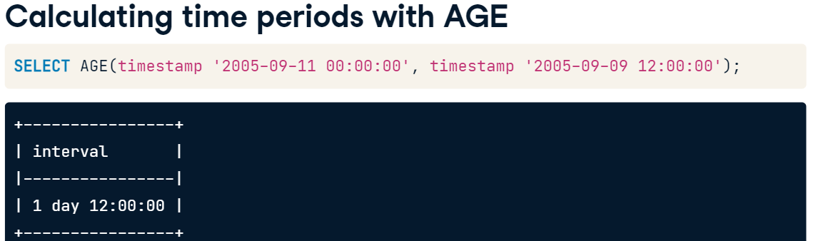

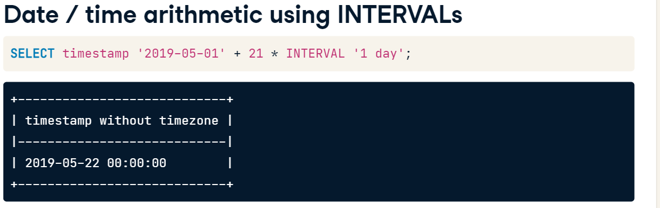

Ex1. Calculate Days Rented

SELECT f.title, f.rental_duration,

    -- Calculate the number of days rented

    r.return_date - r.rental_date AS days_rented

FROM film AS f

     INNER JOIN inventory AS i ON f.film_id = i.film_id

     INNER JOIN rental AS r ON i.inventory_id = r.inventory_id

ORDER BY f.title;



Again, but with AGE()

SELECT f.title, f.rental_duration,

    -- Calculate the number of days rented

    AGE(r.return_date, r.rental_date) AS days_rented

FROM film AS f

    INNER JOIN inventory AS i ON f.film_id = i.film_id

    INNER JOIN rental AS r ON i.inventory_id = r.inventory_id

ORDER BY f.title;

Ex2. Conversion to interval

SELECT

    f.title,

    -- Convert the rental_duration to an interval

    INTERVAL '1' day * f.rental_duration,

    -- Calculate the days rented as we did previously

    r.return_date - r.rental_date AS days_rented

FROM film AS f

    INNER JOIN inventory AS i ON f.film_id = i.film_id

    INNER JOIN rental AS r ON i.inventory_id = r.inventory_id

-- Filter the query to exclude outstanding rentals

WHERE r.return_date IS NOT NULL

ORDER BY f.title;



Ex.3 Calculating the expected return date

SELECT

    f.title,

    r.rental_date,

    f.rental_duration,

    -- Add the rental duration to the rental date

    INTERVAL '1' day * f.rental_duration + rental_date AS expected_return_date,

    r.return_date

FROM film AS f

    INNER JOIN inventory AS i ON f.film_id = i.film_id

    INNER JOIN rental AS r ON i.inventory_id = r.inventory_id

ORDER BY f.title;



Retrieving the current date/time

**NOW()** – retrieves current timestamp

**CAST() –**

**Postgresql** specific:

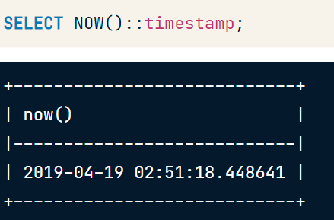 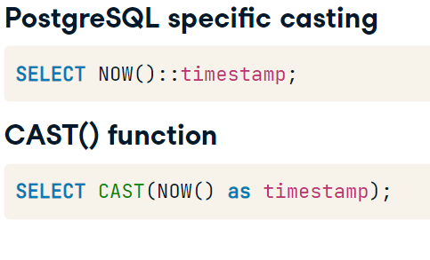

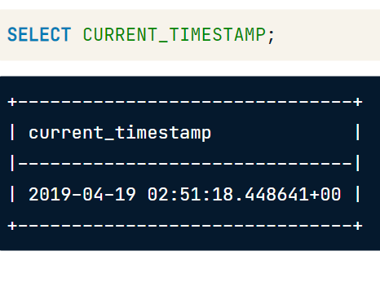 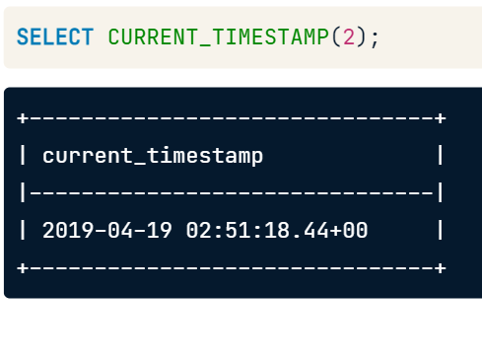

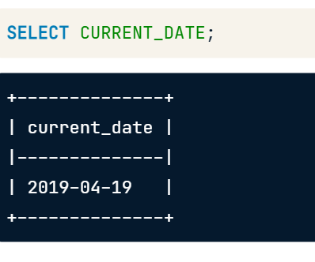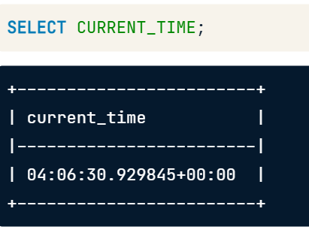

Ex1.

SELECT

    NOW(),

    CURRENT_TIMESTAMP,

    CURRENT_DATE,

    CURRENT_TIME;

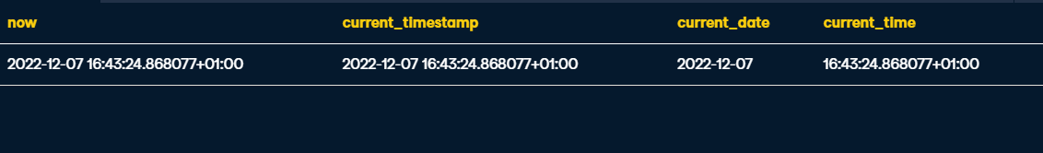

Ex2. Timestamp without timezone

--Select the current timestamp without a timezone

SELECT CAST( NOW() AS timestamp )

Ex3. Date without time

SELECT

    -- Select the current date

    CURRENT_DATE,

    -- CAST the result of the NOW() function to a date

    CAST( NOW() AS date )



Ex4. Select the current timestamp without timezone

--Select the current timestamp without timezone

SELECT CURRENT_TIMESTAMP::timestamp AS right_now;

Ex5. select a timestamp five days from now

SELECT

    CURRENT_TIMESTAMP::timestamp AS right_now,

    INTERVAL '5 days' + CURRENT_TIMESTAMP AS five_days_from_now;

Ex6. use a second-level precision with no fractional digits for both the right_now and five_days_from_now fields

SELECT

    CURRENT_TIMESTAMP(0)::timestamp AS right_now,

    interval '5 days' + CURRENT_TIMESTAMP(0) AS five_days_from_now;

**EXTRACT(), DATE_PART(), DATE_TRUNC()**

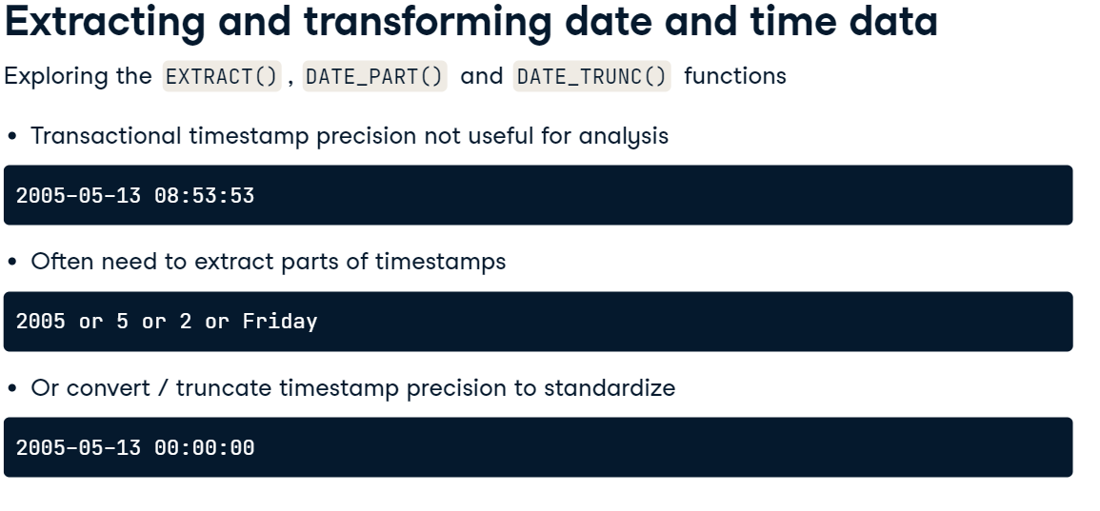

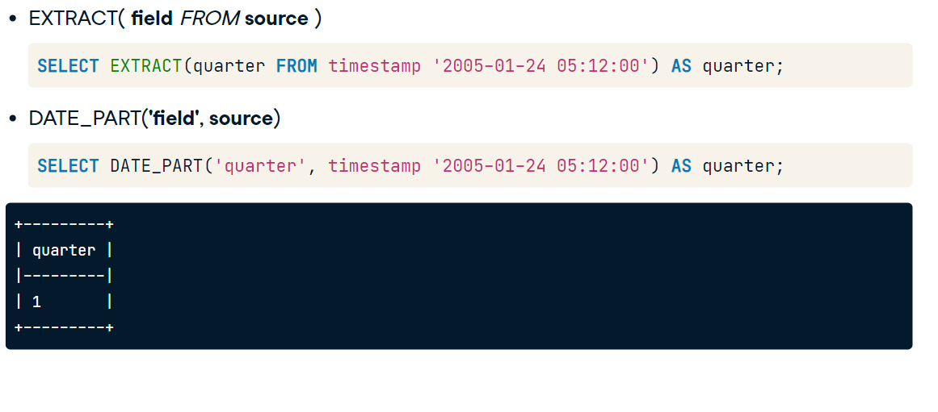

DATASET:

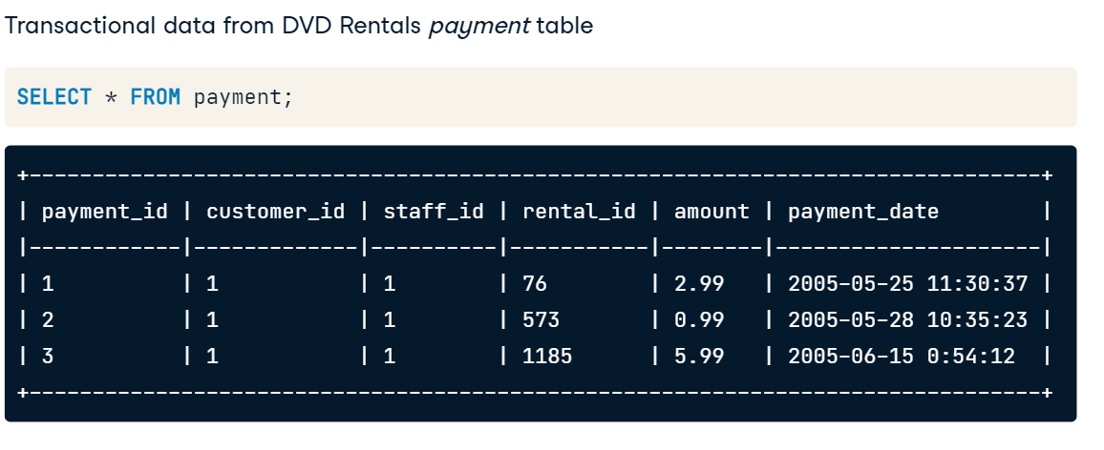

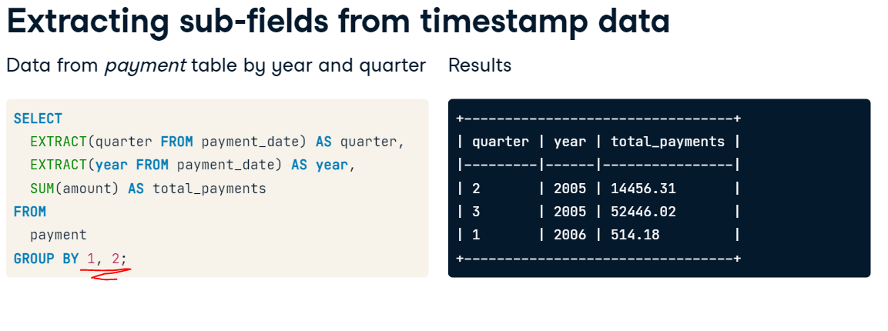

NOTE: **Numeric Referencing** can be used with **GROUP BY**. These are in reference to the items in the **SELECT** clause

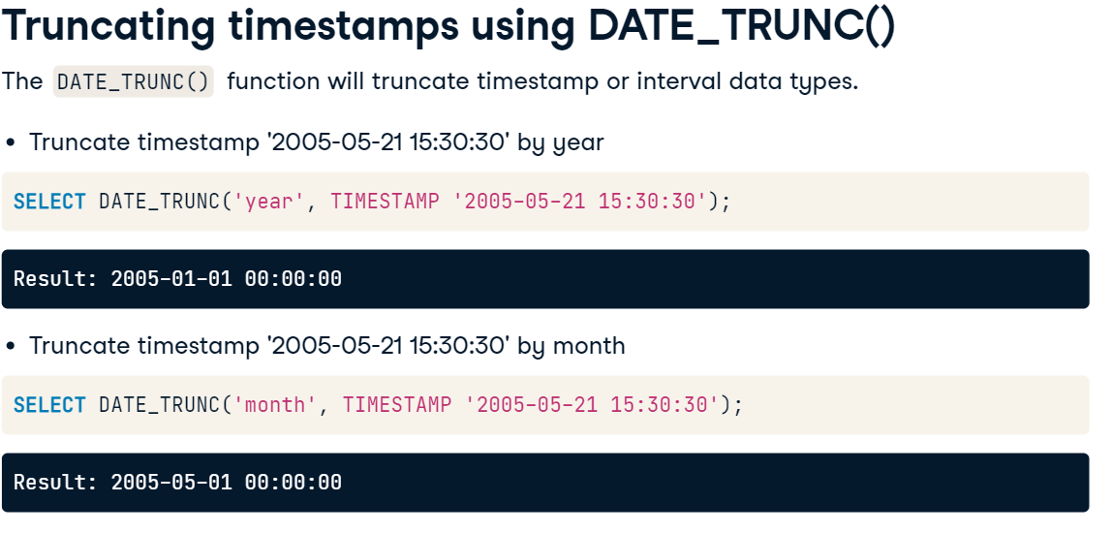

^Returns INTERVAL or TIMESTAMP value rather than a Numeric value

Ex1. Find number of rentals per day of the week from the rental date column

-- Extract day of week from rental_date

SELECT

  EXTRACT(dow FROM rental_date) AS dayofweek,

  -- Count the number of rentals

  COUNT(*) as rentals

FROM rental

GROUP BY 1;

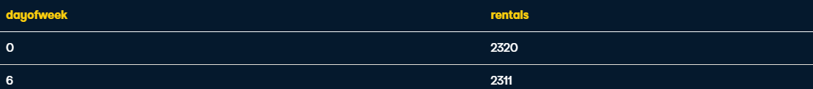

EX2. Truncate the rental_date field by year

-- Truncate rental_date by year

SELECT DATE_TRUNC('year', rental_date) AS rental_year

FROM rental;



Ex2. truncate the rental_date by month

-- Truncate rental_date by month

SELECT DATE_TRUNC('month', rental_date) AS rental_month

FROM rental;



Ex3. COUNT rentals each day

SELECT

  DATE_TRUNC('day', rental_date) AS rental_day,

  -- Count total number of rentals

  COUNT(*) AS rentals

FROM rental

GROUP BY 1;

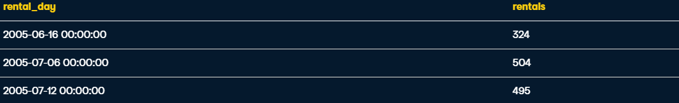

Ex4.

Extract the day of the week from the rental_date column using the alias dayofweek.

Use an INTERVAL in the WHERE clause to select records for the 90 day period starting on 5/1/2005.

SELECT

  -- Extract the day of week date part from the rental_date

  EXTRACT(dow FROM rental_date) AS dayofweek,

  AGE(return_date, rental_date) AS rental_days

FROM rental AS r

WHERE

  -- Use an INTERVAL for the upper bound of the rental_date

  rental_date BETWEEN CAST('2005-05-01' AS date)

   AND CAST('2005-05-01' AS date) + INTERVAL '90 day';



Ex5. Finally, use a CASE statement and DATE_TRUNC() to create a new column called past_due which will be TRUE if the rental_days is greater than the rental_duration otherwise, it will be FALSE

SELECT

  c.first_name || ' ' || c.last_name AS customer_name,

  f.title,

  r.rental_date,

  -- Extract the day of week date part from the rental_date

  EXTRACT(dow FROM r.rental_date) AS dayofweek,

  AGE(r.return_date, r.rental_date) AS rental_days,

  -- Use DATE_TRUNC to get days from the AGE function

  CASE WHEN DATE_TRUNC('day', AGE(r.return_date, r.rental_date)) >

  -- Calculate number of d

    f.rental_duration * INTERVAL '1' day

  THEN TRUE

  ELSE FALSE END AS past_due

FROM

  film AS f

  INNER JOIN inventory AS i

    ON f.film_id = i.film_id

  INNER JOIN rental AS r

    ON i.inventory_id = r.inventory_id

  INNER JOIN customer AS c

    ON c.customer_id = r.customer_id

WHERE

  -- Use an INTERVAL for the upper bound of the rental_date

  r.rental_date BETWEEN CAST('2005-05-01' AS DATE)

  AND CAST('2005-05-01' AS DATE) + INTERVAL '90 day';

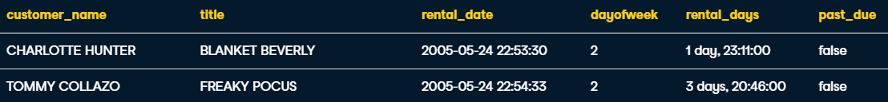

**Reformatting String and Character Data**

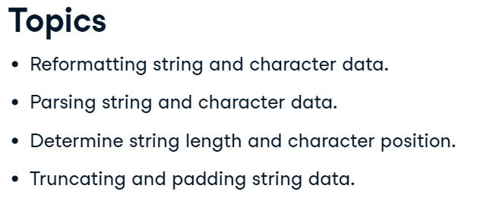

Concatenation - **||** or  **CONCAT()**

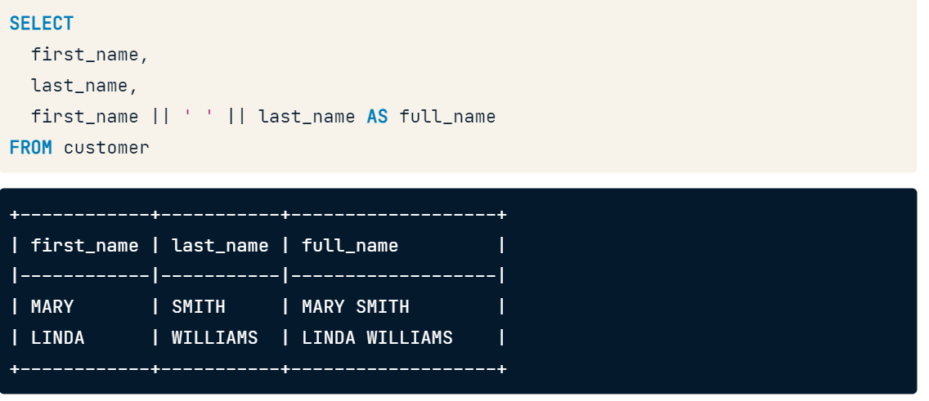

Changing case format with **UPPER() LOWER() & INITCAP()**

Replacing Characters in a String with  **REPLACE(**field, find, replace**)**

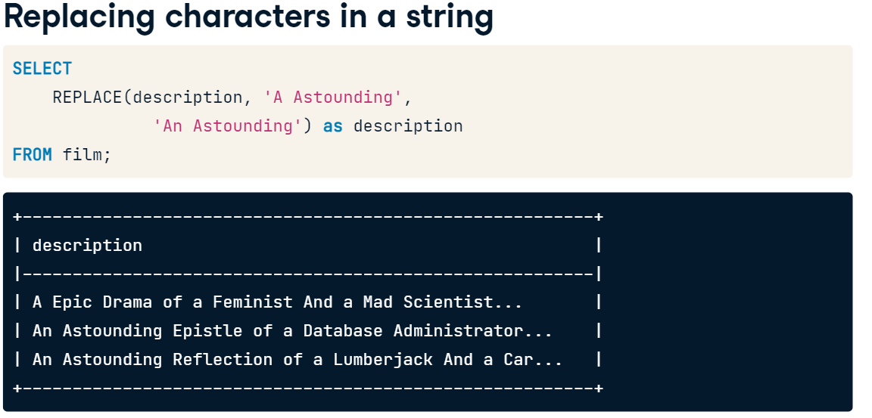

Note also **REVERSE( )** to flip a strings character

Ex1. concatenate

-- Concatenate the first_name and last_name and email

SELECT first_name || ' ' || last_name || ' <' || email || '>' AS full_email

FROM customer

Ex2. Same with CONCAT ( )

-- Concatenate the first_name and last_name and email

SELECT CONCAT(first_name, ' ', last_name, ' <', email, '>') AS full_email

FROM customer

Ex3. UPPER LOWER and INITCAP

SELECT

  -- Concatenate the category name to coverted to uppercase

  -- to the film title converted to title case

  UPPER(name)  || ': ' || INITCAP(title) AS film_category,

  -- Convert the description column to lowercase

  LOWER(description) AS description

FROM

  film AS f

  INNER JOIN film_category AS fc

    ON f.film_id = fc.film_id

  INNER JOIN category AS c

    ON fc.category_id = c.category_id;

Ex4. Replace spaces with underscores

SELECT

  -- Replace whitespace in the film title with an underscore

  REPLACE(title, ' ', '_') AS title

FROM film;

Parsing String and Character data

**CHAR_LENGTH ( )** – finds length of string

**LENGTH ( ) –** is analogous to **CHAR_LENGTH**

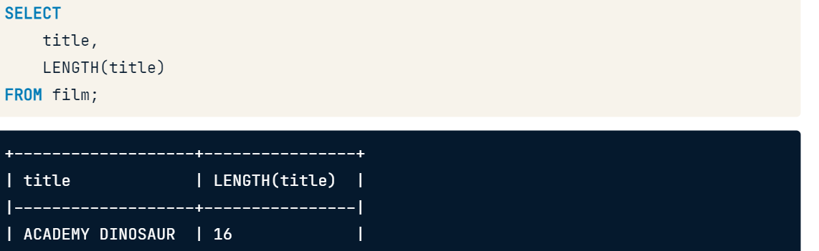

Finding Character position:

**POSITION (**‘character’ **IN** field**)** – finds the position of a character in a string

**STRPOS (**field, ‘character’**)** – is analogous to **POSITION ( )**

Parsing strings:

**LEFT / RIGHT (**field, x number of characters**)** – returns x number of characters from a sting starting from the left or right

**SUBSTRING (**field, starting position, number of characters**)**

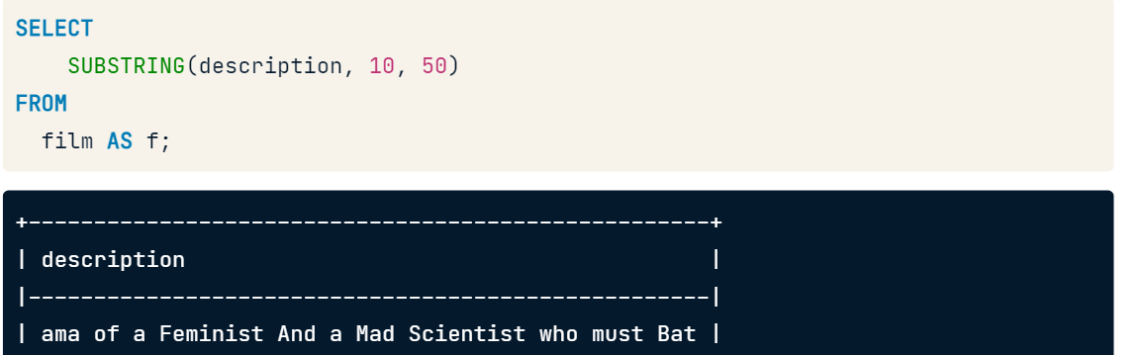

Combining **POSITION()** and **SUBSTRING()**  to subset from a certain character:

Eg. Selecting characters left-side of the ‘@’ in emails

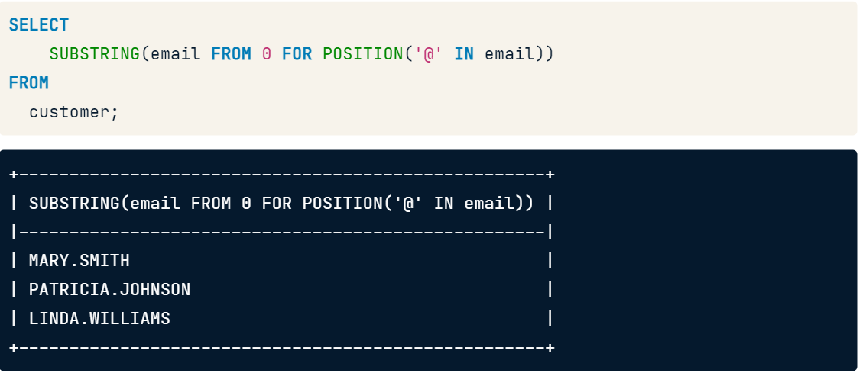

Eg2. Selecting characters right-side of the ‘@’ in emails

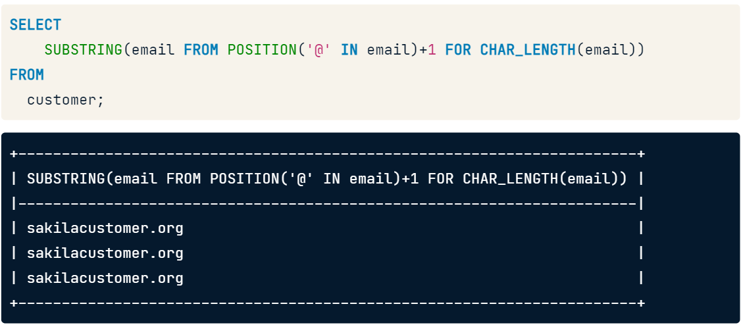

**SUBSTR (**field, starting character, no. of characters**)** – is analogous to SUBSTRING() but does not allow for this alternative syntax

Ex1.

SELECT

  -- Select the first 50 characters of description

  LEFT(description, 50) AS short_desc

FROM

  film AS f;

ex2.

SELECT

  -- Select only the street name from the address table

  SUBSTRING(address FROM POSITION(' ' IN address)+1 FOR CHAR_LENGTH(address))

FROM

  address;

ex3. substring from right and left

SELECT

  -- Extract the characters to the left of the '@'

  SUBSTRING(email FROM 0 FOR POSITION('@' IN email)) AS username,

  -- Extract the characters to the right of the '@'

  SUBSTRING(email FROM POSITION('@' IN email)+1 FOR CHAR_LENGTH(email)) AS domain

FROM customer;



Truncating and Padding strings

TRIM()

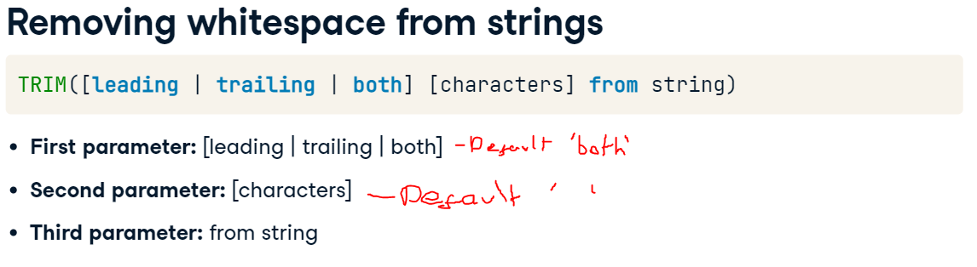

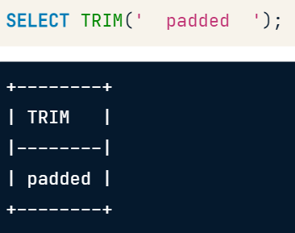 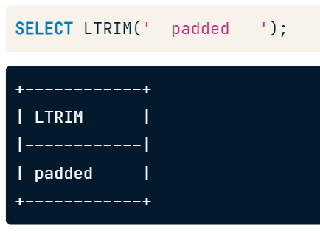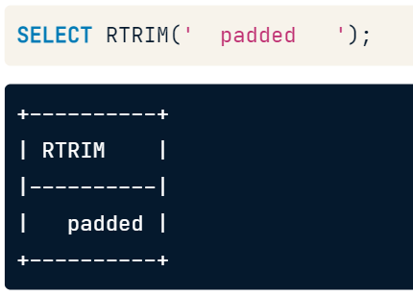

Padding:

LPAD() & RPAD()

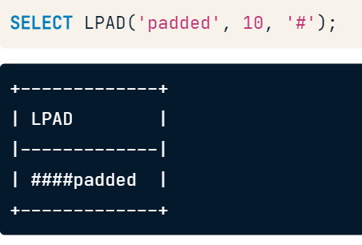 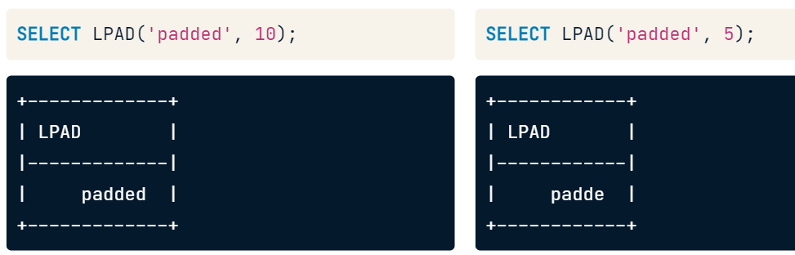

Ex1. Add a single space to the right or end of the first_name column.

Add the characters < to the right or end of last_name column.

Finally, add the characters > to the right or end of the email column.

SELECT

    RPAD(first_name, LENGTH(first_name)+1)

    || RPAD(last_name, LENGTH(last_name)+2, ' <')

    || RPAD(email, LENGTH(email)+1, '>') AS full_email

FROM customer;



Ex2. Convert the film category name to uppercase and use the CONCAT() concatenate it with the title.

Truncate the description to the first 50 characters and make sure there is no leading or trailing whitespace after truncating.

-- Concatenate the uppercase category name and film title

SELECT

  CONCAT(UPPER(c.name), ': ', f.title) AS film_category,

  -- Truncate the description remove trailing whitespace

  RTRIM(LPAD(f.description,50)) AS film_desc

FROM

  film AS f

  INNER JOIN film_category AS fc

    ON f.film_id = fc.film_id

  INNER JOIN category AS c

    ON fc.category_id = c.category_id;



Ex3. Get the first 50 characters of the description column

Determine the position of the last whitespace character of the truncated description column and subtract it from the number 50 as the second parameter in the first function above.

SELECT

  UPPER(c.name) || ': ' || f.title AS film_category,

  -- Truncate the description without cutting off a word

  LEFT(description, 50 -

    -- Subtract the position of the first whitespace character

    POSITION(

      ' ' IN REVERSE(LEFT(description, 50))

    )

  )

FROM

  film AS f

  INNER JOIN film_category AS fc

    ON f.film_id = fc.film_id

  INNER JOIN category AS c

    ON fc.category_id = c.category_id;

Full Text Search



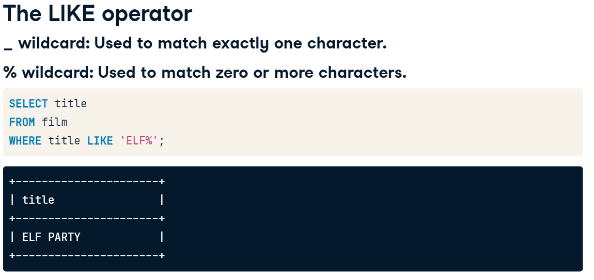

Wildcard positioning

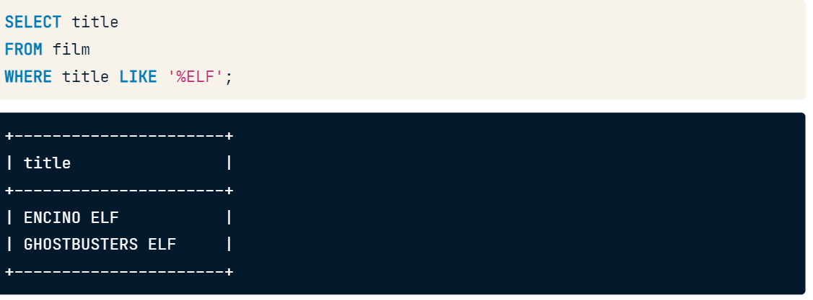

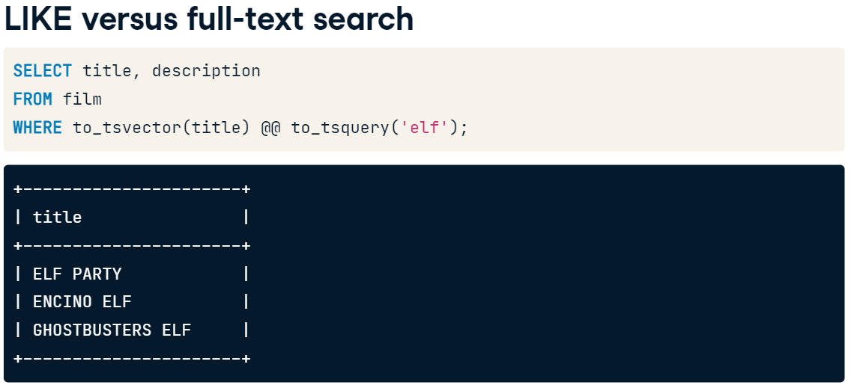

Full test search, accounts for variation in search string and is case insensitive.

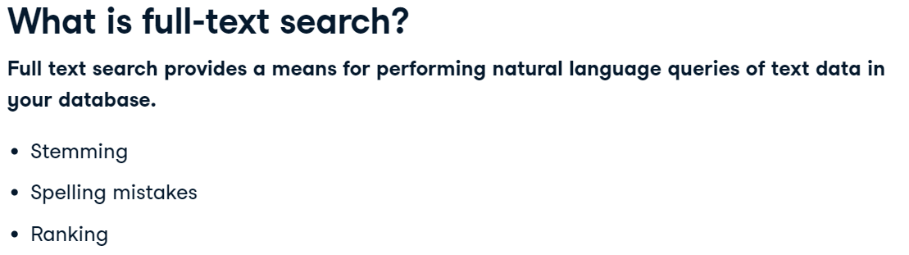

@@ - match operator to compare values of two functions 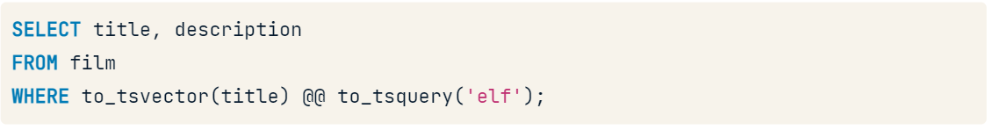

These functions convert text and string data to a ‘ts’ vector datatype, a sorted list of words that have been normalised into variants (leximes) of the same word

Ex1. LIKE

SELECT *

FROM film

-- Select only records that contain the word 'GOLD'

WHERE title LIKE '%GOLD%';

Ex2. Converting to tsvector

-- Select the film description as a tsvector

SELECT (description)

FROM film;



-- Select the film description as a tsvector

SELECT to_tsvector(description)

FROM film;



Ex3. Full text search of title for ‘elf’

-- Select the title and description

SELECT title, description

FROM film

-- Convert the title to a tsvector and match it against the tsquery

WHERE to_tsvector(title) @@ to_tsquery('elf');



Extending PostgreSQL

User-defined data types: 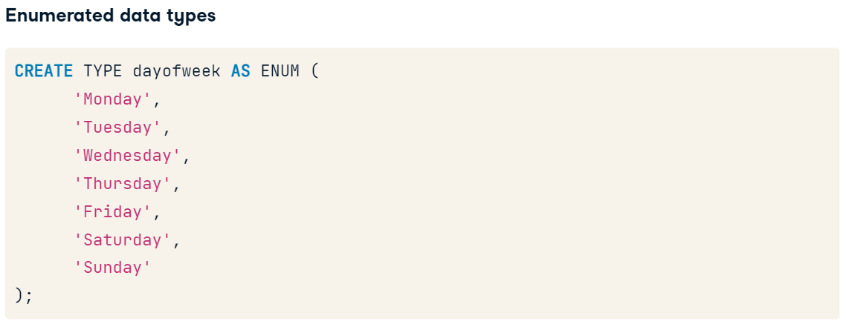

**pg_type** - to query your postgreSQL database of all its datatypes

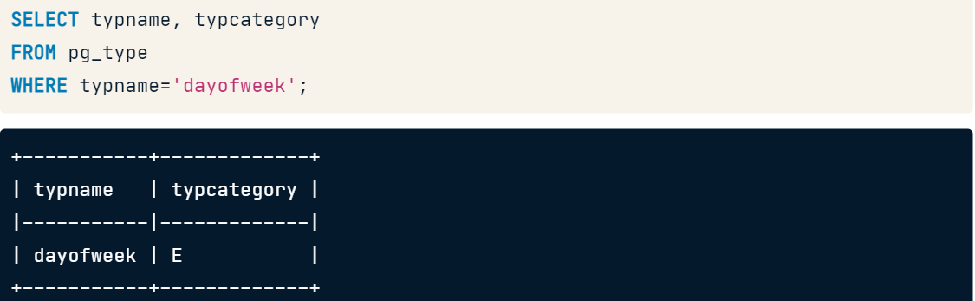

**INFORMATION_SCHEMA** also contains this data

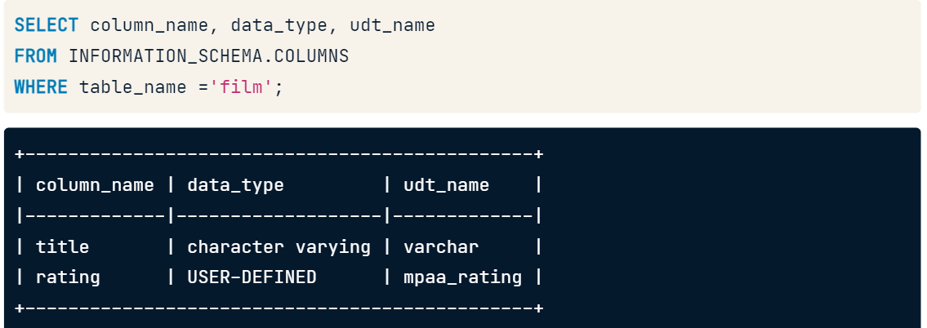

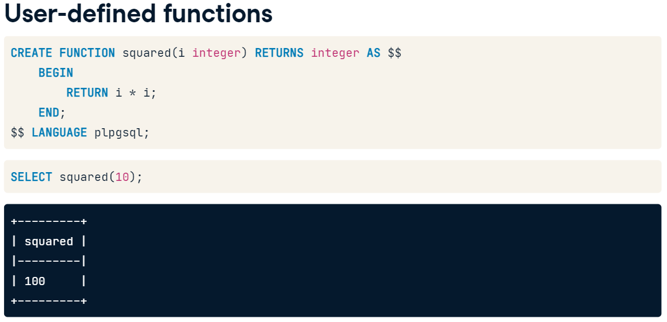

In this example we define the function squared that accepts an integer, i, as an input parameter and returns the square of that parameter as the result. The double dollar sign syntax specifies that the function will be using SQL as the language.

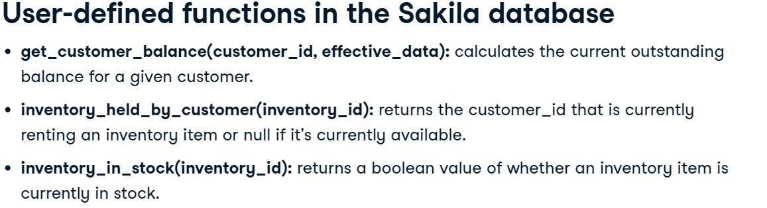

Ex1. Create an enumerated data type and find it using ‘**pg_type**’

-- Create an enumerated data type, compass_position

CREATE TYPE compass_position AS ENUM (

    -- Use the four cardinal directions

    'North',

    'South',

    'East',

    'West'

);

-- Confirm the new data type is in the pg_type system table

SELECT *

FROM pg_type

WHERE typname='compass_position';



Ex1. Filter search INFORMATION_SCHEMA.COLUMNS for user ‘rating’ data type

-- Select the column name, data type and udt name columns

SELECT column_name, data_type, udt_name

FROM INFORMATION_SCHEMA.COLUMNS

-- Filter by the rating column in the film table

WHERE table_name ='film' AND column_name='rating';



Ex2. Select all columns from the pg_type table where the type name is equal to mpaa_rating.

SELECT *

FROM pg_type

WHERE typname = 'mpaa_rating'



Ex3. Use user function to find if items are held by customer

-- Select the film title, rental and inventory ids

SELECT

    f.title,

    i.inventory_id,

    -- Determine whether the inventory is held by a customer

    inventory_held_by_customer(i.inventory_id) AS held_by_cust

FROM film as f

    -- Join the film table to the inventory table

    INNER JOIN inventory AS i ON f.film_id=i.film_id



Ex4. Filter previous for non null values

-- Select the film title and inventory ids

SELECT

    f.title,

    i.inventory_id,

    -- Determine whether the inventory is held by a customer

    inventory_held_by_customer(i.inventory_id) as held_by_cust

FROM film as f

    INNER JOIN inventory AS i ON f.film_id=i.film_id

WHERE

    -- Only include results where the held_by_cust is not null

    inventory_held_by_customer(i.inventory_id) IS NOT NULL



**PostgreSQL extensions**

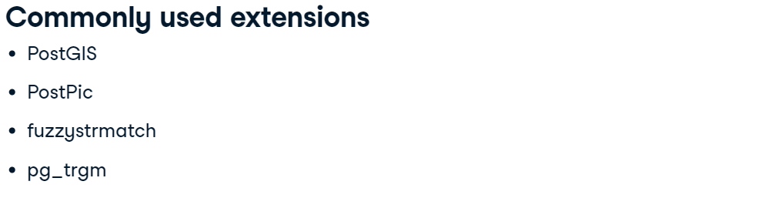PostGIS adds support for allowing location queries to be run in SQL.

PostPic allows for image processing within the database.

fuzzystrmatch and pg_trgm provide functions that extend full text search capabilities by finding similarities between strings.

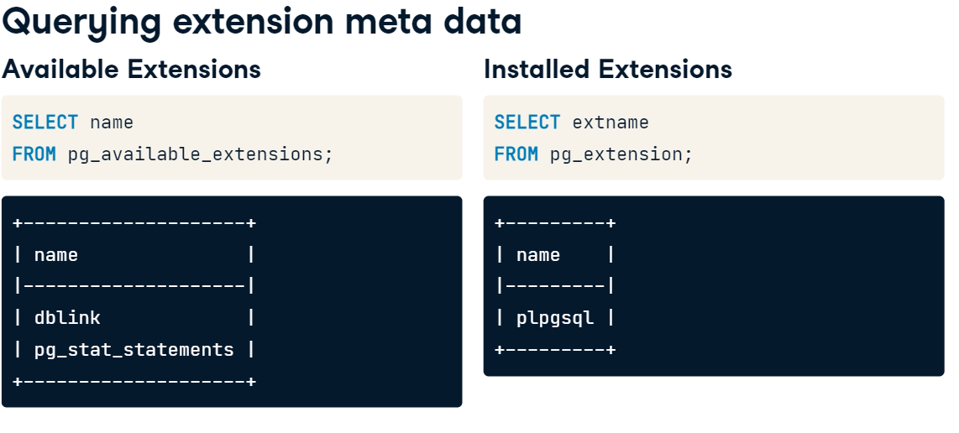

Enabling an extension

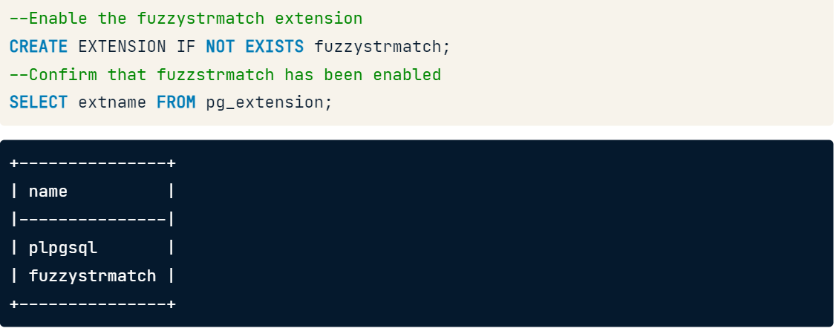

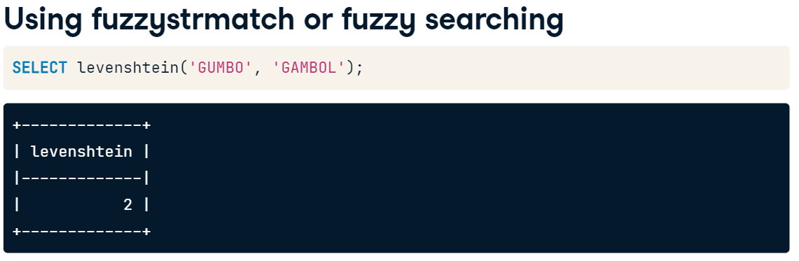

^ calculates the **levenshtein** distance between two strings which is the number of edits required for the strings to be a perfect match

**Trigrams** are groups of 3 consecutive characters in a string and based on the number of matching trigrams in two strings will provide a measurement of how similar they are.

The **pg_trgm** extension provides functions and operators to determine the similarity of two strings using **trigram matchings:**

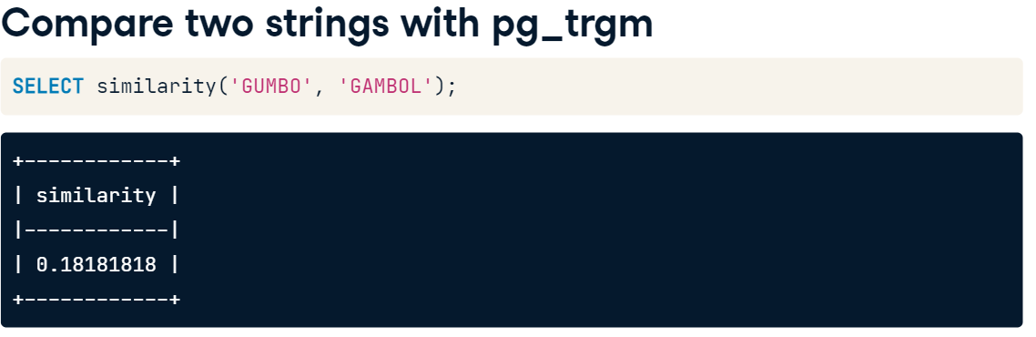

Ex1. confirm that both fuzzystrmatch and pg_trgm are enabled

-- Select all rows extensions

SELECT *

FROM pg_extension;

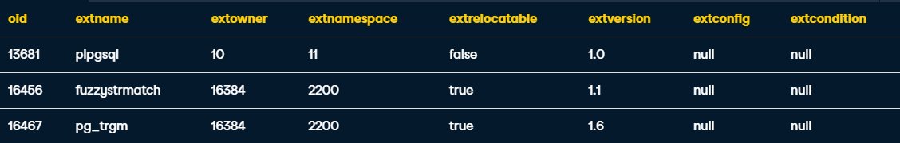

Ex2. Calculate the similarity between the title and description

-- Select the title and description columns

SELECT

  title,

  description,

  -- Calculate the similarity

  similarity(title, description)

FROM

  film

ex3. Calculate the levenshtein distance for the film title with the string JET NEIGHBOR

-- Select the title and description columns

SELECT

  title,

  LEFT(description,20),

  -- Calculate the levenshtein distance

  levenshtein('JET NEIGHBOUR', title) AS distance

FROM

  film

ORDER BY 3

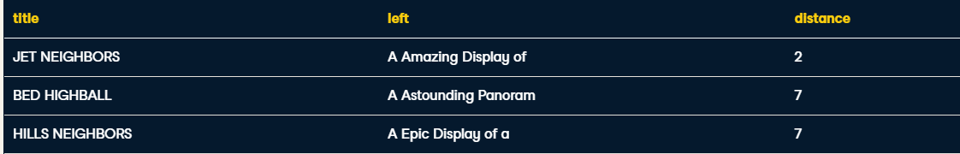

Ex4. Perform a full-text search by converting the description to a tsvector and match it to the phrase 'Astounding & Drama' using a tsquery in the WHERE clause.

-- Select the title and description columns

SELECT

  title,

  description

FROM

  film

WHERE

  -- Match "Astounding Drama" in the description

  to_tsvector(description) @@

  to_tsquery('Astounding & Drama');



Ex5. Add a new column that calculates the similarity of the description with the phrase 'Astounding Drama'.

Sort the results by the new similarity column in descending order.

SELECT

  title,

  description,

  -- Calculate the similarity

  similarity('Astounding Drama', description)

FROM

  film

WHERE

  to_tsvector(description) @@

  to_tsquery('Astounding & Drama')

ORDER BY

  similarity('Astounding Drama', description) DESC;

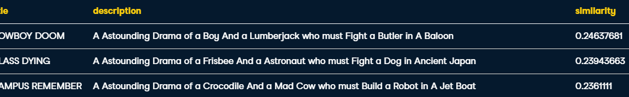

Module Review

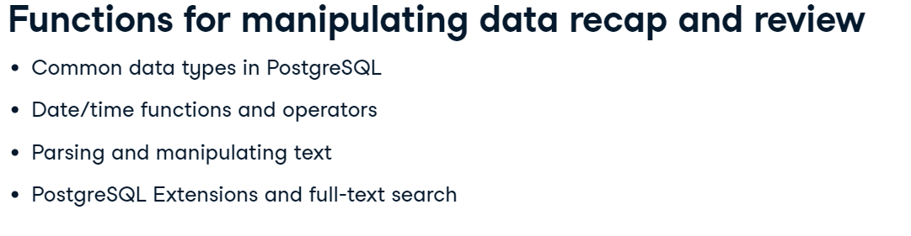

First you learned about common data types including strings, numerics and arrays. You learned about arrays and their special characteristics and how to use arrays to store lists of data and access and search elements in the list. Next you learned how to manipulate and query date and time objects including how to use the current timestamp in your queries, extract sub fields from existing date and time fields and what to expect when you perform date and time arithmetic. You learned how to manipulate string and text data by transforming case, parsing and truncating text and extracting substrings from larger strings. And finally, you learned about how to extend PostgreSQL capabilities using extensions and explored full text search using the extensions fuzzystrmatch and pg_trgm.

**Revision for Data Analysis in SQL (PostgreSQL)**

1. Understanding the structure of your data with simple SQL commands

2. Creating aggregate summaries and ordering data

3. Working with specific data types, such as character strings, numeric data, and dates

4. Joining multiple tables and adding new rows and columns to your data

5. Creating subqueries in the SELECT, FROM, and WHERE clauses

**Exploratory Data Analysis**

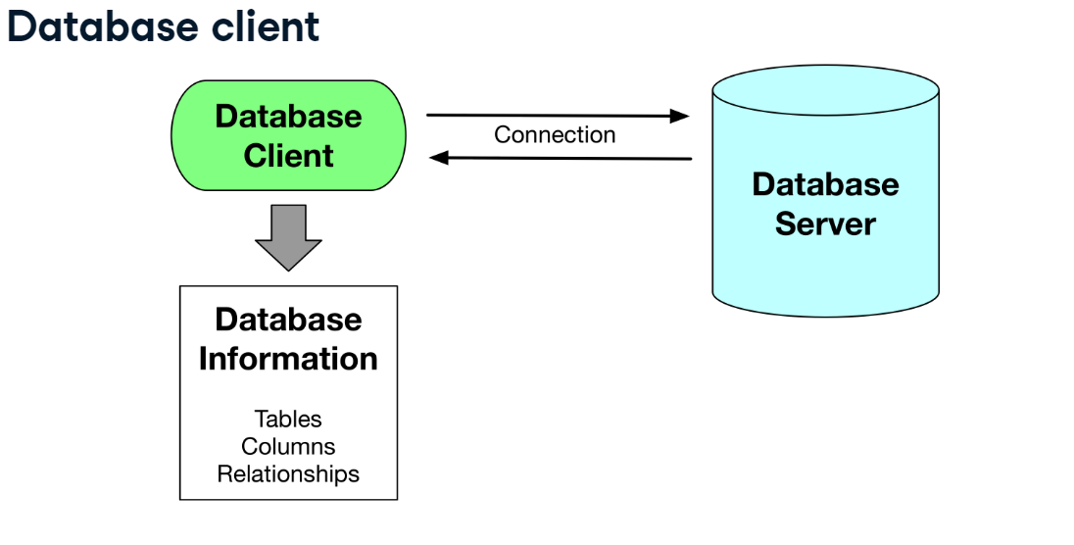

**Entity database Diagrams**

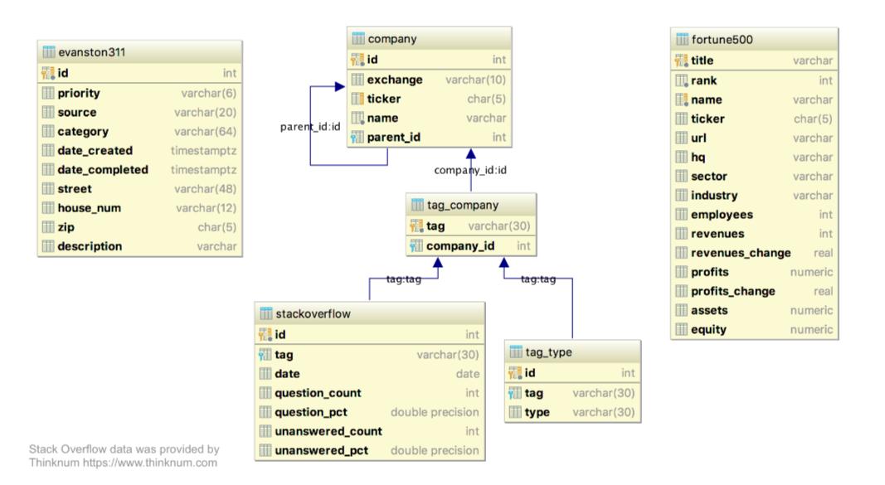

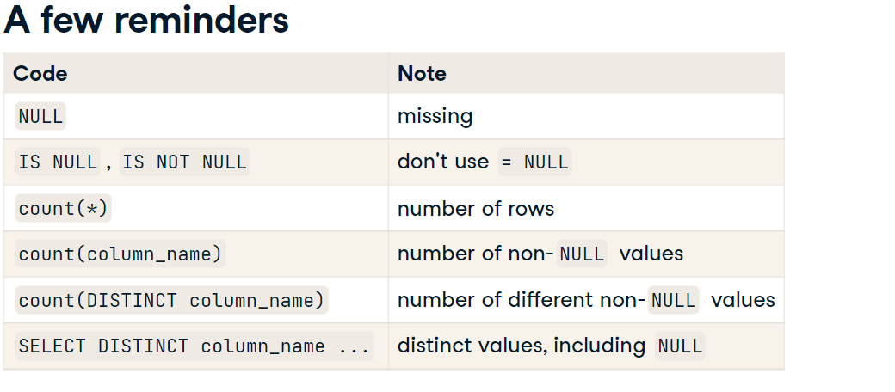

Ex1. Find number of missing values from column

SELECT COUNT(*) - COUNT(industry) AS missing

FROM fortune500

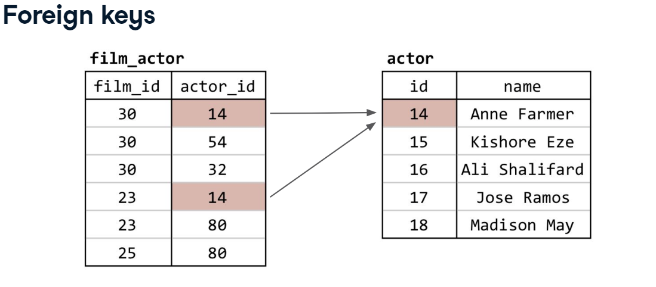

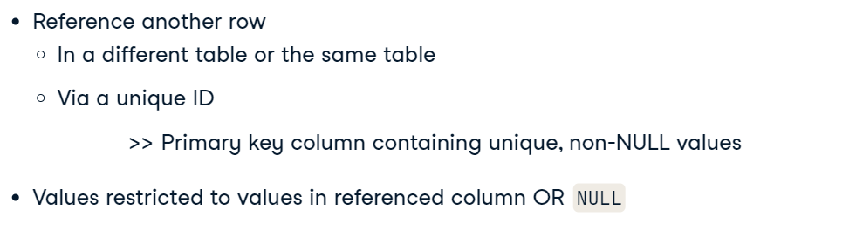

COALESCE

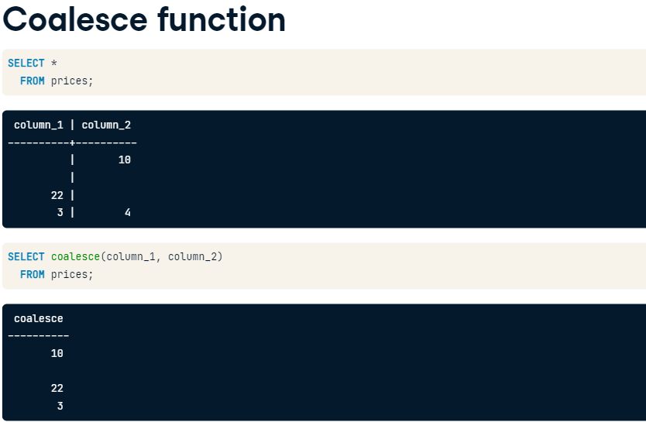

Foreign Keys must reference a column with unique values for each row so the referenced row can be identified.

Ex1. Count the tag types and find the most common one

-- Count the number of tags with each type

SELECT type, COUNT(type) AS count

  FROM tag_type

 -- To get the count for each type, what do you need to do?

 GROUP BY type

 -- Order the results with the most common

 -- tag types listed first

 ORDER BY count DESC;

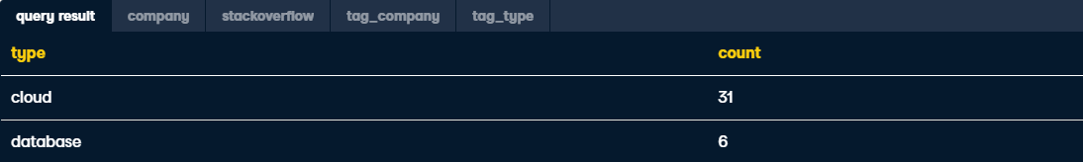

Ex2. Double join to find mutually occurring records of cloud type companies

-- Select the 3 columns desired

SELECT company.name, tag_type.tag, tag_type.type

  FROM company

       -- Join to the tag_company table

       INNER JOIN tag_company

       ON company.id = tag_company.company_id

       -- Join to the tag_type table

       INNER JOIN tag_type

       ON tag_company.tag = tag_type.tag

  -- Filter to most common type

  WHERE type='cloud';

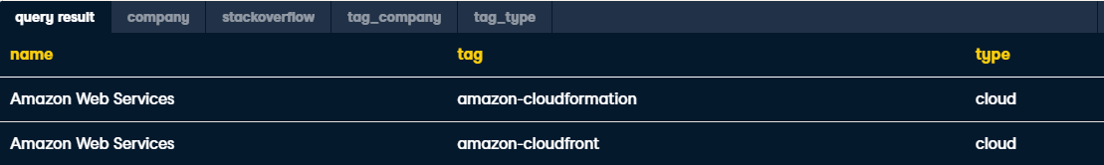

Ex3. Use COALESCE to find the most common industry of companies

-- Use coalesce

SELECT coalesce(industry, sector, 'Unknown') AS industry2,

       -- Don't forget to count!

       COUNT(*)

  FROM fortune500

-- Group by what? (What are you counting by?)

 GROUP BY industry2

-- Order results to see most common first

 ORDER BY count DESC

-- Limit results to get just the one value you want

 LIMIT 1;



Ex4. Use JOIN to include subsidiaries of **fortune500** companies from the **company** table. Use COALESCE for joining ON, so that the parent company code is prioritised

SELECT company_original.name, fortune500.title, fortune500.rank

  -- Start with original company information

  FROM company AS company_original

       -- Join to another copy of company with parent

       -- company information

     LEFT JOIN company AS company_parent

       ON company_original.parent_id = company_parent.id

       -- Join to fortune500, only keep rows that match

       INNER JOIN fortune500

       -- Use parent ticker if there is one,

       -- otherwise original ticker

       ON coalesce(company_original.ticker,

                   company_parent.ticker) =

             fortune500.ticker

 -- For clarity, order by rank

 ORDER BY rank;

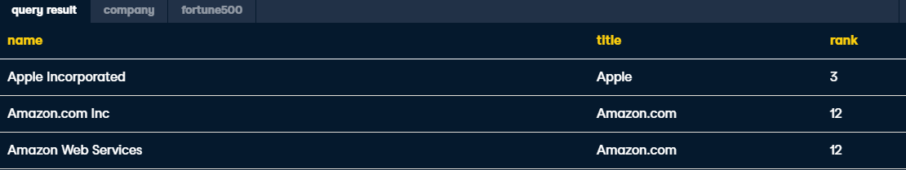

**Column types and Constraints**

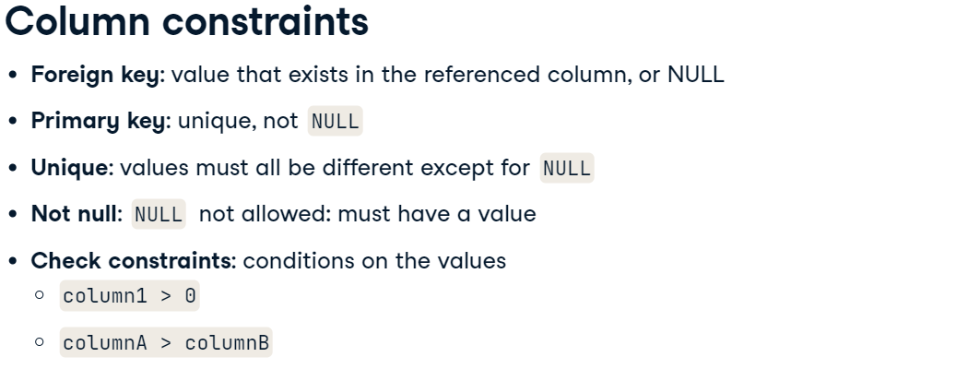

The Main Constraints are:

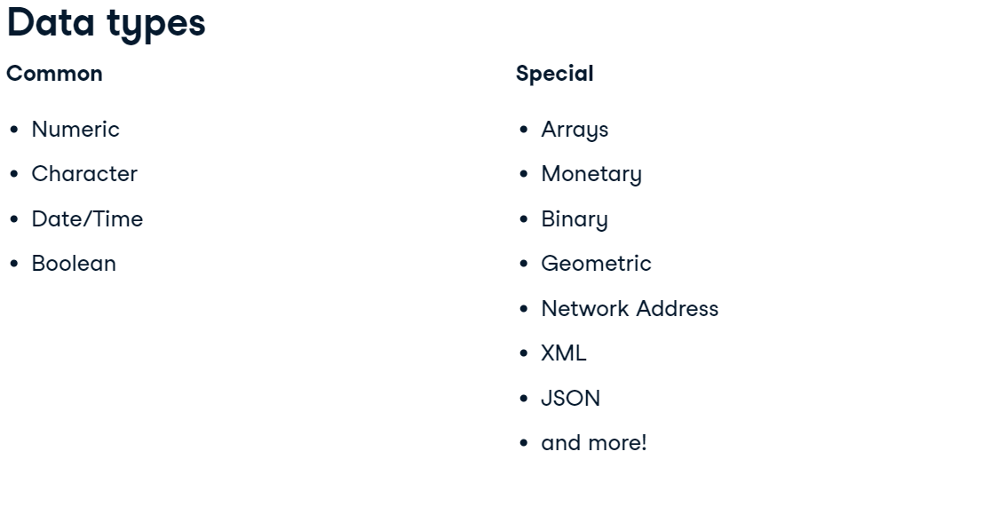

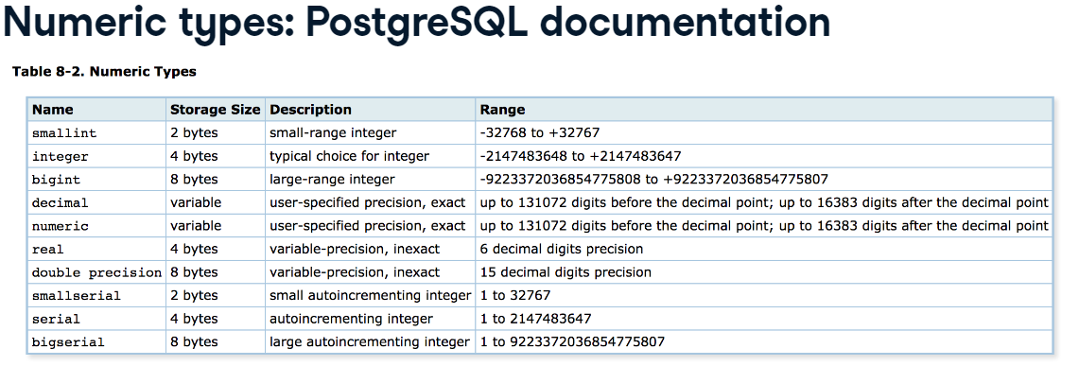

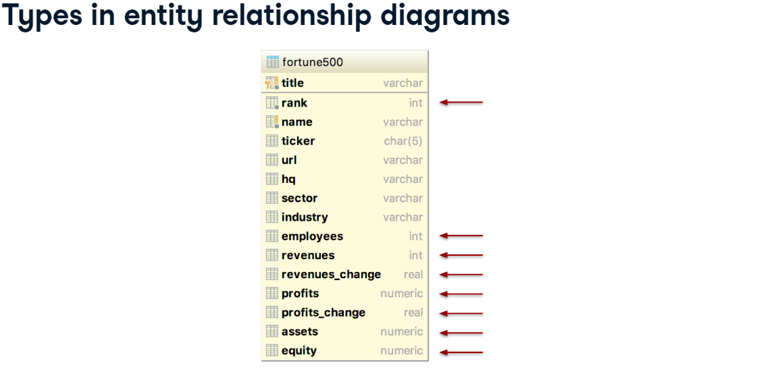

Converting Values with CAST() or ::

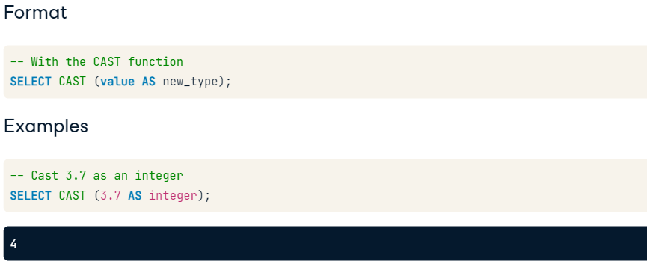

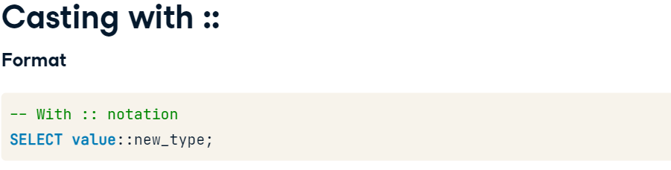

Ex1.

-- Select the original value

SELECT profits_change,

        -- Cast profits_change

       CAST(profits_change AS integer) AS profits_change_int

  FROM fortune500;

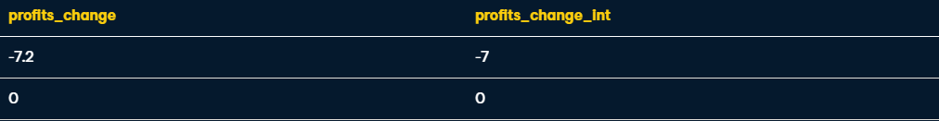

Ex2.

-- Divide 10 by 3

SELECT 10/3,

       -- Cast 10 as numeric and divide by 3

       10::numeric/3;



Ex3.

SELECT '3.2'::numeric,

       '-123'::numeric,

       '1e3'::numeric,

       '1e-3'::numeric,

       '02314'::numeric,

       '0002'::numeric;

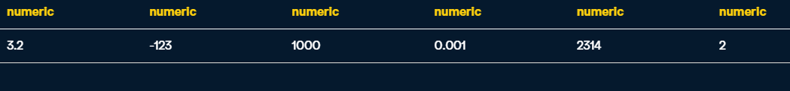

Ex4. cast revenues_change as an integer to reduce the number of different values.

-- Select the count of each revenues_change integer value

SELECT revenues_change::integer, COUNT(*)

  FROM fortune500

 GROUP BY revenues_change::integer

 -- order by the values of revenues_change

 ORDER BY count desc;

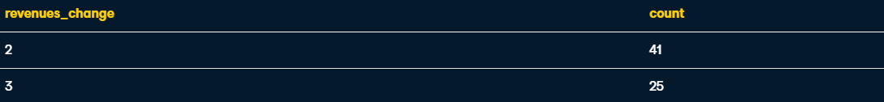

Numeric Types and Summary Functions

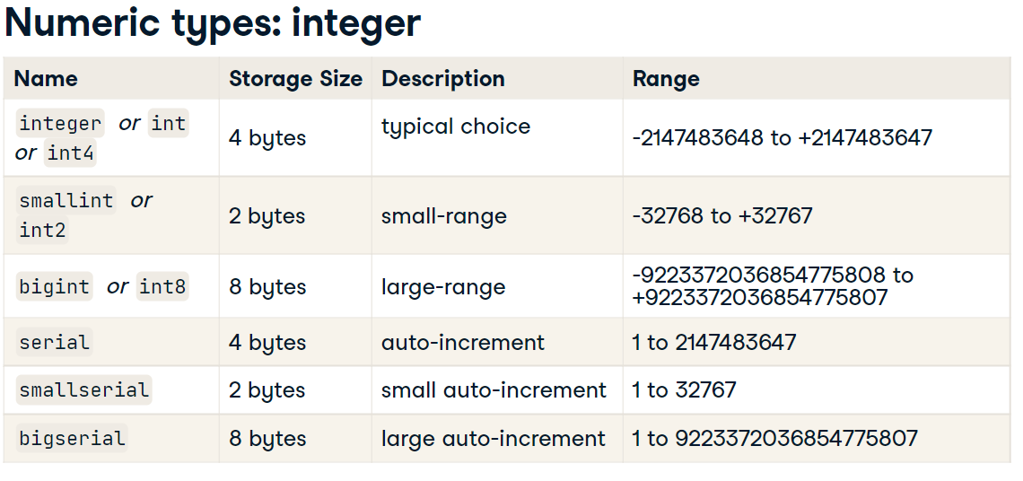

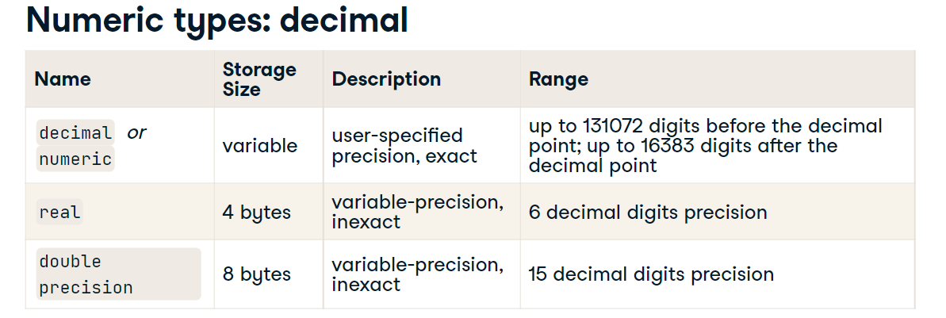

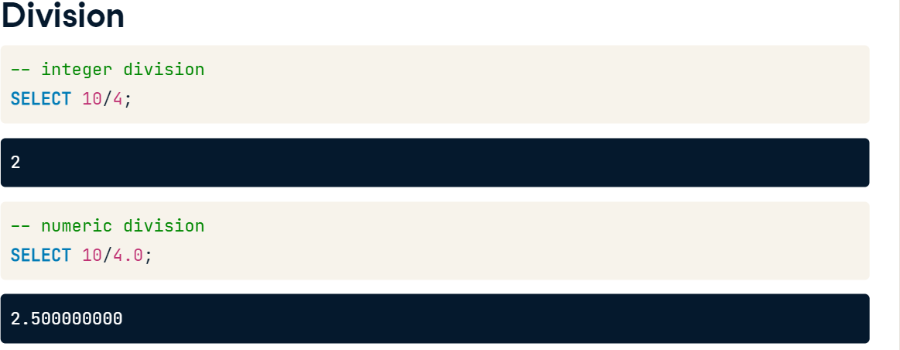

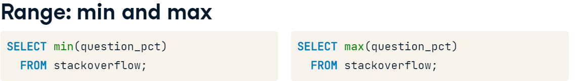

AVG()

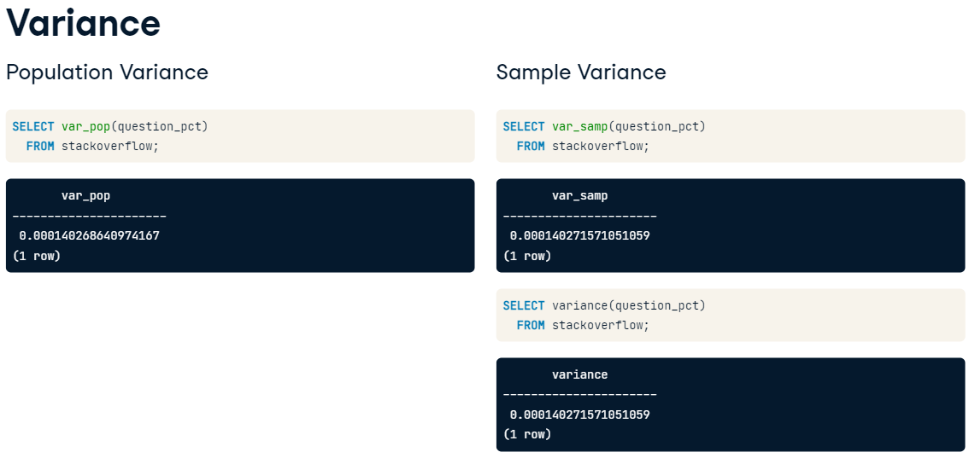

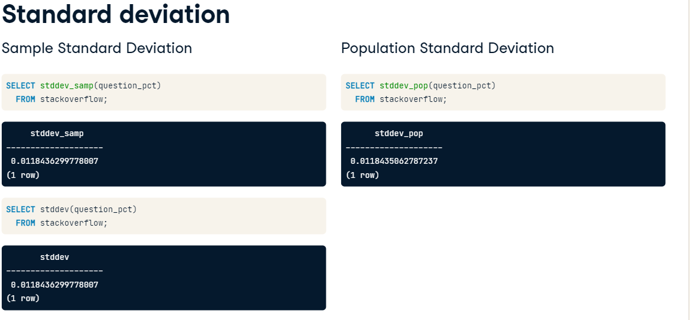

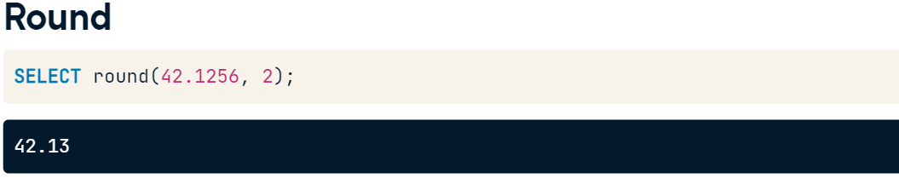

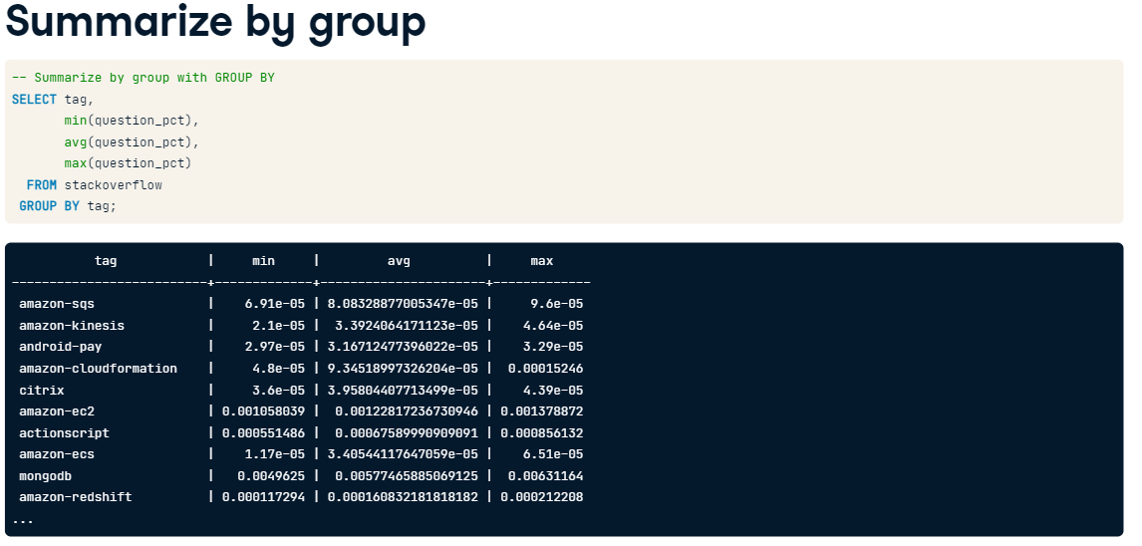

Ex1.

-- Select average revenue per employee by sector

SELECT sector,

       AVG(revenues/employees::numeric) AS avg_rev_employee

  FROM fortune500

 GROUP BY sector

 -- Use the column alias to order the results

 ORDER BY avg_rev_employee;



Ex2. Find whether the unanswered percentage column is the percent of questions with the tag that are unanswered.

-- Divide unanswered_count by question_count

SELECT unanswered_count/question_count::numeric AS computed_pct,

       -- What are you comparing the above quantity to?

       unanswered_pct

  FROM stackoverflow

 -- Select rows where question_count is not 0

 WHERE question_count > 0

 LIMIT 10;

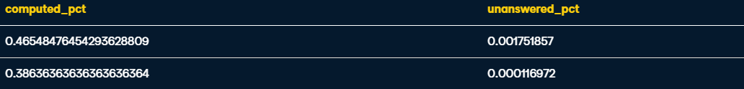

Ex3. Summarise Profits Column

-- Select min, avg, max, and stddev of fortune500 profits

SELECT MIN(profits),

       AVG(profits),

       MAX(profits),

       STDDEV(profits)

  FROM fortune500;



Ex4. By sector

-- Select sector and summary measures of fortune500 profits

SELECT sector,

       MIN(profits),

       AVG(profits),

       MAX(profits),

       STDDEV(profits)

  FROM fortune500

 -- What to group by?

 GROUP BY sector

 -- Order by the average profits

 ORDER BY AVG;

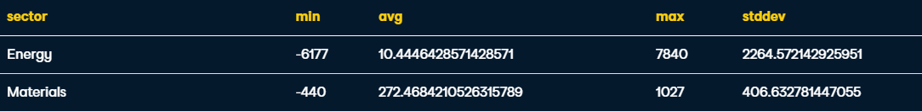

Ex5. Summarise the Maximum values of question count by tag

-- Compute standard deviation of maximum values

SELECT STDDEV(maxval),

           -- min

       MIN(maxval),

       -- max

       MAX(maxval),

       -- avg

       AVG(maxval)

  -- Subquery to compute max of question_count by tag

  FROM

  (SELECT MAX(question_count) AS maxval

          FROM stackoverflow

         -- Compute max by...

         GROUP BY tag) AS max_results; -- alias for subquery



Exploring Distributions

Simple look into spread is to count the frequency of datapoints:

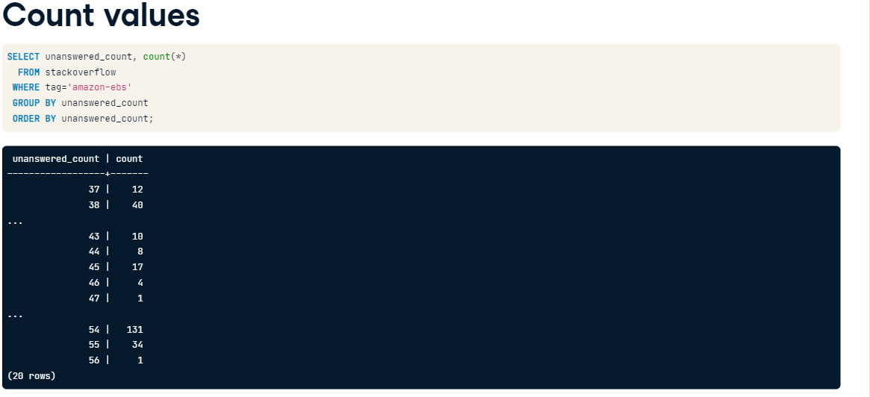

You can create ‘bins’ with TRUNC, by reducing the significant figures:

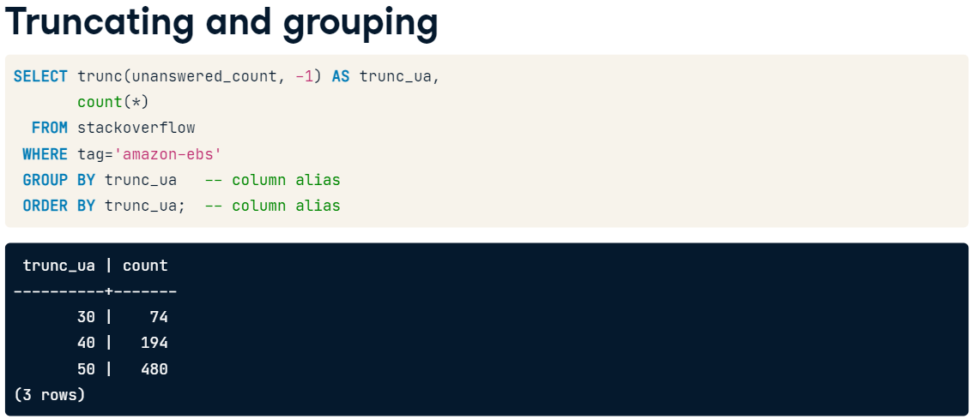

A more elegant solution is GENERATE_SERIES

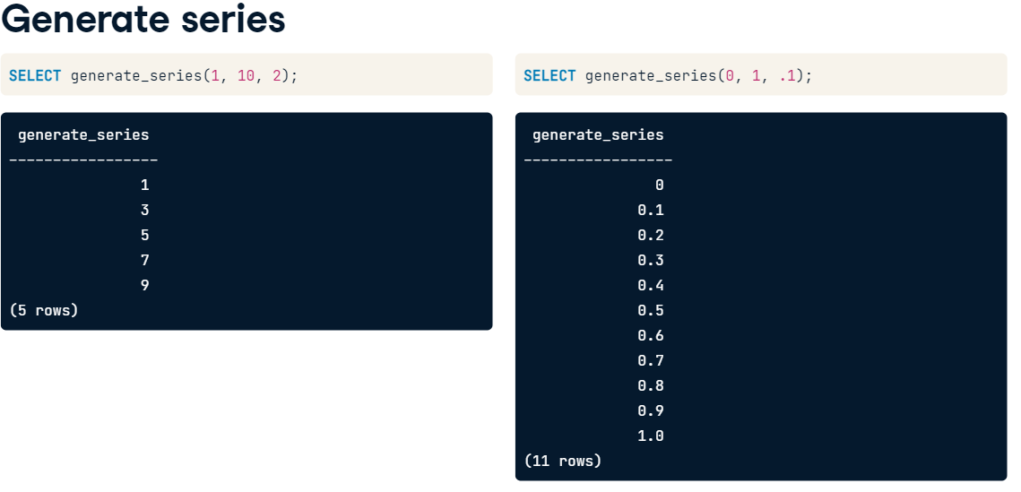

Generate Series can be used to create bins:

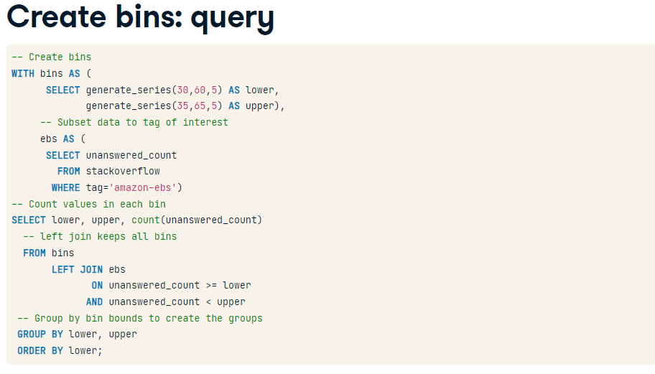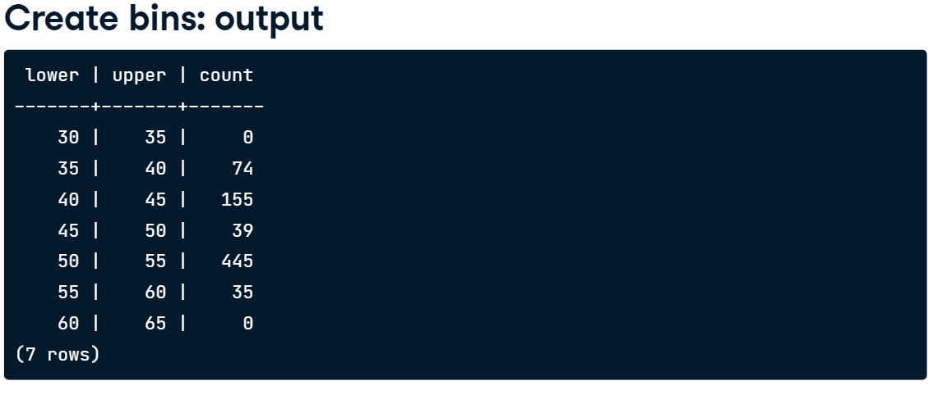

Ex1. Use trunc() to truncate employees to the 100,000s (5 zeros).

Count the number of observations with each truncated value.

-- Truncate employees

SELECT TRUNC(employees, -5) AS employee_bin,

       -- Count number of companies with each truncated value

       COUNT(*)

  FROM fortune500

 -- Use alias to group

 GROUP BY employee_bin

 -- Use alias to order

 ORDER BY employee_bin;

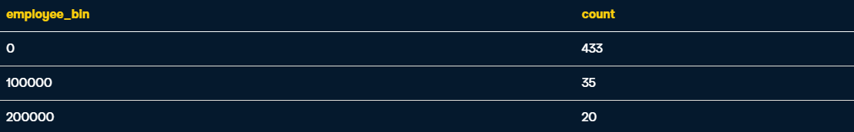

Ex2. Generate upper and lower bins

-- Create lower and upper bounds of bins

SELECT generate_series(2200, 3050, 50) AS lower,

       generate_series(2250, 3100, 50) AS upper;

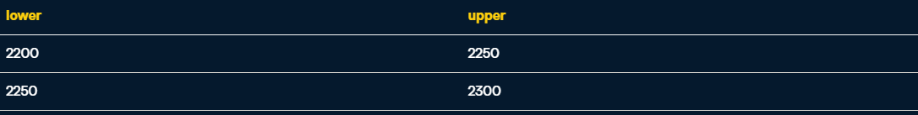

Ex3. Use generate_series to Summarize the distribution of the number of questions with the tag "dropbox" on Stack Overflow per day by binning the data

-- Bins created in Step 2

WITH bins AS (

      SELECT generate_series(2200, 3050, 50) AS lower,

             generate_series(2250, 3100, 50) AS upper),

     -- Subset stackoverflow to just tag dropbox (Step 1)

     dropbox AS (

      SELECT question_count

        FROM stackoverflow

       WHERE tag='dropbox')

-- Select columns for result

-- What column are you counting to summarize?

SELECT lower, upper, count(question_count)

  FROM bins  -- Created above

       -- Join to dropbox (created above),

       -- keeping all rows from the bins table in the join

       LEFT JOIN dropbox

       -- Compare question_count to lower and upper

         ON question_count >= lower

        AND question_count < upper

 -- Group by lower and upper to count values in each bin

 GROUP BY lower, upper

 -- Order by lower to put bins in order

 ORDER BY lower;

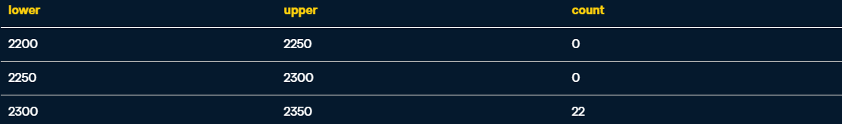

More Summary Functions:

CORR() - correlation

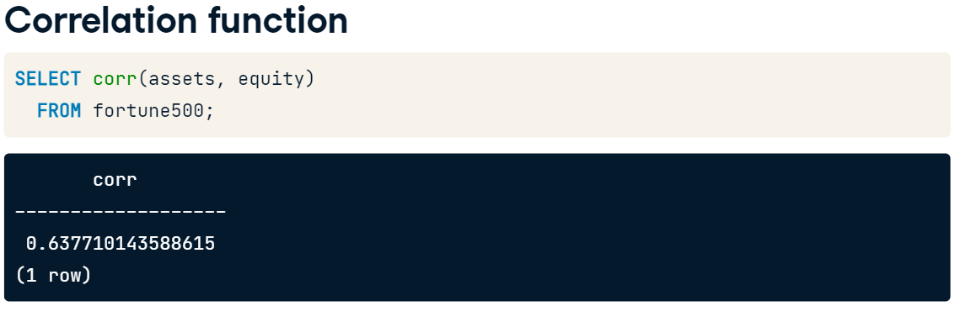

Median:

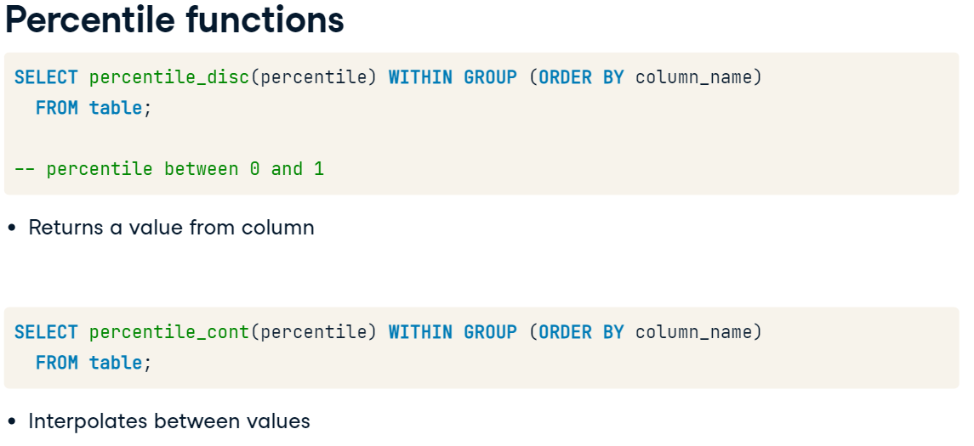

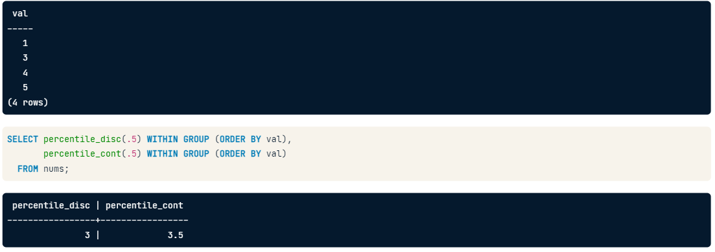

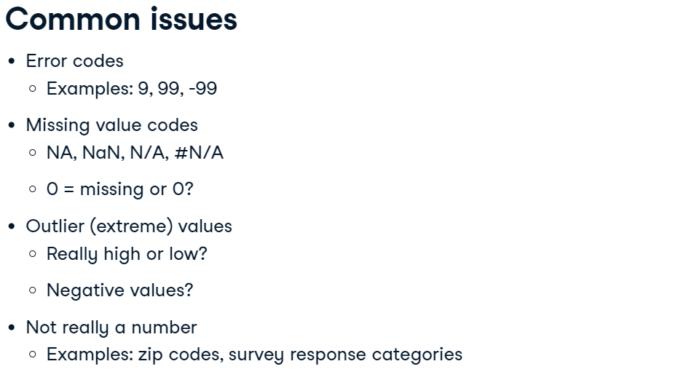

Ex1. Find correlation values

-- Correlation between revenues and profit

SELECT CORR(revenues, profits) AS rev_profits,

        -- Correlation between revenues and assets

       CORR(revenues, assets) AS rev_assets,

       -- Correlation between revenues and equity

       CORR(revenues, equity) AS rev_equity

  FROM fortune500;



Ex2. Mean and Median

-- What groups are you computing statistics by?

SELECT sector,

       -- Select the mean of assets with the avg function

       AVG(assets) AS mean,

       -- Select the median

       percentile_disc(.5) WITHIN GROUP (ORDER BY assets) AS median

  FROM fortune500

 -- Computing statistics for each what?

 GROUP BY sector

 -- Order results by a value of interest

 ORDER BY median;

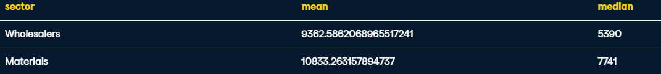

Temporary Tables

You will have to have special permissions to create tables in a database. Temporary tables however are allowed.

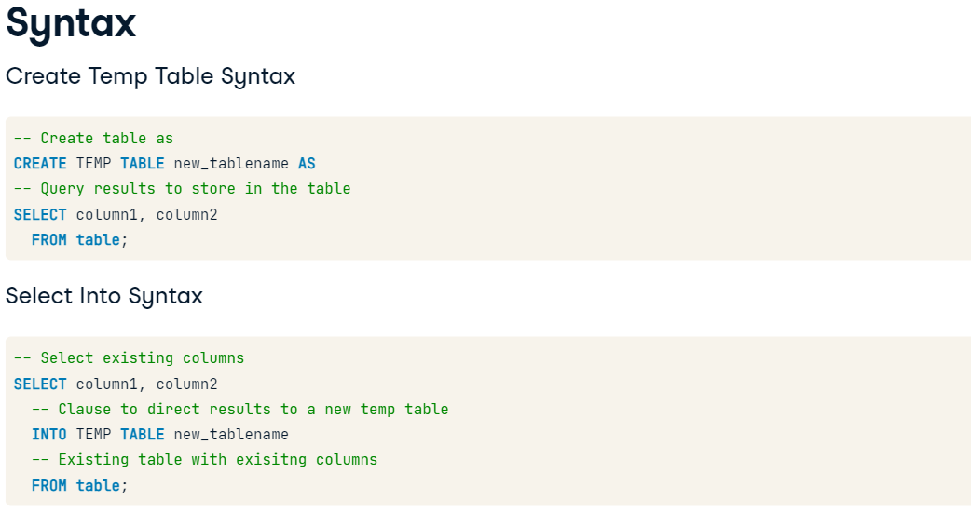

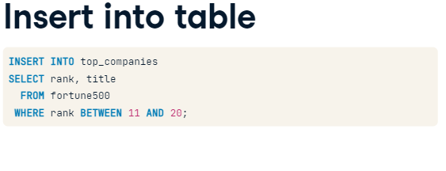

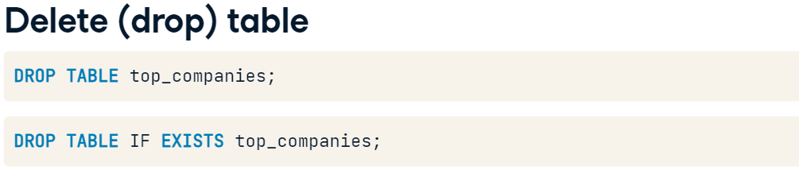

Ex1. Create a table of the 80th percentile profits of each sector in the fortune500

-- To clear table if it already exists;

-- fill in name of temp table

DROP TABLE IF EXISTS profit80;

-- Create the temporary table

CREATE TEMP TABLE profit80 AS

  -- Select the two columns you need; alias as needed

  SELECT sector,

         percentile_disc(.8) WITHIN GROUP (ORDER BY profits) AS pct80

    -- What table are you getting the data from?

    FROM fortune500

   -- What do you need to group by?

   GROUP BY sector;

-- See what you created: select all columns and rows

-- from the table you created

SELECT *

  FROM profit80;

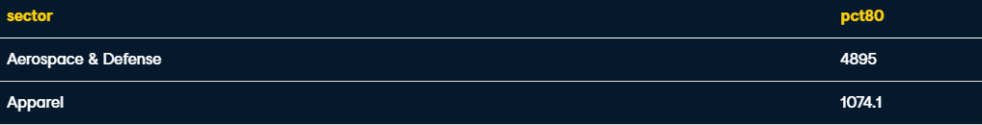

Ex2. Explore whether profits are greater than 80% of the companies sector

-- Code from previous step

DROP TABLE IF EXISTS profit80;

CREATE TEMP TABLE profit80 AS

  SELECT sector,

         percentile_disc(0.8) WITHIN GROUP (ORDER BY profits) AS pct80

    FROM fortune500

   GROUP BY sector;

-- Select columns, aliasing as needed

SELECT title, fortune500.sector,

       profits, profits/pct80 AS ratio

-- What tables do you need to join?

  FROM fortune500

       LEFT JOIN profit80

-- How are the tables joined?

       ON profit80.sector = fortune500.sector

-- What rows do you want to select?

 WHERE fortune500.profits > profit80.pct80;

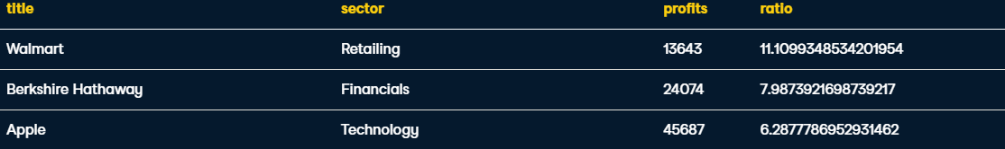

Ex3. Find out how many questions had each tag on the first date for which data for the tag is available, as well as how many questions had the tag on the last day. Also, compute the difference between these two values.

To do this, first compute the minimum date for each tag.

Then use the minimum dates to select the question_count on both the first and last day. To do this, join the temp table startdates to two different copies of the stackoverflow table: one for each column - first day and last day - aliased with different names.

-- To clear table if it already exists

DROP TABLE IF EXISTS startdates;

CREATE TEMP TABLE startdates AS

SELECT tag, min(date) AS mindate

  FROM stackoverflow

 GROUP BY tag;

-- Select tag (Remember the table name!) and mindate

SELECT startdates.tag,

       mindate,

       -- Select question count on the min and max days

     so_min.question_count AS min_date_question_count,

       so_max.question_count AS max_date_question_count,

       -- Compute the change in question_count (max- min)

       so_max.question_count - so_min.question_count AS change

  FROM startdates

       -- Join startdates to stackoverflow with alias so_min

       INNER JOIN stackoverflow AS so_min

          -- What needs to match between tables?

          ON startdates.tag = so_min.tag

         AND startdates.mindate = so_min.date

       -- Join to stackoverflow again with alias so_max

       INNER JOIN stackoverflow AS so_max

          -- Again, what needs to match between tables?

          ON startdates.tag = so_max.tag

         AND so_max.date = '2018-09-25';

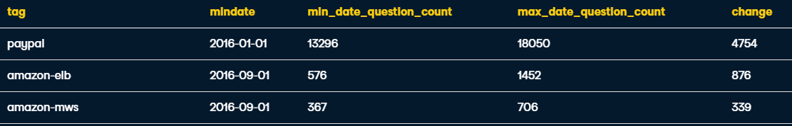

Ex4. Generate correlation table like so:

| **measure** | **profits** | **profits_change** | **revenues_change** |
| --- | --- | --- | --- |
| profits | 1.00 | # | # |
| profits_change | # | 1.00 | # |
| revenues_change | # | # | 1.00 |

DROP TABLE IF EXISTS correlations;

CREATE TEMP TABLE correlations AS

SELECT 'profits'::varchar AS measure,

       corr(profits, profits) AS profits,

       corr(profits, profits_change) AS profits_change,

       corr(profits, revenues_change) AS revenues_change

  FROM fortune500;

INSERT INTO correlations

SELECT 'profits_change'::varchar AS measure,

       corr(profits_change, profits) AS profits,

       corr(profits_change, profits_change) AS profits_change,

       corr(profits_change, revenues_change) AS revenues_change

  FROM fortune500;

INSERT INTO correlations

SELECT 'revenues_change'::varchar AS measure,

       corr(revenues_change, profits) AS profits,

       corr(revenues_change, profits_change) AS profits_change,

       corr(revenues_change, revenues_change) AS revenues_change

  FROM fortune500;

-- Select each column, rounding the correlations

SELECT measure,

       ROUND(profits::numeric, 2) AS profits,

       ROUND(profits_change::numeric, 2) AS profits_change,

       ROUND(revenues_change::numeric, 2) AS revenues_change

  FROM correlations;

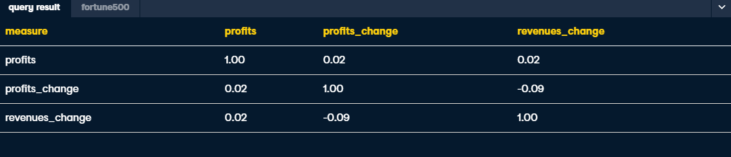

Character types

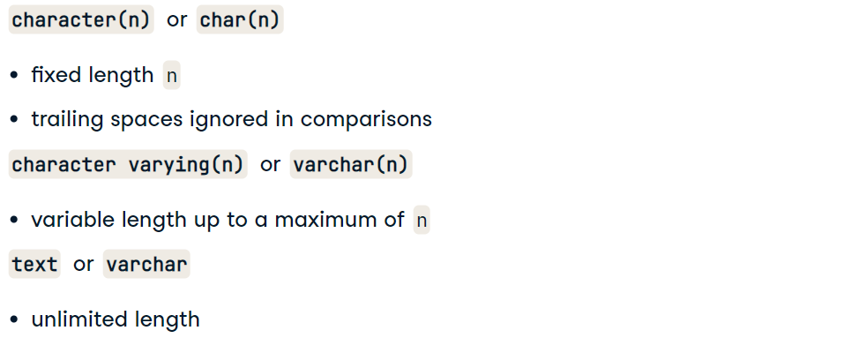

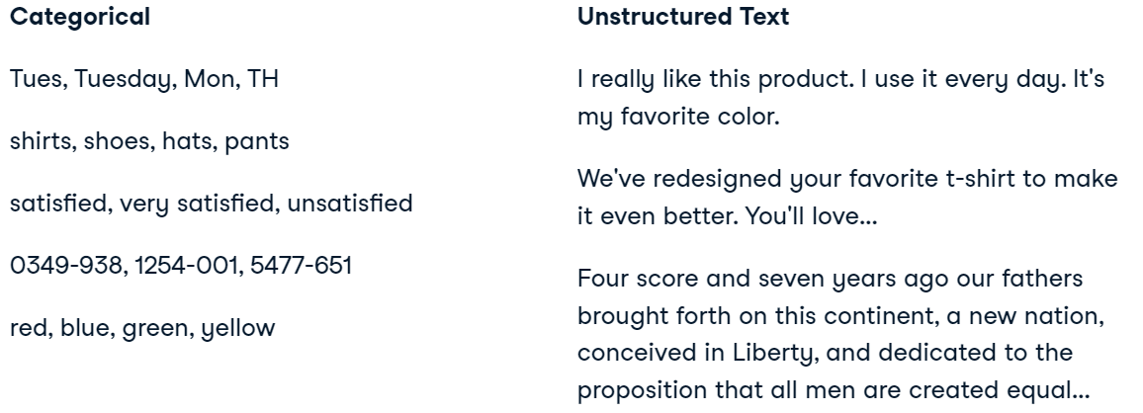

For finding the most common categories

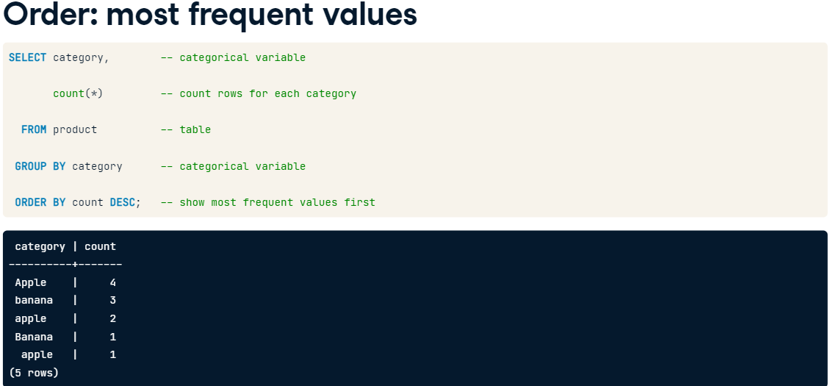

For finding duplicate categories

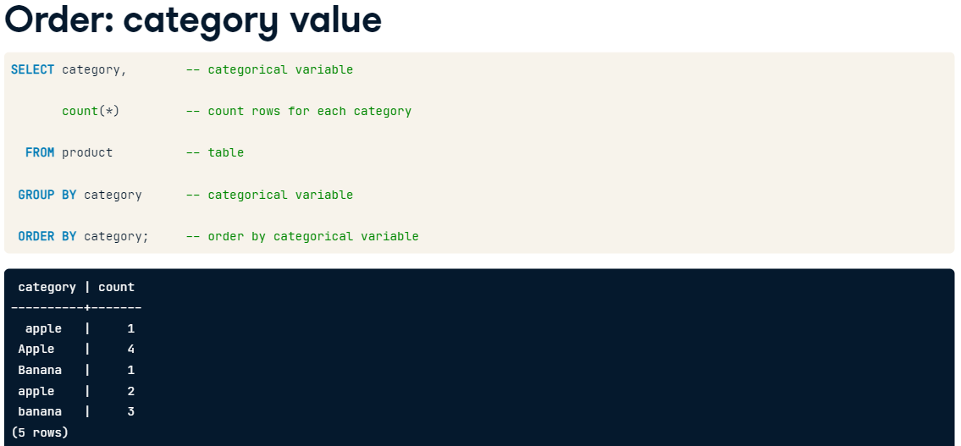

Common issues with character data

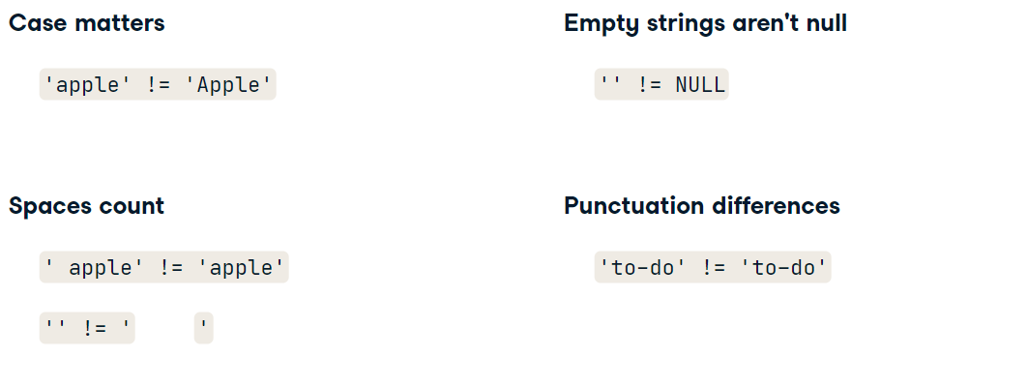

Data:

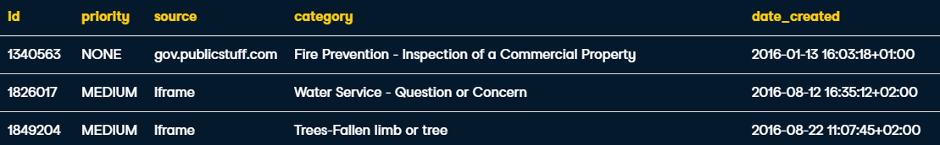

Ex1. How many rows does each priority level have?

-- Select the count of each level of priority

SELECT priority, COUNT(*)

  FROM evanston311

 GROUP BY priority;



Ex2. How many distinct values of zip appear in at least 100 rows?

-- Find values of zip that appear in at least 100 rows

-- Also get the count of each value

SELECT zip, COUNT(*)

  FROM evanston311

 GROUP BY zip

HAVING COUNT(*) >= 100;

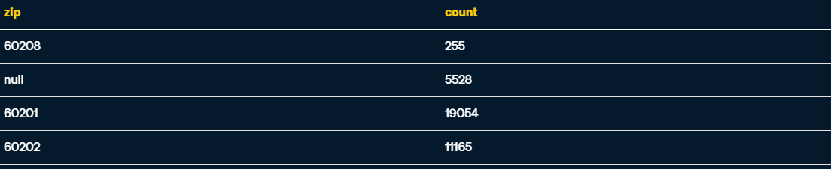 (HAVING is used like a WHERE clause but for aggregate functions)

Ex3. Select the five most common values of street and the count of each.

Find the 5 most common values of street and the count of each

SELECT street, COUNT(*)

  FROM evanston311

 GROUP BY street

 ORDER BY COUNT(*) DESC

 LIMIT 5;

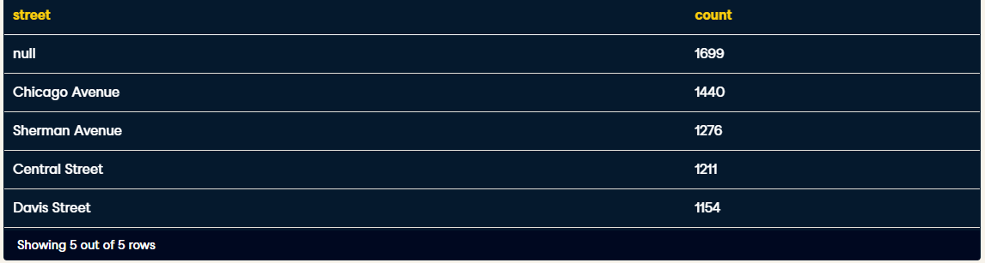

Fixing Case inconsistencies

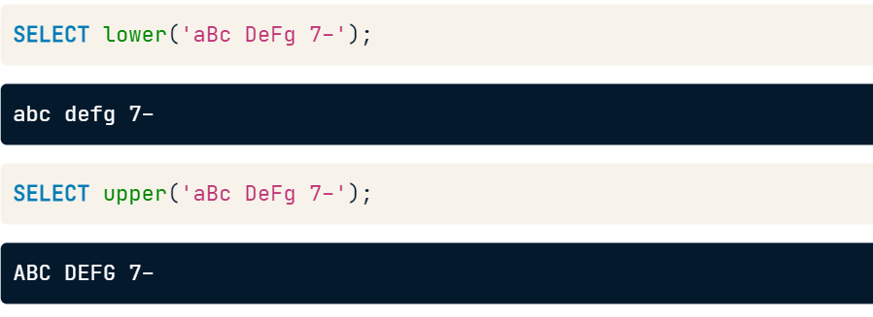

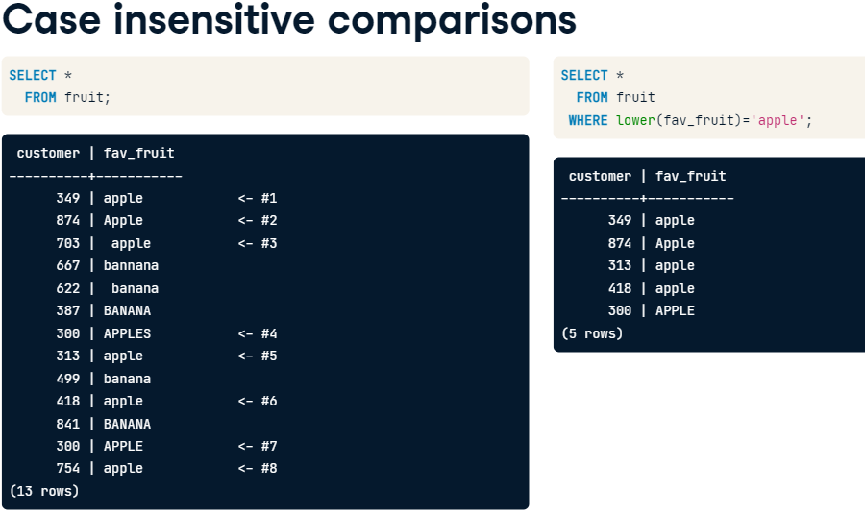

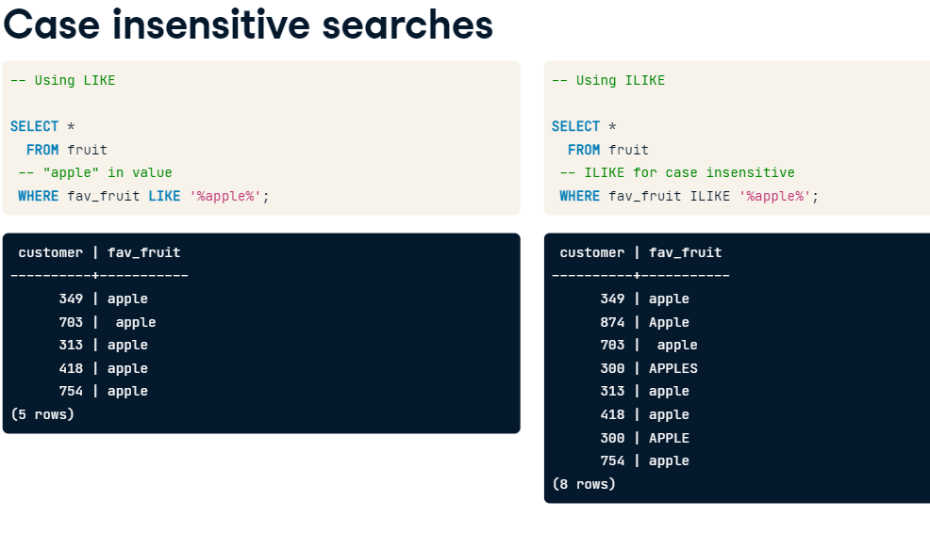

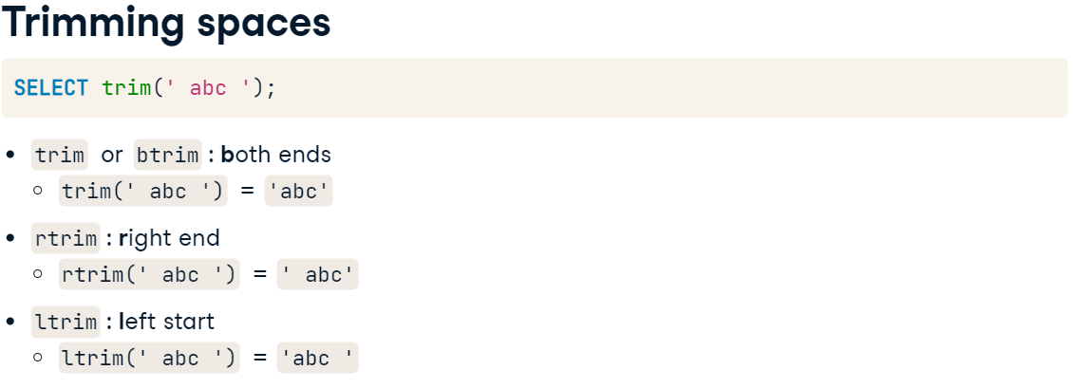

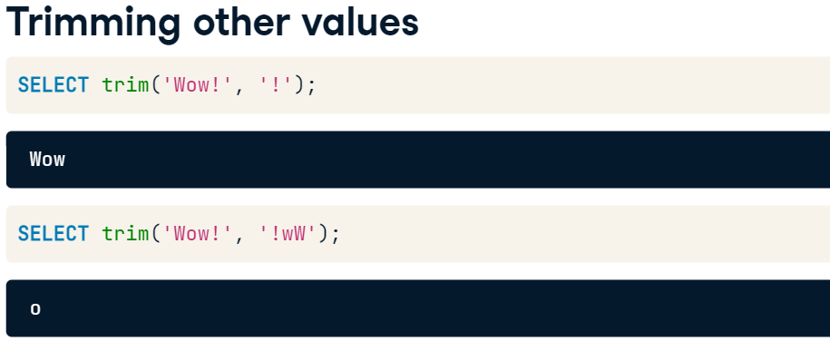

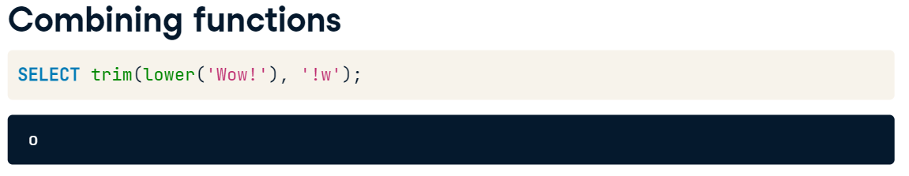

Ex1. Clean street values

SELECT distinct street,

       -- Trim off unwanted characters from street

       trim(street, '0123456789 #/.') AS cleaned_street

  FROM evanston311

 ORDER BY street;

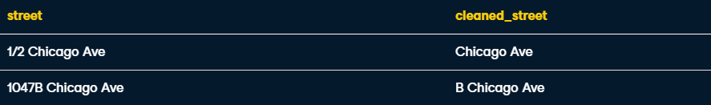

Ex2. find inquires that mention trash or garbage in the description without trash or garbage being in the category. What are the most frequent categories for such inquiries?

-- Count rows with each category

SELECT category, count(*)

  FROM evanston311

 WHERE (description ILIKE '%trash%'

    OR description ILIKE '%garbage%')

   AND category NOT LIKE '%Trash%'

   AND category NOT LIKE '%Garbage%'

 -- What are you counting?

 GROUP BY category

 --- order by most frequent values

 ORDER BY count DESC

 LIMIT 10;

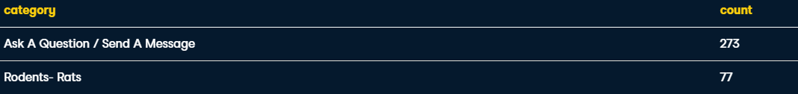

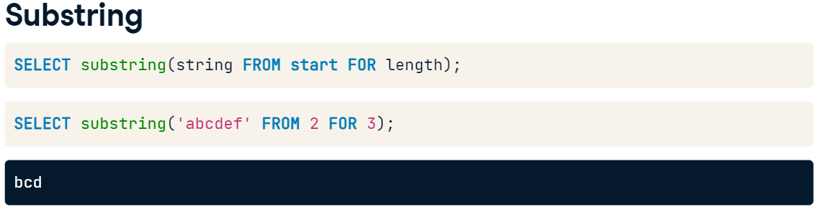

Splitting string on delimiter

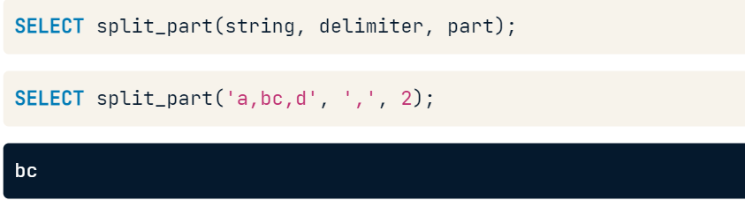

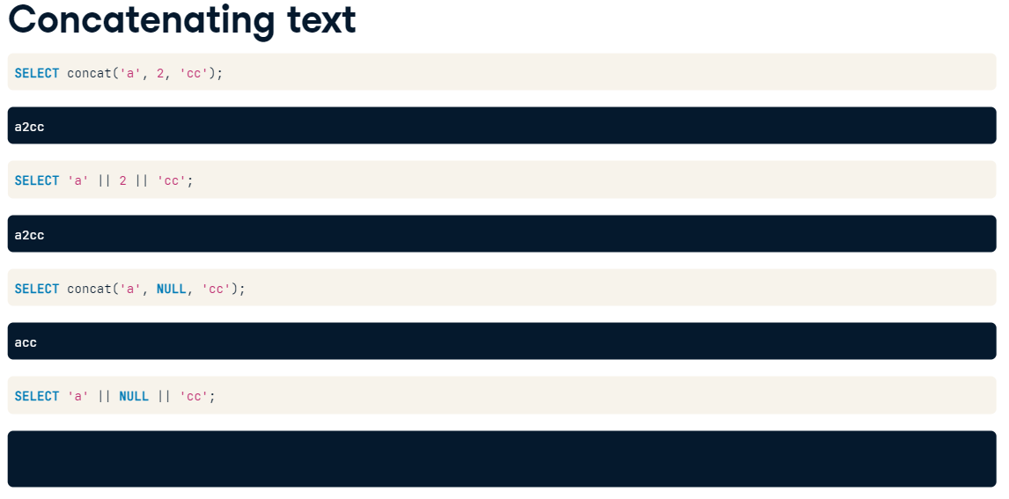

Ex1. House number (house_num) and street are in two separate columns in evanston311. Concatenate them together with concat() with a space in between the values.

-- Concatenate house_num, a space, and street

-- and trim spaces from the start of the result

SELECT ltrim(concat(house_num , ' ' , street)) AS address

  FROM evanston311;

Ex2. Extract just the first word of each street value to find the most common streets regardless of the suffix.

-- Select the first word of the street value

SELECT split_part(street, ' ', 1) AS street_name,

       count(*)

  FROM evanston311

 GROUP BY street_name

 ORDER BY count DESC

 LIMIT 20;

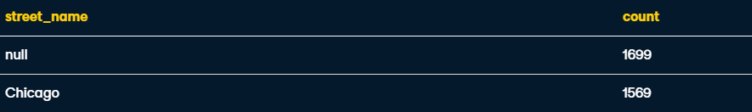

Ex3. Select the first 50 characters of description when description starts with the word "I".

-- Select the first 50 chars when length is greater than 50

SELECT CASE WHEN length(description) > 50

            THEN left(description, 50) || '...'

       -- otherwise just select description

       ELSE description

       END

  FROM evanston311

 -- limit to descriptions that start with the word I

 WHERE description LIKE 'I %'

 ORDER BY description;



Multiple Transformations

For when -, | or : are used as delimiters:

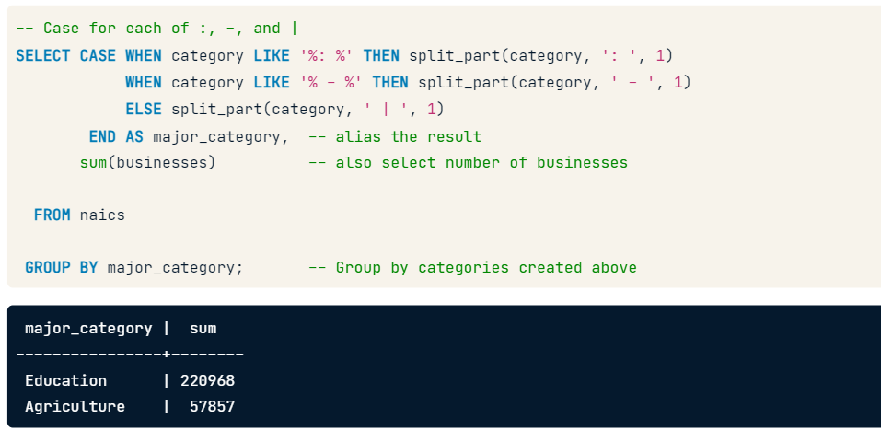

Recoding a table

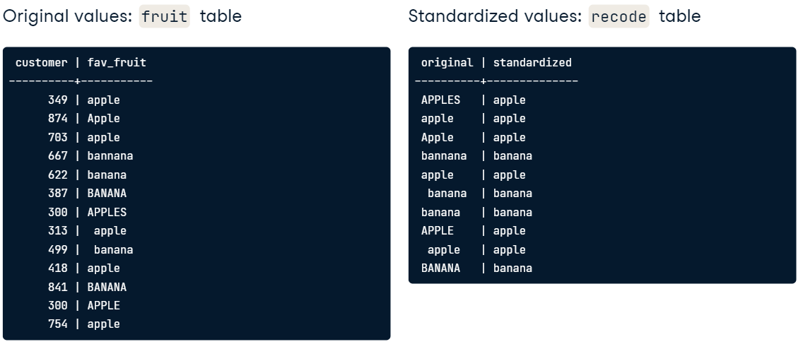

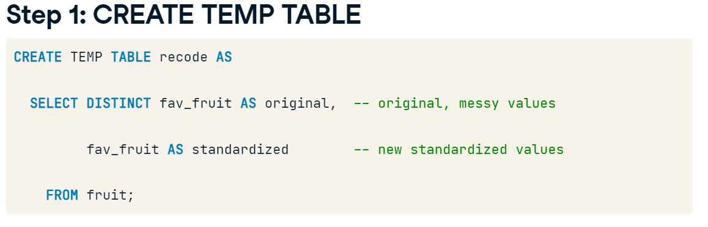

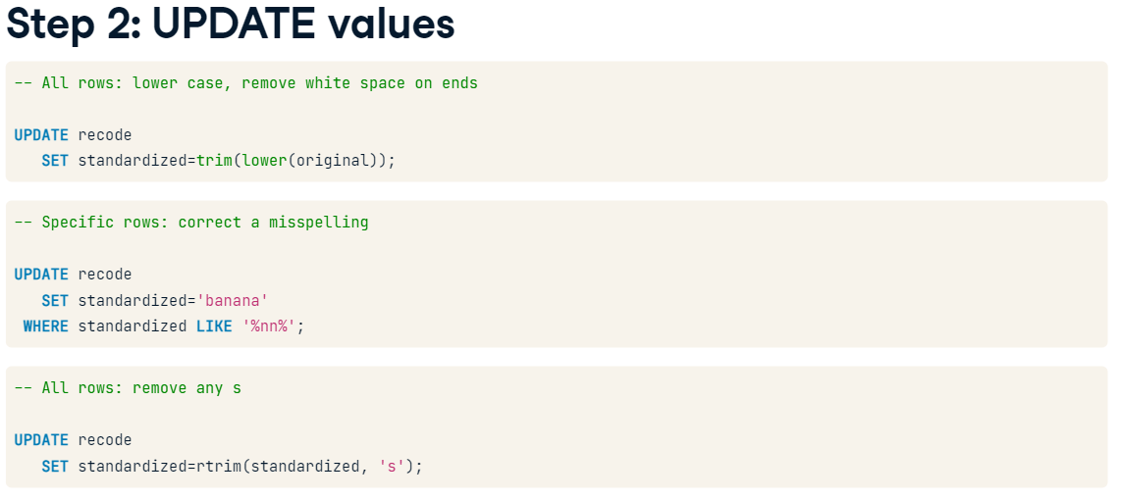

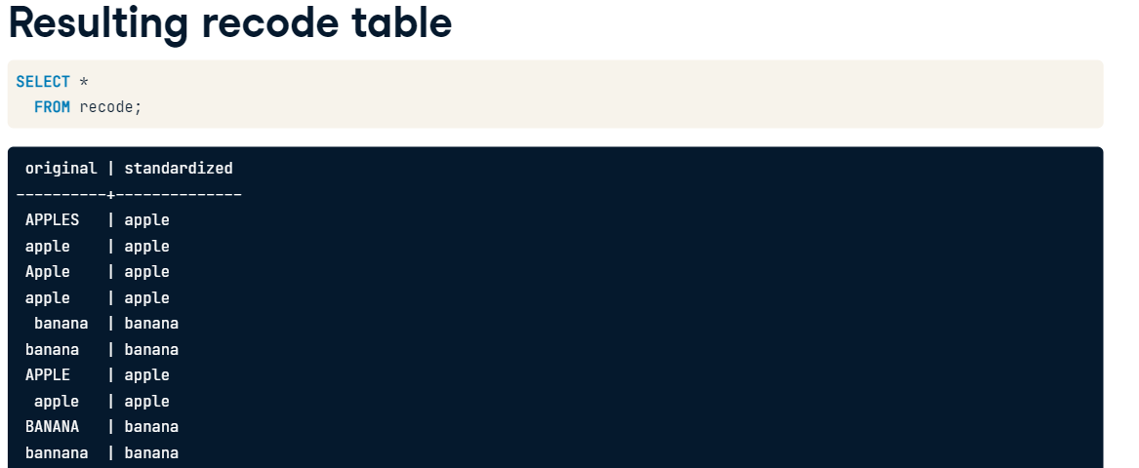 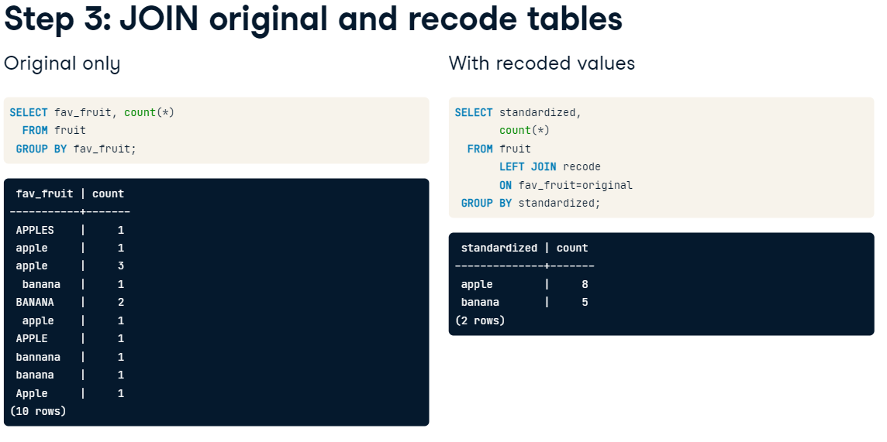

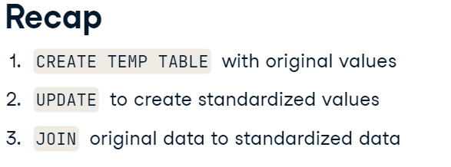

Ex1. create a temporary table recode mapping distinct category values to new, standardized values. Make the standardized values the part of the category before a dash ('-'). Extract this value with the split_part() function.

You'll also need to do some additional cleanup of a few cases that don't fit this pattern.

Then the evanston311 table can be joined to recode to group requests by the new standardized category values.

-- Code from previous step

DROP TABLE IF EXISTS recode;

CREATE TEMP TABLE recode AS

  SELECT DISTINCT category,

         rtrim(split_part(category, '-', 1)) AS standardized

  FROM evanston311;

UPDATE recode SET standardized='Trash Cart'

 WHERE standardized LIKE 'Trash%Cart';

UPDATE recode SET standardized='Snow Removal'

 WHERE standardized LIKE 'Snow%Removal%';

UPDATE recode SET standardized='UNUSED'

 WHERE standardized IN ('THIS REQUEST IS INACTIVE...Trash Cart',

               '(DO NOT USE) Water Bill',

               'DO NOT USE Trash', 'NO LONGER IN USE');

-- Select the recoded categories and the count of each

SELECT standardized, count(*)

-- From the original table and table with recoded values

  FROM evanston311

       LEFT JOIN recode

       -- What column do they have in common?

       ON evanston311.category=recode.category

 -- What do you need to group by to count?

 GROUP BY standardized

 -- Display the most common val values first

 ORDER BY count DESC;

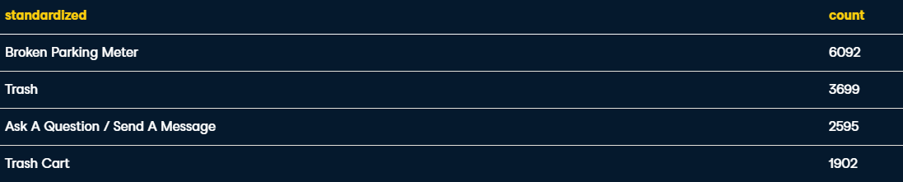

Ex2. Determine whether medium and high priority requests in the evanston311 data are more likely to contain requesters' contact information: an email address or phone number.

-- To clear table if it already exists

DROP TABLE IF EXISTS indicators;

-- Create the temp table

CREATE TEMP TABLE indicators AS

  SELECT id,

         CAST (description LIKE '%@%' AS integer) AS email,

         CAST (description LIKE '%___-___-____%' AS integer) AS phone

    FROM evanston311;

-- Select the column you'll group by

SELECT priority,

       -- Compute the proportion of rows with each indicator

       SUM(email)/COUNT(*)::numeric AS email_prop,

       SUM(phone)/COUNT(*)::numeric AS phone_prop

  -- Tables to select from

  FROM evanston311

       LEFT JOIN indicators

       -- Joining condition

       ON evanston311.id=indicators.id

 -- What are you grouping by?

 GROUP BY priority;

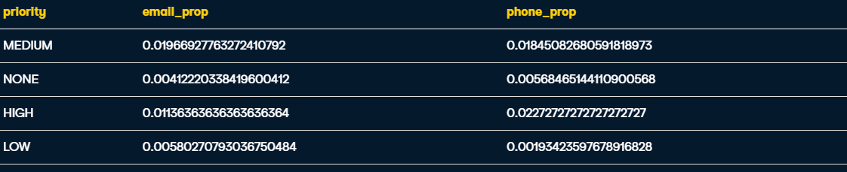

# Date/time types and formats

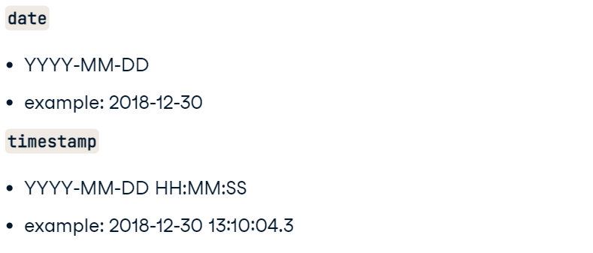

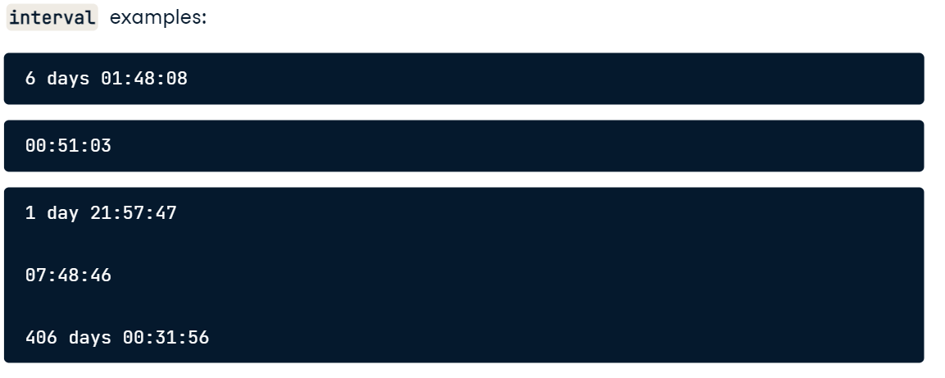

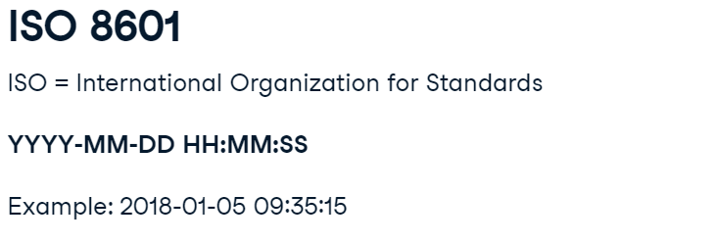

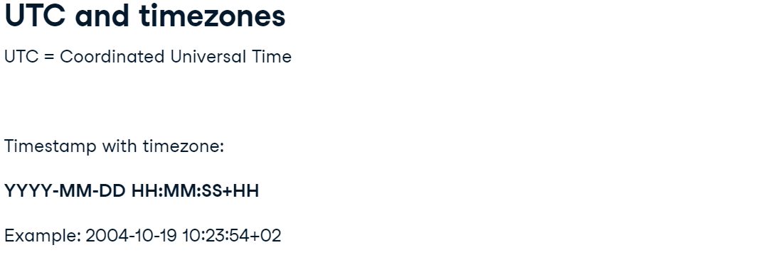

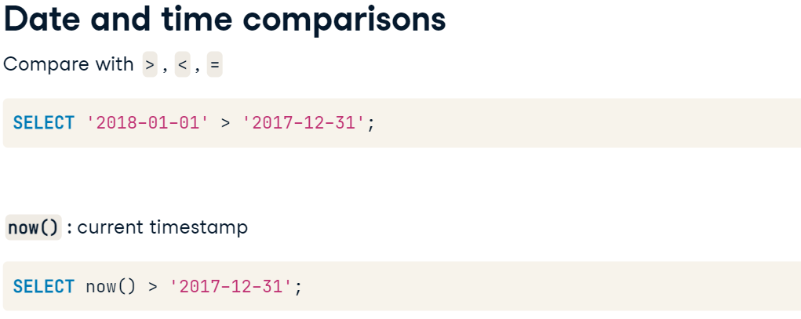 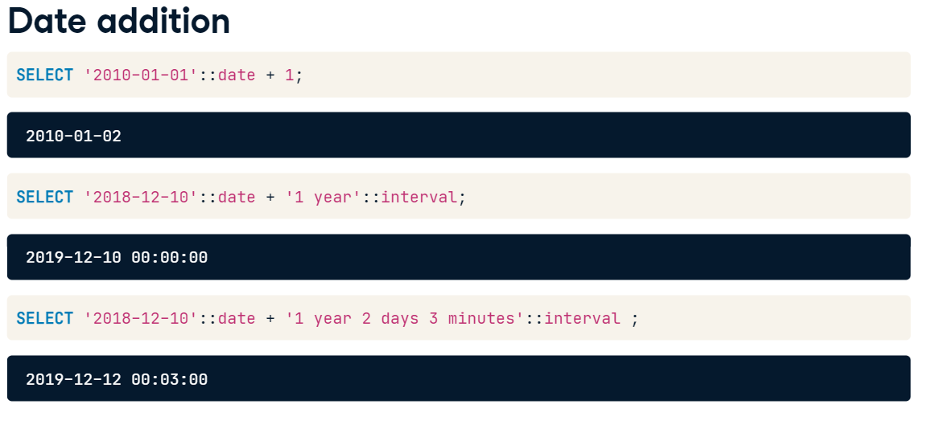

Ex1. Count the number of Evanston 311 requests created on January 31, 2017 by casting date_created to a date.

-- Count requests created on January 31, 2017

SELECT count(*)

  FROM evanston311

 WHERE date_created::date = '2017-01-31';

Ex2. Count the number of Evanston 311 requests created on February 29, 2016 by using >= and < operators.

-- Count requests created on February 29, 2016

SELECT count(*)

  FROM evanston311

 WHERE date_created >= '2016-02-29'

   AND date_created < '2016-03-01';



Ex3. Count the number of requests created on March 13, 2017.

Specify the upper bound by adding 1 to the lower bound.

-- Count requests created on March 13, 2017

SELECT count(*)

  FROM evanston311

 WHERE date_created >= '2017-03-13'

   AND date_created < '2017-03-13'::date + '1 day'::interval;



Ex4. Using now(), find out how old the most recent evanston311 request was created.

-- How old is the most recent request?

SELECT now() - MAX(date_created)

  FROM evanston311;

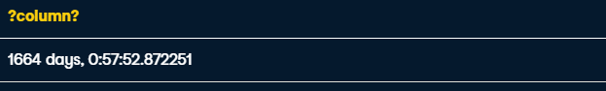

Ex5. -- Add 100 days to the current timestamp

SELECT now() + '100 days'::interval;

Ex6.

-- Select the current timestamp,

-- and the current timestamp + 5 minutes

SELECT now(), now() + '5 minutes'::interval;

EX7. Select the category and the average completion time by category

SELECT category,

       AVG(date_completed - date_created) AS completion_time

  FROM evanston311

 GROUP BY category

-- Order the results

ORDER BY completion_time DESC;

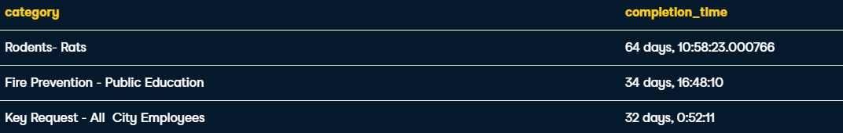

Date/Time components and Aggrregation

